South West Jersey Club
Chairman
James Montgomery
Treasurer
Peter Venn
Secretary
Jenny Ravenhill
Great Blakewell Farm
Chittlehampton
Umberleigh
Devon EX37 9AJ
Tel: 01769 540274
jenny@greatblakewell.co.uk
ARCHIVE REPORT
2019 South West Jersey Club On Farm Challenge Results
Judge: Mr Mark Logan
WHOLE MILKING HERD – SMALL HERDS, 100 cows or less - RIGGISTON CUP
1st Riverview Herd - Chris & Connie Creeper
2nd Coomber Herd - Tim & Julie Garry
3rd Hollesley Herd - Tigger Day
WHOLE MILKING HERD – LARGE HERDS, 101 cows or more - SOWDEN CUP
1st Quintrell Herd - Mike & Claire Colwell
2nd Whitemhill Herd - Bruce, Jenny & Jessica Ravenhill-White
3rd Rivermead Herd - The Davis Family
JUNIOR COW IN MILK - CHILLITON CUP
1st Hannahs Tequila Monica - Chris & Connie Creeper
2nd Whitenhill Rileys Coleus - Bruce, Jenny & Jessica Ravenhill-White
3rd Quintrell Spectrum Dianna - Mike & Claire Colwell
INTERMEDIATE COW - MAUNLAKE CUP
1st Whitenhill Coltons Lorinda - Bruce, Jenny & Jessica Ravenhill-White
2nd Scotsbridge Lix Winnie - Chris & Connie Creeper
3rd Rivermead Volcano Heather - The Davis Family
SENIOR COW, fourth lactation onwards - BOCM CUP
1st Quintrell Reagan Annabella - Mike & Claire Colwell
2nd Quintrell Klipper Girlfriend - Chris & Connie Creeper
3rd Sowden Hilux Miranda - James Warren
HEIFER IN MILK - BADCOCK & EVERARD TROPHY
1st Whitenhill Barnabas Crunchy Nut - Bruce, Jenny & Jessica Ravenhill-White
2nd Riverview Branson Tessa - Chris & Connie Creeper
3rd Cardinney Joel Glamour - James Warren

INCALF HEIFER - MORRISH TROPHY
1st Rivermead SG Bess - The Davis Family
2nd Whitenhill Victorious Cercis - Bruce, Jenny & Jessica Ravenhill-White
3rd Quintrell Christoph Fate - Mike & Claire Colwell
GROUP OF £ DAUGHTERS, by same Sire out of same Dam - CANONTEIGN CUP
1st Sunset Canyon Maximus - Chris & Connie Creeper
2nd Goldust Kabala Ladd - Carol Pledge
3rd Arethusa Jade Velocity - Tim & Julie Garry
DAM & DAUGHTER - DALENDA TROPHY
1st Whitenhill Coalitions Hazelnut & Whitenhill Barnabas Crunchy Nut - Bruce, Jenny & Jessica Ravenhill-White
2nd Quintrell May Dianna & Quintrell Spectrum Dianna - Mike & Claire Colwell
3rd Callestock Maximus Pepper Tessa & Riverview Branson Tessa - Chris & Connie Creeper
WHOLE HERD INSPECTION PRODUCTION - DAY CUP
1st Whitenhill Herd - Bruce, Jenny & Jessica Ravenhill-White
2nd Sunnydawn Herd - Carol Pledge
3rd Quintrell Herd - Mike & Claire Colwell
TWO HOME BRED COWS OR HEIFERS, by same UK bred bull - GUNN SHIELD
1st Bluegrass Pollys Long Island Iced Tea - Bruce, Jenny & Jessica Ravenhill-White
2nd Sunnydawn Platinum - Carol Pledge
3rd Coomber Dellas Envoy - Tom & Julie Garry
FAMILY LINE, 3-4 Generations - GOSLING CUP
1st Rose Family - Tim & Julie Garry
2nd Five Pence Family - Bruce, Jenny & Jessica Ravenhill-White
3rd Blossom Family - The Davis Family
LIFETIME PRODUCTION INSPECTION - MONTGOMERY CUP
1st Sunnydawn Herbys Fenella - Carol Pledge
2nd Kit Hot Primrose 121 - James & Nancy Scott
3rd Glanmor Julian Winc - James Warren
PRODUCTION INSPECTION, TWO CONSECUTIVE LACTATIONS - ELDON TROPHY
1st Sunnydawn Success Papaya - Carol Pledge
2nd Whitenhill Iatolas Hilda - Bruce, Jenny & Jessica Ravenhill-White
3rd Cardinney Big Boys Honey 2nd - James Warren
JUDGES CHOICE - COOMBER CUP
Whitenhill Coalitions Hazelnut - Bruce, Jenny & Jessica Ravenhill-White

2018 South West Jersey Club Herd Competition Results
Judge: Miss Sarah Pye
WHOLE MILKING HERD, Small Herds (100 cows or less)
Riggiston Cup
1st Sowden Herd - Malcolm & Anne Huxtable
2nd Riverview Herd - Chris Creeper & Connie Baldock
3rd Coomber Herd - Tim & Julie Garry
WHOLE MILKING HERD, Large Herds (101 cows or more)
Sowden Cup
1st Quintrell Herd - Mike, Claire & Jenny Colwell
2nd Whitenhill Herd - Bruce & Jenny Ravenhill
3rd Rivermead Herd - The Davis Family
JUNIOR COW IN MILK
Chilliton Cup
1st Rivermead Reagan Blossom - The Davis Family
2nd Quintrell Innovation Bee - Mike, Claire & Jenny Colwell
3rd Quintrell Klipper Girlfriend - Chris Creeper & Connie Baldock
SENIOR COW, Fourth Lactation Onwards
BOCM Cup
1st Sowden Tempest Miranda 2 - Malcolm & Anne Huxtable
2nd Philmor Signature Blossom - The Davis Family
3rd Quintrell Ballard Devotional - Mike, Claire & Jenny Colwell
HEIFER IN MILK
Badcock & Everard Trophy
1st Rivermead Colton Rose - The Davis Family
2nd Hannahs Tequila Monica - Chris Creeper & Connie Baldock
3rd Whitenhill Primeros Caspia - Bruce & Jenny Ravenhill
INCALF HEIFER
Morrish Trophy
1st Whitenhill Primeros Puerto Rico - Bruce & Jenny Ravenhill
2nd Riverview Yegabomb Clio - Chris Creeper & Connie Baldock
3rd Cardinney Joel Glamour - James Warren
GROUP OF THREE DAUGHTERS, by same Sire or out of same Dam
Canonteign Cup
1st Potterswalls Timekeeper - Malcolm & Anne Huxtable
2nd Rapid Bay Reagan - Mike, Claire & Jenny Colwell
3rd Tregibby Yegabomb - The Davis Famiy

DAM & DAUGHTER
Dalena Trophy
1st Philmor Signature Blossom & Rivermead Reagans Blossom - The Davis Family
2nd Sowden Tempest Miranda 6 & Sowden Timekeeper Miranda 2 - Malcolm & Anne Huxtable
3rd Quintrell Exceptional Devotion & Quintrell Ballard Devotional - Mike, Claire & Jenny Colwell
WHOLE HERD INSPECTION PRODUCTION
Day Cup
1st Sunnydawn Herd - Carol Pledge
2nd Whitenhill Herd - Bruce & Jenny Ravenhill
3rd Cardinney Herd - James Warren
HOMEBRED COWS OR HEIFERS BY SAME UK BRED BULL
Gunn Shield
1st Potterswalls Timekeeper - Malcolm & Anne Huxtable
2nd Tregibby Yegabomb - The Davis Family
3rd Quintrell Maximum Cobalt - Mike, Claire & Jenny Colwell
FAMILY LINE, 3-4 Generations
Gosling Cup
1st Blossom Family - The Davis Family
2nd Devotion Family - Mike, Claire & Jenny Colwell
3rd Rose Family - Tim & Julie Garry
LIFETIME PRODUCTION INSPECTION
Montgomery Cup
1st Sunnydawn Herbys Fenella - Carol Pledge
2nd Coomber HH Legacy 29 - Tim & Julie Garry
3rd Whitenhill Fusions Windswept - Bruce & Jenny Ravenhill
PRODUCTION INSPECTION of two consecutive lactations
Eldon Trophy
1st Sunnydawn Krunch Narina - Carol Pledge
2nd Whitenhill Iatola Hilda - Bruce & Jenny Ravenhill
3rd Quintrell E Devotion - Mike, Claire & Jenny Colwell
JUDGES CHOICE
The Coomber Trophy
Rivermead Colton Rose - The Davis Family
2017 South West Jersey Club Herd Competition Results
Judge: Derek Frigot
WHOLE MILKING HERD – SMALL HERD (120 cows or less) (Riggiston Cup)
1st Coomber Herd - Tim & Julie Garry
2nd Hollesley Herd - Tigger Day
3rd Sunnydawn Herd - Carol Pledge
WHOLE MILKING HERD – LARGE HERD (121 cows or more) (Sowden Cup)
1st Whitenhill Herd - Bruce & Jenny Ravenhill
2nd Quintrell Herd - Mike & Claire Colwell
3rd Rivermead Herd - The Davis Family
JUNIOR COW IN MILK (Chilliton Cup)
1st Whitenhill Tequila Logical - Bruce & Jenny Ravenhill
2nd Quintrell Kyros Indigo - Mike & Claire Colwell
3rd Sunnydawn Excite Pink - Carol Pledge
SENIOR COW 4th LACTATION ONWARDS (BOCM Cup)
1st Quintrell Reagan Scarlet - Mike & Claire Colwell
2nd Whitenhill Above & Beyond Delphi - Bruce & Jenny Ravenhill
3rd Philmor Signatures Blossom - The Davis Family
HEIFER IN MILK (Badcock & Everard Trophy)
1st Cardinney Valentino Mylady 2 - James Warren
2nd Quintrell Tequila Imagine - Mike & Claire Colwell
3rd Whitenhill Iced Teas Deliria - Bruce & Jenny Ravenhill
IN CALF HEIFER (Morrish Trophy)
1st Rivermead Genominator Cash - The Davis Family
2nd Sunnydawn Ladd Silvanverry - Carol Pledge
3rd Cardinney Vanhalem Winner - James Warren
GROUP OF THREE DAUGHTERS BY THE SAME SIRE OR OUT OF THE SAME DAM (Canonteign Cup)
1st Quintrell Maximus Cobalt - Mike & Claire Colwell
2nd Potterswalls Lord Excite - Carol Pledge
3rd Sunset Canyon Maximus - Chris Creeper & Connie Baldock
DAM & DAUGHTER (Dalena Trophy)
1st Carol Pledge - Dam: Sunnydawn Regan Nigella - Daughter: Sunnydawn Excite Pinetta
2nd Mike & Claire Colwell - Dam: Quintrell Exceptional Devotion - Daughter: Quintrell Ballard Devotion
3rd The Davis Family - Dam: Philmor Signatures Blossom - Daughter: Rivermead Reagan Blossom
WHOLE HERD INSPECTION PRODUCTION (Day Cup)
1st Whitenhill Herd - Bruce & Jenny Ravenhill
2nd Sunnydawn Herd - Carol Pledge
3rd Ritherdens Herd - William & Peter Venn
TWO HOMEBRED COWS OR HEIFERS BY SAME UK BRED BULL (Gunn Shield)
1st Quintrell Maximus Colbalt - Mike & Claire Colwell
2nd Potterswalls Minister - Bruce & Jenny Ravenhill
3rd Coomber Dellas Envoy - Tim & Julie Garry
FAMILY LINE 3-4 GENERATIONS (Gosling Cup)
1st Mike & Claire Colwell - Scarlet, Magenta, Carmine Family
2nd Bruce & Jenny Ravenhill - Delarosa Family
3rd Tim & Julie Garry - Who Family
LIFETIME PRODUCTION INSPECTION (Montgomery Cup)
1st Whitenhill Sambos Delamay Sire: Lester Sambo - Bruce & Jenny Ravenhill
2nd Kit Hot Primrose 121 Sire: Jas Hot - James & Nancy Scott
3rd Sunnydawn Herbys Fenella Sire: Crockett Farms Golden Herby - Carol Pledge
PRODUCTION INSPECTION FOR TWO CONSECUTIVE LACTATIONS (Eldon Trophy)
1st Sunnydawn May Koral Sire: DJ May - Carol Pledge
2nd Whitenhill Iatolas Hilda Sire: SC Gold Dust Paramount Iatola - Bruce & Jenny Ravenhill
3rd Quintrell Elton Minstrell Sire: Cairnbrae Jacess Elton - Mike & Claire Colwell
JUDGES CHOICE
The Riverview Herd - Chris Creeper & Connie Baldock

2014 South West Jersey Club Herd Competition
Judge – Izzy Wright
Class 1
Whole Milking Herd (Small Herd) - Riggiston Cup
1st Hilary Day - Hollesley Jerseys
2nd Huxtable Family - Sowden Jerseys
3rd Carole Pledge - Sunnydawn Jerseys
Whole Milking Herd (Large Herd) - Sowden Cup
1st Colwell Family - Quintrell Jerseys
2nd Davis Family - Rivermead Jerseys
3rd JA & E Montgomery - Orchard Jerseys
Class 2 Junior Cow (2nd or 3rd Lactation) - Chilliton Cup
1st Rivermead Jerseys - Bluegrass Grandprix Supersonic Black
2nd Quintrell Jerseys - Quintrell Reagan Scarlet
3rd Josie’s Jerseys – Vagg Juno Dillwyn
Class 3 Senior Cow (4th Lactation onwards) - BOCM Cup
1st Sowden Jerseys - Sowden Sampson Ceres
2nd Orchard Jerseys - Orchard Remake Tribute
3rd Quintrell Jerseys - Quintrell Iatola Inform
Class 4 Best Heifer In Milk - Badcock & Everard Trophy
1st Rivermead Jerseys - Rivermead Java Tor
2nd Quintrell Jerseys - Quintrell Cobalt Garland
3rd Hollesley Jerseys - Hollesley Hillsborough
Class 5 Best Heifer In Calf - Morrish Trophy
1st Rivermead Jerseys - Rivermead Tequila Fantasia
2nd Quintrell Jerseys - Quintrell Reagan Annabella
3rd Sunnydawn Jerseys - Sunnydawn Belvedere Otaheited Apple
Class 6 Group of three daughters by same sire or out of same dam – Canonteign Cup
1st Quintrell Jerseys - S C Gold Dust Paramount Iatola
2nd Sunnydawn Jerseys - S C Gold Dust Paramount Iatola
3rd Coomber Jerseys - Pine Haven Senior

Class 7 Dam & Daughter, Daughter to be at least in calf with 1st Calf - Dalena Trophy
1st Sunnydawn Jerseys - Sunnydawn Sultan Hallina & Sunnydawn Reagan Nigella
2nd Quintrell Jerseys - Quintrell Sultan Datastream & Quintrell McGuire Google
3rd Josie’s Jerseys - Tremeere Impulse Dillwyn & Vagg Juno Dillwyn
Class 8 Whole herd production & Inspection - Day Cup
1st Sunnydawn Jerseys
2nd Quintrell Jerseys
3rd Maunlake Jerseys
Class 9 Two home bred cows or heifers by the same UK bred sire
1st Quintrell Jerseys - Quintrell Maximus Cobalt
2nd Sunnydawn Jerseys - Sunnydawn Caramel Krunch
3rd Hollesley Jerseys - Hollesley Solar
Class 10 Family Line (Min. of three consecutive generations max. of four animals) - Gosling Cup
1st Quintrell Jerseys
2nd Sunnydawn Jerseys
3rd Coomber Jerseys
Class 11 Lifetime Production/Inspection - Montgomery Cup
1st Sunnydawn Jerseys - Sunnydawn Triumph Blackcurrant
2nd Orchard Jerseys - Orchard Lenora
3rd Coomber Jerseys - Coombers Galaxy Legacy
Class 12 Production/Inspection for two consecutive lactations - Eldon Trophy
1st Orchard Jerseys - Orchard Lenora
2nd Sunnydawn Jerseys - Iatola Bluejohn
3rd Quintrell Jerseys - Charismatic Moll
Judges Choice - Huxtable Family, Sowden Samson Ceres
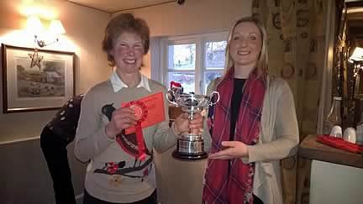
CAPTION: Carole Pledge from Sunnydawn Jerseys won the Dam & Daughter & both production inspection classes

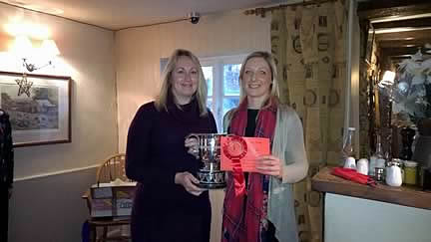
CAPTION: Claire Colwell from Quintrell Jerseys with the cup for Best Family Line
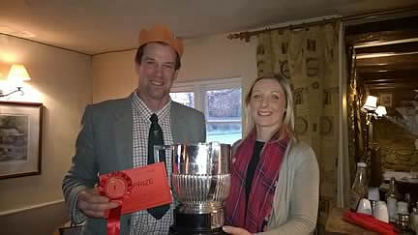
CAPTION: Jamie Montgomery from Orchard Jerseys won the Production inspection award for two consecutive lactations
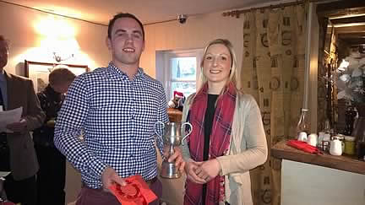
CAPTION; Kev Davis from the Rivermead herd winning the Best heifer in milk class
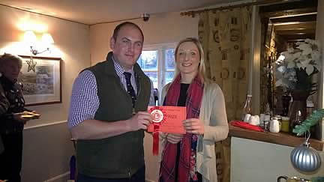
CAPTION: Mark Davis from Rivermead Jerseys won the Junior cow class, Best heifer in milk & the heifer in calf classes
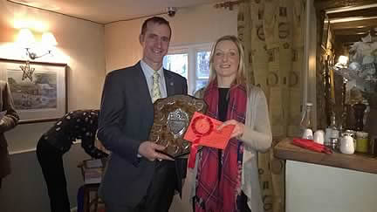
CAPTION: Mike Colwell took home the home bred pairs, group of three and large herd cups

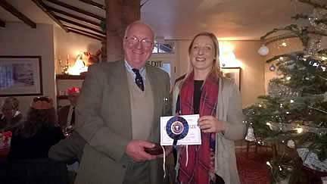
CAPTION; Sowden Jerseys won both the Judges choice cup & the Senior cow Cup

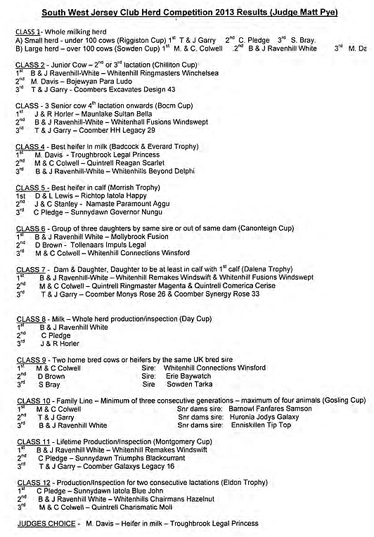

2012 South West Jersey Club
Herd Competition 2012
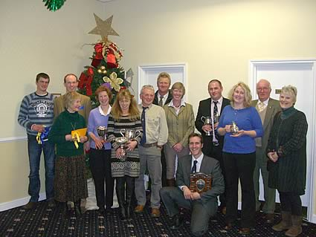
CAPTION: South West Jersey Club Herd Competition 2012 Winners
Judge Jenny Daw
CLASS 1- Whole milking herd
A) Small herd - under 90 cows (Riggiston Cup)
1st M DAVIS
2nd J & P SCOTT
3rd CAROL PLEDGE
B) Large herd – over 90 cows (Sowden Cup)
1st B & J RAVENHILL-WHITE
2nd MCJ COLWELL
3rd SIMON BRAY
CLASS 2 - Junior Cow – 2nd or 3rd lactation (Chilliton Cup)
1st CAROL PLEDGE "Sunnydawn Excitation Jackfruit"
2nd B & J RAVENHILL-WHITE “Whitenhill Fusions Windswept"
3rd MCJ COLWELL "Quintrell Excitation Dianne"
CLASS - 3 Senior cow 4th lactation onwards (Bocm Cup)
1st T & J GARRY "Coomber Vindication Parsley"
2nd B & J RAVENHILL-WHITE “Whitenhill Fusions Windsale"
3rd M & A HUXTABLE & SON "Sowden Juno Tracy"
CLASS 4 - Best heifer in milk (Badcock & Everard Trophy)
1st M DAVIS "IJB Excitations Princess"
2nd M & A HUXTABLE & SON "Sowden Legal Corny"
3rd SIMON BRAY "Southley Prides Sophia 2"
CLASS 5 - Best heifer in calf (Morrish Trophy)
1st W VENN & SON "Ritherden Harvest"
2nd SIMON BRAY "Southley Tarka Sienna Who"
3rd CAROL PLEDGE "Sunnydawn Belmont Mistletoe"
CLASS 6 - Group of three daughters by same sire or out of same dam (Canonteign Cup)
1st B & J RAVENHILL-WHITE Sire: "Mollybrook Fusion"
2nd M S ASHTON & SON Sire: "S.C Goldust Paramount Iatola"
3rd MCJ COLWELL Sire "Devichoys Unbeatabull"
CLASS 7 - Dam & Daughter, Daughter to be at least in calf with 1st calf (Dalena Trophy)
1st B & J RAVENHILL-WHITE Whitenhill Remakes Windswift EX96 & Whitenhill Fusions Windswept EX91
2nd M & A HUXTABLE & SON Sowden Juno Tracey EX96 & Sowden Sampson Tracey EX94
3rd M S ASHTON Morebridge Sultans Philippa & Morebridge Excitations Bridget
CLASS 8 - Milk – Whole herd production/inspection (Day Cup)
1st B & J RAVENHILL-WHITE
2nd MCJ COLWELL
3rd W VENN & SON
CLASS 9 - Two home bred cows or heifers by the same sire
1st MCJ COLWELL Sire: "Devichoys Unbeatabull"
2nd SIMON BRAY Sire: "Bridon Excitation"
3rd HILARY DAY Sire "Hollesley Sterling"
CLASS 10 - Family Line – Minimum of three consecutive generations – maximum of four animals (Gosling Cup)
1st MCJ COLWELL Snr dams sire: "Perfection Judes Stylemaster"
2nd T & J GARRY Snr dams sire: "Huronia Jodys Galaxy"
3rd B & J RAVENHILL-WHITE Snr dams sire: "Enniskillin Tip Top"
CLASS 11 - Lifetime Production/Inspection (Montgomery Cup)
1st CAROL PLEDGE "Sunnydawn Triumph Blackcurrant"
2nd MCJ COLWELL "Quintrell Ultramarine"
3rd B&J RAVENHILL WHITE "Whitenhill Remakes Windswift"
CLASS 12 - Production/Inspection for two consecutive lactations (Eldon Trophy)
1st B & J RAVENHILL-WHITE "Whitenhill Fusions Windsale"
2nd CAROL PLEDGE "Sunnydawn Hot Greengage"
3rd HILARY DAY "Hollesley Hot Lime"
JUDGES CHOICE
B & J RAVENHILL-WHITE "Whitenhill Remakes Windswift"

2011 South West Jersey Club News
Competition Results
Class 1a) Riggiston Cup, herd 90 and under milkers
1) T & J Garry
2) Mark Davis
3) Hilary Day
Class 1b) Sowden Cup, Herd over 90 milkers
1) J & M Colwell
2) Carol Pledge
3) M & A Huxtable & Son
Class 2 Chillaton Cup, Junior cow 2nd or 3rd lactation
1) Mark Davis “Angersleigh L Ina
2) J & M Colwell “Quintrell May Katrina”
3) J Ashton “Morebridge Casino”
Class 3 BOCM cup, Senior cow 4th lactation onwards
1) J & M Colwell “Quintrell PJSM Ultramarine”
2) T & J Garry “Coomber Raptors Mischance 32”
3) W J Venn & Son “Ritherdens Sambo 1207”
Class 4 Badcock and Everard Trophy, Best heifer in milk
1) S Bray “Southley Excitation Magic 2”
2) Carol Pledge “Sunnydawn Bigshow Lattice”
3) M & A Huxtable & Son “Sowden Tempest Miranda 2”
Class 5 Morrish Trophy, Best heifer in calf
1) Maundrils Partnership “Maunlake Bigshow Daydream”
2) S Bray “Southley Prides Celia 3”
3) Carol Pledge “Sunnydawn Target Loyalist”
Class 6 Canonteign Cup, Group of 3 daughters Sire/Dam
1) T & J Garry Sire/Coomber Montgomery
2) S Bray Sire/Potterswalls Belles Pride
3) Carol Pledge Sire/Bridon Excitation
Class 7 Dalena Trophy, Dam and Daughter
1) J Montgomery “Orchard Remake Tribute/O.Roman Tribute 2
2) Mark Davis “Angersleigh L Ina/Rivermead C Ivy
3) M&A Huxtable & Son “Sowden Juno Miranda/ S Samson Miranda 9”
Class 8 Day Cup, Whole herd Production/Inspection
1) W J Venn & Son 1301 points
2) Maundrils Partnership 1292 points
3) Carol Pledge 1291 points
Class 9 Homebred Females progeny of UK Bull
1) M&A Huxtable & Son Sire/Potterswalls Lord Juno
2) T & J Garry Sire/Coomber Montgomery
3) Hilary Day Sire/Hollesley Stirling
Class 10 Gosling Cup, Family line, min 3 generations
1) M&C Colwell “Quintrell PJSM Ultramarine”
2) T&J Garry “Coomber Galaxys Royalty 18”
3) M&A Huxtable & Son “Sowden Louis Miranda”
Class 11 Montgomery Cup, Lifetime Production/Inspection
1) Carol Pledge “Sunnydawn Bygs Yonda” 6931 points
2) J Montgomery “Orchard Leonora” 5847 points
3) T&J Garry “Coomber Saturns Design 19” 4538 points
Class 12 Elmdon Trophy, judged on last 2 lactations fat plus milk weight and inspection points
1) Hilary Day “Hollesley Hot Lime” 253.4 points
2) Carol Pledge “Sunnydawn Hot Greengage” 251.8 points
3) N & C Colwell “Quintrell Sambos Nicandra” 242.4 points
Judges Favourite: S Bray “Southley Excitation Magic” Heifer in Milk
Reserve: M Davis “Angersleigh L Ina” Junior Cow

2011 The Dairy Show
Wednesday 5th October
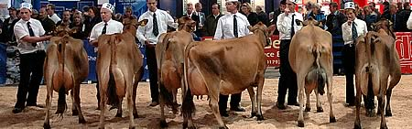
UK Jerseys and the South West Jersey Club had a stand near the Jersey show ring at the Dairy show on Wednesday October 5th at The Royal Bath and West showground.

2011 Honiton Agricultural Show - Thursday 4th August
Judge: Mr David Christopher
Well done to Mark Davis for winning the champion Jersey and Carol Pledge for reserve.
South West Jersey Club Young Handler Results
Class 1 (9 - 12 years)
1st Chloe Fewings (12)
2nd Emily Davis (9)
3rd Owen Rendall (12)
4th Amy Lewis (11)
5th Cameron Lewis (9)
Class 2 (13 – 19 years)
1st Jessica Ravenhill – white (17)
2nd Sunny Selway (19)
3rd Mary Scott (13)
Champion - Jessica Ravenhill-White
Reserve champion - Chloe Fewings
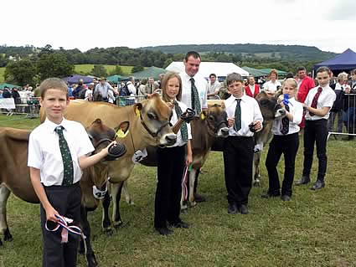
CAPTION: From right to left; Winner Chloe Fewings, 2nd place Emily Davis, 3rd place Owen Rendell, (Judge David Christophers), 4th place Amy Lewis, 5th place Cameron Lewis
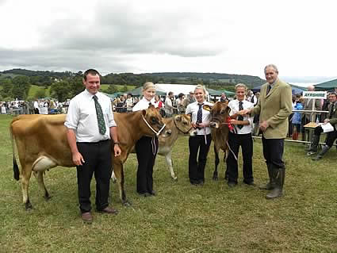
CAPTION: From right to left Kevin Roberts (Three Counties Feeds – Sponsor), Winner Jessica Ravenhill-White, 2nd place Sunny Selway, 3rd place Mary Scott
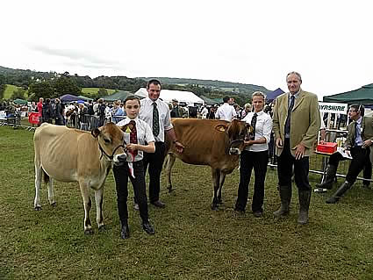
CAPTION: Champion young handler Jessica Ravenhill-White, Reserve Champion young handler Chloe Fewings
Well done to everyone and thank you to Three Counties Feeds for sponsoring the classes and David Christophers for judging.

2011 Stock Judging Workshop
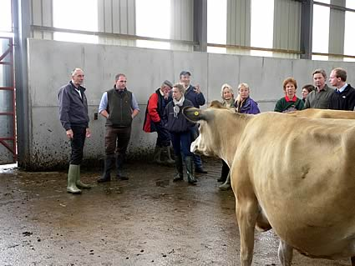
On Tuesday 19th July a very successful Stock judging workshop was held at the Sowden Herd. Grateful thanks to Malcolm and Ann Huxtable for hosting the event and Charles Reader for coming all the way down to Devon to share his expert knowledge with us.

2010 South West Jersey Club
Honiton Show - 5th August 2010
South West Jersey Club Young Handlers competition - Judge: Nick Hill
Well done to all exhibitors for a superb effort and high level of showmanship
Results
Class 1 (5 - 11 years)  1st Oliver Schuster-wood  2nd Emily Davis  3rd Chloe Fewings  4th Charlotte Roberts  5th Ellie Parkhouse  6th Owen Rendall | Class 2 (12 - 19 years)  1st Sunny Selway  2nd Jessica Ravenhill-white  3rd Samantha Fewings  4th Mary Scott  5th Emily Vallis
Champion: Oliver Schuster-wood
Reserve champion: Sunny Selway

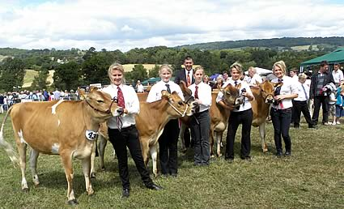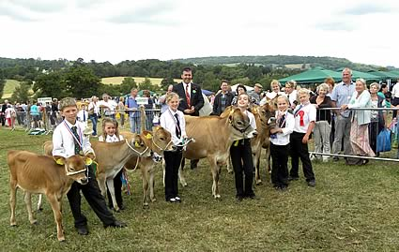
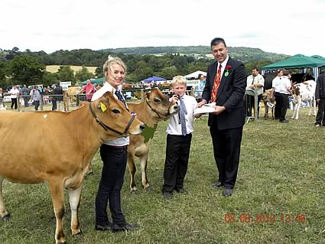

2009 South West Jersey Club News
Results of young handlers classes at Honiton Agricultural Show 2009
Class one 10 years & under
1st Chloe Fewings (10)
2nd Emily Davis (7)
3rd Oliver Schuster-Wood (10 )
4th Andrew Stanbury (9)
5th Emily Stanbury (6 )
Class two 11 -21 years
1st Samantha Fewings (18 )
2nd Sunny Selway (17 )
3rd Jessica Ravenhill-White (15)
4th Emily Vallis (15 )
5th Mary Scott (11)
Champion Handler: Chloe Fewings
Reserve Champion Handler: Samantha Fewings
Well done Mary, Emily and Andrew Stanbury, it was their first show with their calves.
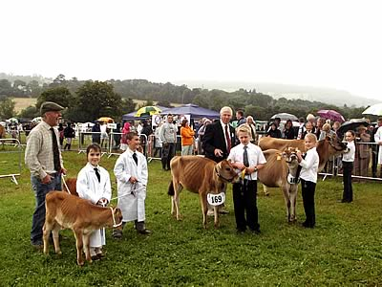

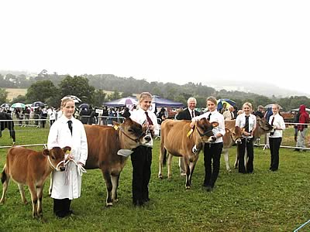
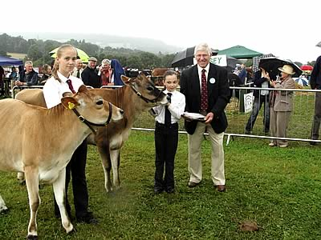

2008 South West Jersey Club News
2008 SOUTH WEST JERSEY CLUB HERD COMPETITION RESULTS
CLASS 1 SMALL HERDS UNDER 90 COWS
1st M & A Huxtable & Son 570 points
2nd H Day 550 points
3rd C Pledge 530 points
CLASS 1 LARGE HERDS OVER 90 COWS
1st International Jersey Breeders 600 points
2nd B & J Ravenhill White 585 points
3rd T & J Garry 560 points
CLASS 2 JUNIOR COW 2/3 LACTATIONS CHILLATON CUP
1st B & J Ravenhill White WHITENHILL FUSIONS WINDSALE
2nd IJB IJB HANNIBALS GALAXY
3rd M & A Huxtable & Son SOWDEN SAMSON CERES
CLASS 3 SENIOR COW 4 PLUS LACTATIONS BOCM CUP
1st M & A Huxtable & Son SOWDEN JUNO TRACY
2nd M & C Colwell QUINTRELL ULTRA MARINE
3rd IJB I J B MASTERS SNOWBERRY
CLASS 4 BEST HEIFER IN MILK BADCOCK AND EVERARD TROPHY
1st IJB IJB SULTANS MONICA
2nd Mrs H Woodget SPICE NEBRASKA TULIP 2nd
3rd B & J Ravenhill White WHITENHILL VALIANTS ESBALINDA
CLASS 5 BEST HEIFER IN CALF MORRISH TROPHY
1st M S Ashton & Sons MOREBRIDGE MOONSHINE
2nd T & J Garry COOMBER GOLDEN LEGACY 33
3rd IJB IJB SIGNATORS ASTER
CLASS 6 GROUP OF 3 BY SAME SIRE/DAM CONONTEIGN CUP
1st M & C Colwell STYLEMASTER
2nd T & J Garry COOMBER MONTGOMERY
3rd IJB CENTURIANS SULTAN
CLASS 7 DAM AND DAUGHTER DALENA TROPHY
1st B & J Ravenhill White W. WINDSWIFT/WINDSALE
2nd Mrs H Woodget SPICE TULIP/TULIP 2
3rd M & A Huxtable & Son SOWDEN JUNO TRACY/SAMSON TRACY
CLASS 8 WHOLE HERD PRODUCTION/INSPECTION DAY CUP
1st B & J Ravenhill White 1338 points
2nd Carol Pledge 1262 points
3rd H Day 1250 points
CLASS 9 HOME BRED COWS/HEIFERS
1st T & J Garry Sire: COOMBER MONTGOMERY
2nd IJB Sire: IJB BREEZES ROMULUS
3rd B & J Ravenhill White Sire: W. SAMBOS HOPPETT
CLASS 10 FAMILY LINE MIN 3 GENERATIONS
1st B & J Ravenhill White WHITENHILL WINIFRED
2nd IJB IJB SNOWBERRY
3rd T & J Garry COOMBER WHOOPI
CLASS 11 LIFETIME PRODUCTION/INSPECTION MONTGOMERY CUP
1st J A & E Montgomery 2122 pts ORCHARD HIGHLAND TRIBUTE
2nd Carol Pledge 1781 pts SUNNYDAWN DEXTAS WANDA
3rd B & J Ravenhill White 1696 pts WHITENHILL KHAN SMALLTALK
CLASS 12 REG RECORDED COW LAST 2 LACTATIONS ELDON TROPHY
1st M & C Colwell 252 pts Q PJSM ULTRAMARINE
2nd H Day 240 pts HOLLESLEY RED ELLAN
3rd B & J Ravenhill White 237 pts WHITENHILL PERIMS. BLUEBERRY
JUDGES CHOICE: SPICE NEBRASKA TULIP : Mrs H WOODGET

2008 Young Handlers Competition
Honiton Show
Sponsored by Stags Auctioneers
Judge Mr Jeff Dawes
Class 1 - 11 years olds & under
1st Chloe Fewings
2nd Laura Huxtable
Class 2 - over 11 years old
1st Samantha Fewings
Robert Selway
Jessica Ravenhill-White
Champion Young Handler winner of the Mistletoe Perpetual Shield
Samantha Fewings
Reserve
Chloe Fewings

2007 South West Jersey Club News
The SW Club staged a Photo Competition as an alternative to its 2007 Herds’ Competition.
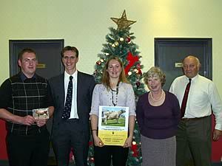
CAPTION: The challenge was taken up by the younger breeders in the Club and pictured are, left to right, Mark Davies (Rivermead) with Lanhydrock Danish Poppy, an early purchase for the herd which has already taken the Devon County Breed Champion, Michael and Claire Colwell (Quintrell) with Quintrell Ultramarine, the successful Inter-Breed Champion at the 2007 Royal Cornwall Show, and Liz and Tyrell Selway who retired in 2007, having organised the SW Herds’ Competition for well over a decade.

2007 Young Handlers Competition
Honiton Show
Judge: Mr David Christopher, Cornwall
RESULTS
Class 1 10 years and under
1st Emily Davis
2nd Oliver Schuster-Wood
3rd Chloe Fewings
Class 2 11 years and over
1st Samantha Fewings
2nd Kevin Davis
3rd Becky Davis
4th Sarah Newman
CHAMPION
Samantha Fewings
RESERVE
Emily Davis

