South Wales Jerseys De Cymru
President
Jim Edwards
Chairman
Andrew Batchelor
Treasurer
Nicola Evans
Secretary
Huw Evans
Nantyci
College Road
Carmarthen
SA33 6AG
Tel: 07721 386617
huwevansauctioneer@hotmail.com
ARCHIVE REPORTS
2018 SOUTH WALES DAIRY CALF SHOW 15th September
Judge: Mr James Doherty
JUNIOR SHOWMANSHIP, aged 12 years and under on 1st January 2018
1st William Campbell
2nd Sara Evans
3rd Sophie Carpenter
3rd Tomos Morgan
3rd Ifan Lloyd Evans
INTERMEDIATE SHOWMANSHIP, aged between 13 & 15 years on 1st January 2018
1st Elan Thomas
SENIOR SHOWMANSHIP, aged between 16 & 20 years on 1st January 2018
1st Iwan Jones
2nd Rosie Davies
CHAMPION Iwan Jones
RESERVE CHAMPION Elan Thomas
HONOURABLE MENTION Rosie Davies
HONOURABLE MENTION INTERBREED SHOWMANSHIP Iwan Jones

JERSEY CALF CLASSES
JERSEY CALF, born on or after 1st March 2018
1st Salfach Viral Crunchie - Salfach Jerseys
2nd Salfach Viral Penny - Salfach Jerseys
3rd Salfach Viral Nova - Salfach Jerseys
4th Tregibby Excitations Pandora - RE & C Evans
JERSEY CALF, born 1st December 2017 – 28th February 2018
1st Tregibby Tequila Petal - RE & C Evans
2nd Mydrim Rockcliff Tequilas Heidi - James Evans, Barrie Evans & Frank Poskitt
3rd Carps Tequila Poppy - Messrs Carpenter & Evans
JERSEY CALF, born 1st September 2017 – 30th November 2017
1st Futuredreams Excitations September Veronica - Futuredreams Partnership
JERSEY CALF, born 1st May 2017 – 31st August 2017
1st Lanstar Stacey - Tasha Arber
2nd Futuredreams Ressurection Summertime Veronica - Futuredreams Partnership
3rd Carps Dermot Alix - Messrs Carpenter & Evans
4th Salfach Barcelona Pikachu - Salfach Jerseys
JERSEY CALF, born 1st January 2017 – 30th April 2017
1st Futuredreams Geminis Blossom - Futuredreams Partnership
2nd Futuredreams Exciting Daffodil - Futuredreams Partnership
3rd Salfach Firepower Twtsi - Salfach Jerseys
CHAMPION Salfach Viral Crunchie
RESERVE CHAMPION Futuredreams Geminis Blossom
HONOURABLE MENTION Lanstar Stacey

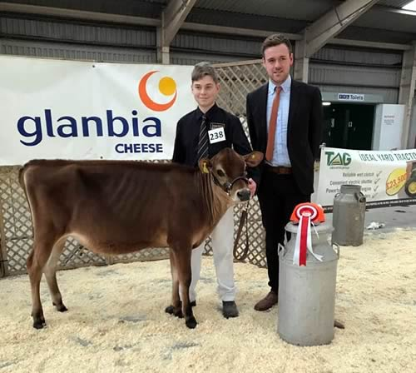
CAPTION: Champion - Salfach Viral Crunchie
2017 South Wales De Cymru Herd Competition 2017
Judge: Mr Seimon Thomas
An entry of five herds was led once again by the Glanmor herd of Dafydd, Helen and Tanwen Cox. Their herd of 140 milkers based at Laugharne also took honours for best bull, cow, senior bull progeny, youngstock and production inspection.
Other awards were shared equally with Elan Thomas’ Clarity herd at Meidrim the best new entrant and the senior maiden heifer trophy. Ioan Harries took honours for the best Dam and Daughter with Gwenlas GG Florence and her yearling daughter. His Felin herd stood second in several of the other sections.
Winning heifer and awarded the Judges prize for the best and most promising animal viewed throughout the competition was Carwyn Valentino Ophelia from the Griffiths family at Maenclochog. It is unfortunate that due to TB restrictions this animal is unlikely to enter the show ring this season.
Junior bull progeny winners were a group of Gatrog Scoobie Doo daughters, bred in the Chapel herd of the Batchelor family at Castlemartin, with the Carpenter family’s Carps Windigo Poppy the best junior yearling.

2016 SWJDC Club Herds Competition
Glanmor Jerseys had almost a clean sweep at the 2016 Herds Competition, with Judge Colin Evans, Gwarwenallt (Hilcol Guernseys), placing them 1st in 9 out of the 14 classes.
Results:
Overall Herd: Glanmor
Large Herd:
1st - Glanmor, 2nd - Chapel
Small Herd:
1st - Carwyn, 2nd - Salfach, 3rd - Felin
Maiden Herd: Frosty
Senior Progeny:
1st - Glanmor - Griffens Governor, 2nd - Glanmor - Altamont Fantom.
Junior Progeny:
1st - Felin - Bridon Excitation, 2nd - Nicel - Whittenhill On The Money Windigo, 3rd - Carwyn - Tower Vue Primetime Tequila.
Progeny by a UK Bull:
1st - Glanmor - Glanmor Rocket Whiskeys Warrior, 2nd - Glanmor - Glanmor Julian Mr Frosty, 3rd - Nicel - Glanmor Belmont Welsh Wizard.
Cow in 2nd - 4th Lactation:
1st - Gatrog - Nicel Dion Tare, 2nd - Glanmor - Glanmor Governor Purple Pie, 3rd - Felin - Gwenlas GG Florence.
Aged Cow 5th Lactation+:
1st - Glanmor - Glanmor Romeo Snowhite, 2nd - Chapel - Hillhoath Brass Bayleaf, 3rd - Salfach - Wellhead Duaiseor Marie.
Heifer In Milk:
1st - Glanmor - Glanmor Tequila Sweetie, 2nd - Glanmor - Glanmor Tequila Little Losin, 3rd - Frosty - Swangrove Stag Creamy.
Home Bred Youngstock:
1st - Glanmor, 2nd - Nicel, 3rd - Carwyn.
Dam & Daughter:
1st - Glanmor - Glanmor Guapo Fashion/Glanmor Wesley Flame, 2nd - Felin - Gwenlas GG Florence/Felin Excitation Florence, 3rd - Gatrog - Fourcrosses Resurrection Dream/Gatrog Tequila Dream.
Heifer Born 2015:
1st - Gatrog - Gatrog Tequila Dream, 2nd - Clarity - Salfach LC Daiseybelle, 3rd - Carps - Carps Illusion Poppy.
Bull, any age:
1st - Glanmor - Glanmor Gammon Showoff, 2nd - Chapel - Chapel Wizard Winston Churchill.
Production Inspection:
1st - Glanmor - Glanmor Rolf Marmite, 2nd - Glanmor - Felbut Little Lottie, 3rd - Nicel - Gwenlas GG Brownys Louise.
Judge's Prize: Nicel Jerseys.
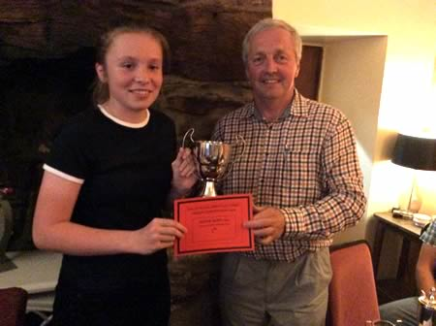
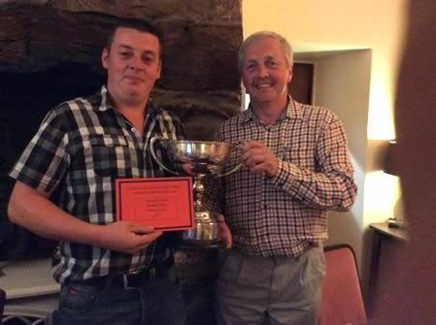
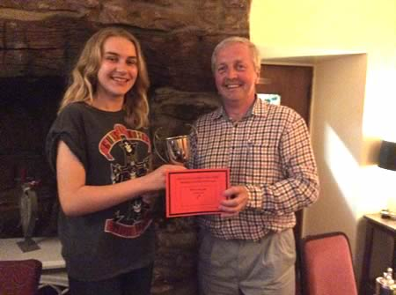

2016 Young Jersey Members at the Cothi Bridge Show, Carmarthenshire, Wales held on Saturday 21st May 2016
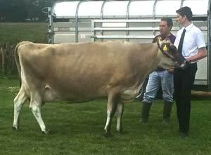
Rhys Jones & Dylan Davies, Salfach Jerseys with winning Dry Cow Wellhead Duaiseor Marie, almost 11 years old, due with her 9th calf and 9 years after she was last at the show, when she won Champion calf.

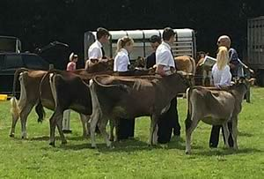
Maiden/In-calf class line-up

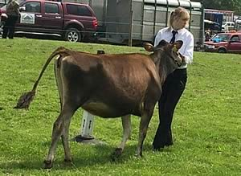
Maiden/In-calf class entry from Felin Jerseys

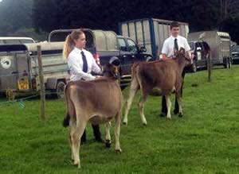
Senior Handler Class
Awen Jones & Dylan Davies, Salfach Jerseys

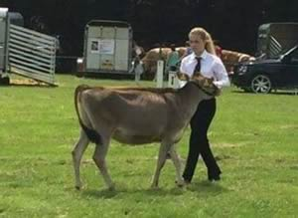
Awen Jones, Salfach Jerseys, Champion Handler,
with Salfach Joel Kara

2016 Dragon Jerseyfest - Monday 28th March
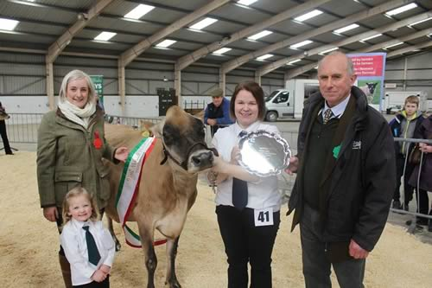
The Evans family of Nicel Jerseys win the Championship at Jersey Dragonfest 2016
RESULTS
Showmanship
Class 1. Handler 10 years old & under on the day of the show
1st - Enfys Wheeler
2nd - Charlie Jones
3rd - Rhydian Richards
4th - Sophie Carpenter
Class 2. Handler 16 years and under
1st - Elan Thomas
2nd - Rhydian Phillips
3rd - Awen Jones
Class 3. Handler 21 years old and under
1st - Ioan Harries
2nd - Iwan Jones
Champion; Ioan Harries
Reserve; Elan Thomas
Hon. Mention; Iwan Jones
Calves
Class 5. Heifer born on or after 1st October 2015
1st - Glanmor Verbatim Vixen - Glanmor Jerseys.
2nd - Nicel Champion Silver - Nicel Jerseys.
Class 6a. Heifer born on or after 1st March and on or before 30th September 2015
1st - Frosty Excitation Beauty - Hollybush Farms
2nd - Salfach Joel Kara - Salfach Jerseys
6b.
1st - Felin Excitation Florence - Ioan Harries
2nd - Starlet G Peakaboo - Hollybush Farms
3rd - Salfach Joel Poppet - Salfach Jerseys
Class 7. Heifer born on or after 1st September 2014 and on or before 28th February 2015
1st - Salfach LC Daisybelle - Elan Thomas
2nd - Daydream 312 - Ioan Harries
Class 8. Heifer born on or after 1st April and on or before 31st August 2014
1st - Salfach Koop Paradise
Class 9. Group of 3 calves owned and bred by exhibitor
1st - Salfach Jerseys
Champion Calf; Salfach LC Daisybelle - Elan Thomas
Reserve; Felin Excitation Florence - Ioan Harries
Hon. Mention; Starlet G Peakaboo - Hollybush Farms
Open
Class 10a Junior Heifer in Milk
1st - Glanmor Tequila Sweetie - Glanmor Jerseys
2nd - Starlet Mysterious Girl - Hollybush Farms
3rd - Colman Broiler Tivoli - Nicel Jersey
Class 10b Senior Heifer in Milk
1st - Glanmor Tequila Little Losin - Glanmor Jerseys
2nd - Glanmor Tequila Fledgling - Glanmor Jerseys
3rd - Felin Eroica Socks - Ioan Harries
4th - Gwenlas GG Butter - Ioan Harries
Champion Heifer; Glanmor Tequila Sweetie - Glanmor Jerseys
Reserve; Starlet Mysterious Girl - Hollybush Farms
Hon. Mention; Glanmor Tequila Little Losin
Class 11. Dry Cow
1st - Nicel Iatola Delight - Nicel Jerseys
Class 12. Junior Cow in Milk
1st - Gwenlas GG Brownys - Nicel Jerseys
2nd - Glanmor Fantom Vimto - Glanmor Jerseys (BU)
Class 13. Intermediate Cow in Milk
1st - Nicel Dion Tare - Nicel Jerseys
2nd - Frosty Blackstone Owl - Hollybush Jerseys (BU)
3rd - Glanmor Frosty Pancake - Glanmor Jerseys
Class 14. Senior Cow in Milk
1st - Nicel Tonic Delight - Nicel Jerseys
Class 15. Group of 3 - owned by, but not necessarily bred by exhibitor
1st - Glanmor Jerseys
2nd - Nicel Jerseys
Champion Cow; Nicel Dion Tare, Nicel Jerseys
Reserve; Frosty Blackstone Owl, Hollybush Farms
Hon. Mention; Gwenlas GG Brownys Louise, Nicel Jerseys
Exhibitor Bred; Nicel Dion Tare, Nicel Jerseys
Best Udder; Frosty Blackstone Owl, Hollybush Farms
Premiere Exhibitor;
1st - Glanmor Jerseys 26pts
2nd - Nicel Jerseys 21pts
3rd - Hollybush Farms 17pts
4th - Ioan Harries 14pts
5th - Salfach Jerseys 12pts
6th - Elan Thomas 5 pts
Premier Breeder;
1st - Glanmor Jerseys 31pts
2nd - Salfach Jerseys 15pts
3rd - Nicel Jerseys 14pts
4th - Hollybush Farms 9pts
5th - Ioan Harries 8pts

2015 South Wales Jersey Herds Competition 2015 Results
This year’s Herds Competition was ably judged during the last week of June/first week of July by Mr Elfyn Thomas of the Saintclear Holstein herd, Foxhole, St Clears. It was very heartening to see some new, young members competing for the first time.
The presentation evening was held on Wednesday 15th July at The Forge, St Clears.
Results
1. Whole Herd:
Large Herd (over 50);
1st – Glanmor
2nd – Chapel
3rd – Nicel
Small (under 50)
1st – Salfach
2nd – Carwyn
2. Maiden Herd
1st – Carwyn
3. Homebred Senior Progeny
1st – Glanmor – Family Hill Ringmaster
2nd – Nicel – Glanmor Julian Pilgrim
4. Junior Homebred Progeny
1st – Carwyn – SHF Centurion Sultan
2nd – Nicel – Glanmor Belmont Welsh Wizard
3rd – Glanmor – Glanmor Rocket Whisky Warrior
5. Progeny by a UK Bull
1st – Glanmor – Glanmor Julian Mr Frosty
2nd – Nicel – Erie Elite
6. Cow 2nd – 4th Lactation
1st – Glanmor – Glanmor Ring Trifle
2nd – Glanmor – Glanmor Saber Phlox
3rd – Nicel – Nicel Beclear Devotion
7. Cow 5th Lactation & over
1st – Salfach – Wellhead Duaiseoir Marie
2nd – Chapel – Nicel Tonic Yarrow
3rd – Chapel – Hillhoath Brass Bayleaf
8. Heifer in Milk
1st – Carps – Salfach Exploit Poppy
2nd – Salfach – Salfach BE Krisko
3rd – Carwyn Big Show Bethan
9. Homebred Youngstock
1st – Nicel
2nd – Glanmor
3rd – Felin
10. Dam & Daughter
1st – Glanmor – Glanmor Romeo Snowhite & Glanmor Fantom Scary Scream
2nd – Nicel – Whitechestnut Danish Suprise & Nicel Leleand Suprise
3rd – Salfach – Salfach Karma Pennsylvania & Salfach Exploit Precious
11. Heifer Born 2014
1st – Glanmor – Glanmor Wesley Asterix
2nd – Carwyn – Carwyn Juno Annabell
3rd – Salfach – Salfach Joel Polly
12. Bull, any age
1st – Nicel – Whitenhill On Moneys Windingo
2nd – Glanmor – Glanmor Gamon Showoff
3rd – Chapel – Glanmor Mr Fandango
13. Production Inspection
1st – Nicel – Nicel Ringer Silver
2nd – Glanmor – Glanmor Romeo Angelina
3rd – Nicel – Nicel Beclear Devotion
14. Judge’s Prize
Enfys Wheeler
Overall Herd - Glanmor
2015 South Wales Jersey Area Club - Dragon Jerseyfest - Monday 6th April
Judged by Lindsay Fleming
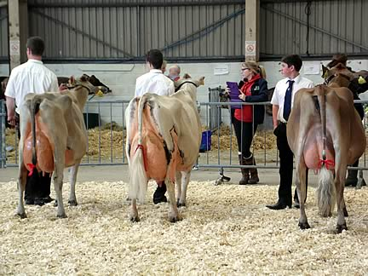
The overall Champion at the Dragon Jerseyfest was Erie Reagan Plait from Erie Jerseys. Reserve champion was Glanmor Sabor Phlox from The Cox Family, honourable mention was owned by Erie Jerseys, Starlet Jerseys & Ben Baker with Erie Greatness Blondette. The show was judged by Lindsay Fleming from Potterswalls Jerseys.
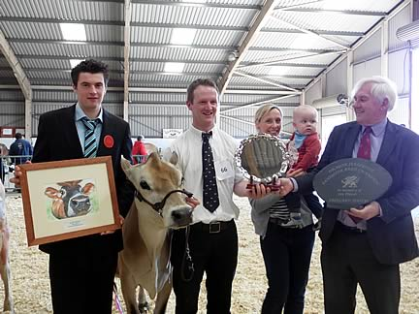

Class 1. Handler 10 years old and under on the day of the show
1st Enfys Wheeler
2nd Morgan Lewis
3rd Sophie Carpenter
4th Sara Evans
Class 2. Handler 16 years old and under on the day of the show
1st Awen Jones
2nd Christie Baker
3rd Ben Baker
4th Tanwen Cox
5th Elan Thomas
6th Iwan Thomas
7th Anwen Thomas
8th Seren Northcroft
9th Harri Ward
Class 3. Handler 26 years old on the day of the show
1st Iwan Jones
2nd Rhydian Jones
3rd Rachel Batchelor
Champion Handler Awen Jones
Reserve Champion Christie Baker
Honourable Mention Iwan Jones
Class 5. Heifer born on or after 1st October 2014
1st Carps Destiny Poppy Sophie Carpenter
2nd Salfach LC Daisybelle Salfach Jerseys
Class 6a. Heifer born on or after 1st March 2014 and born on or before 30th September 2014
1st CB Exciting Elisa Kevin Rickard & Sian Webber
2nd Mydrim Tequila Sandy James Evans
3rd CB Ellie Golding Christie Baker
4th Carwyn Sultan Fantasy 2 Rhys Griffiths
5th Salfach Koop Paradise Salfach Jerseys
Class 6b. Heifer born on or after 1st March 2014 and born on or before 30th September 2014 (continued)
1st Erie Great Louise Erie Holstein & Jerseys
2nd Carwyn Valentinos Ophelia Rhys Griffiths
3rd Glanmor Starbuck Alasha Tanwen Cox
4th Salfach Koop Misty Salfach Jerseys
5th Starlight Iatola Daffodil Sian Cusack
Class 7. Heifer born on or after 1st September 2013 and on before 28th February 2014
1st Futuredreams Tequila’s Veronica 2 Futuredreams Ptns
2nd Erie Velocity Elegance Iwan Morgan
3rd Colman Brolier Tivoli Nicel Jerseys
Class 8. Heifer born on or after 1st April 2013 and on or before 31st August 2013
1st Erie Great Polomint Rachel, Andrew & Kim Batchelor
2nd Glanmor Tequila Little Losin Glanmor Jerseys
3rd Salfach Arrow Jammy Salfach Jerseys
Group of three Calves
1st Salfach Jerseys
Champion Calf Futuredreams Tequilas Veronica 2 Barry & James Evans
Reserve CB Exciting Elisa Kevin & Sian Webber
Honourable Mention Mydrim Tequila Sandy James Evans
Class 10a. Junior Heifer In Milk
1st Erie Greatness Blondette Erie Holstein, Starlet Jerseys & Ben Baker
2nd Mydrim Trecanda Aimless Lady James Evans
3rd Erie Tequila Elaine Erie Holstein & Luke Harris
Class 10b. Senior Heifer In Milk
1st Erie Action Jonqul Erie Holsteins
2nd Glanmor Rolf Marmite Glanmor Jerseys
3rd Salfach Exactly Poppy
Champion Heifer Erie Greatness Blondette Iwan Morgan
Reserve Champion Heifer Erie Action Jonqul Iwan Morgan
Honourable Mention Mydrim Trecanda Aimless Lady James D Evans
Class 11. Dry Cow
1st Felbut Little Lottie Glanmor Jerseys
2nd Mydrim Remakes Tara 2 James D Evans
3rd Bluegrass R Royal Sahara Anwen Thomas
Class 12. Junior Cow in milk 2nd Calver
1st Erie Reagan Plait Erie Holsteins
2nd Starlight Xenon Daphne Rachel, Andrew & Kim Batchelor
3rd Glamor Ring Spring Wish Glanmor Jerseys
4th Nicel Iatola Delight Nicel Jerseys
5th Nicel Dion Tare Nicel Jerseys
Class 13. Intermediate Cow 3rd calver
1st Stowbeck On Time Laura Nicel Jerseys
2nd Nicel Pilgrim Seamaiden Nicel Jerseys
Class 14. Senior Cow
1st Glanmor Sabor Phlox Glanmor Jerseys
2nd Starlight Remakes Daffodil 2 Futuredreams Ptns
3rd Nicel Tonic Delight Nicel Jerseys
Class 15. Group of three
1st Erie Jerseys
2nd Glanmor Jerseys
3rd Nicel Jerseys
Champion Erie Reagan Plait
Reserve Champion Glanmor Sabor Pholx
Honourable Mention Erie Greatness Blondette
Premier Breeder & Premier Exhibitor Glanmor Jerseys

2014 Jerseys De Cymru Dragon Jerseyfest - 21st April
Livestock Centre, Carmarthen
Judge - Mrs Anna Stable
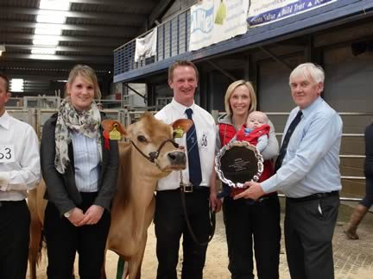
Team Erie with champion cow Erie Baywatch Grove- Sponsors Molevalley Farmers
RESULTS
Class 1 Handler 10 yrs & Under
1st Carys Morse
2nd Rhydian Phillips
3rd Morgan Lewis
Class 2 Handler 16yrs & under
1st Tanwen Cox
2nd Iwan Jones
3rd Awen Jones
4th Anwen Thomas
5th Aled Owens
Class 3 Handler 21yrs & under
1st Rhydian Jones
2nd Ffion Thomas
3rd Ioan Harris
4th Martha Jones
Class 4 Handler 26yrs & under
1st Luke Harris
2nd Steven John
3rd Rachel Batchelor
4th Kat Watkins
Champion Handler Luke Harris
Reserve Champion Tanwen Cox
Honourable Mention Iwan Jones
Class 6 Heifer born between 1st September 2013 – 31st December 2013
1st Erie Jerseys Erie Velocity Elegance
2nd Glanmor Jerseys Glanmor Tequila Sweetie
3rd Glanmor Jerseys Glanmor Beautiful Naughty
4th Salfach Jerseys Salfach On The Money Nessa Jenkins
Class 7 Heifer born between 1st May 2013 – 31st August 2013
1st Ioan Harries Felin Eroica Socks
2nd Glanmor Jerseys Glanmor Gemini Lorinda
3rd Miss Tanwen Cox Whitefire Legacy Fig
4th Salfach Jerseys Salfach Arrow Jammy
5th R A & K Batchelor Nicel Riley Catmint
6th Salfach Jerseys Salfach Trysor O’r Dwyrain
7th Salfach Jerseys Salfach Chilli Apple
Class 8 Heifer born between 1st January 2013- 30th April 2013
1st Erie Jerseys Erie Greatness Veronica
2nd R, A & K Batchelor Chapel Lacation Winnie
3rd Ioan Harries Elite Excitation Louise
4th R, A & K Batchelor Erie Great E Polomint
5th Salfach Jerseys Salfach Habit Dallas
6th Glanmor Jerseys Glanmor Tequila Roxy
7th Glanmor Jerseys Glanmor Tequila Athena
Champion Calf Erie Jerseys Erie Velocity Elegance
Reserve Champion Ioan Harries Felin Eroica Socks
Honourable Mention Glanmor Jerseys Glanmor Gemini Lorinda
Class 9 In Calf Heifer (to be calved before 2yrs 6 months)
1st Ioan Harries Gwenlas Action Tosca
2nd Salfach Jerseys Salfach On Time Sc Surprise
3rd R, A & K Batchelor Glanmor Governor Amazon
4th Glanmor Jerseys Glanmor Rolf Marmite
Class 10 Heifer in milk (Junior)
1st Nicel Jerseys Nicel Iatola Delight Best Udder
2nd Glanmor Jerseys Glanmor Fantom Scary Scream
3rd Salfach Jerseys Salfach Exploit Precious
4th R, A & K Batchelor Starlight Iatola Daphne
Class 10b Heifer in milk (Senior)
1st Erie Jerseys Erie Reagan Devona Best Udder
2nd Glanmor Jerseys & Philip Morgan Glanmor Xenin Maoam
Champion Heifer Erie Jerseys Erie Reagan Devona
Reserve Champion Glanmor Jerseys & Philip Morgan Glanmor Xenon Maoam
Honourable Mention Ioan Harries Gwenlas Action Tosca
Class 11 Dry Cow
1st Erie Jerseys Potterswalls Comericas Veronica
2nd Miss Anwen Thomas Bluegrass Regans Royal Sahara
3rd Salfach Jerseys Salfach Big Show Nevada
4th Nicel Jerseys Nicel Ringer Silver
Class 12 Junior Cow in Milk (2nd Calf)
1st Erie Jerseys Erie Baywatch Grove Best Udder
2nd Nicel Jerseys Stowbeck On Time Mitt
3rd Nicel Jerseys Nicel Pilgrim Moonray
4th Glanmor Jerseys Glanmor Frosty Pancake
5th Glanmor Jerseys Glanmor Action Astra
Class 13 Intermediate Cow (3rd Calf)
1st Glanmor Jerseys Glanmor Saber Phlox Best Udder
2nd R, A & K Batchelor Glanmor Belmont Whistle
3rd Salfach Jerseys Salfach Senior Lara
4th Nicel Jerseys Nicel Adventure Idris
Class 14 Senior Cow (4 or more calves)
1st Nicel Jerseys Brackenhurst Big Time Seamaiden Best Udder
2nd Nicel Jerseys Nicel Adventure Dulcette
Champion Erie Jerseys Erie Baywatch Grove Best Udder & Exhibitor Bred
Reserve Champion Glanmor Jerseys Glanmor Saber Phlox
Honourable Mention Erie Jerseys Erie Reagan Devona
Special Classes – Judged by Mr Jimmy Wilson
Class 15 Group of three animals from classes 5,6,7,& 8 bred & owned by the exhibitor
1st Salfach Jerseys
2nd Glanmor Jerseys
Class 16 Breeders Herd- Senior group of thee animals from classes 9, 10, 11 & 12 bred & owned by the exhibitor
1st Nicel Jerseys
2nd Salfach Jerseys
Class 17 Dam & Daughter / 2 Maternal Sisters
1st Erie Jerseys Potterswalls Comericas Veronica & Erie Greatness Veronica
2nd Nicel Jerseys Seamaidens
3rd R, A & K Batchelor Glanmor Belmont Whistle & Chapel Lacation Winnie
Class 18 Progeny Class
1st Glanmor Jerseys Tower Vue Prime Tequila

2014 South Wales Jerseys De Cymru Herd Competition
The 2014 Herds Competition was held on Tuesday 24th & Wednesday 25th of June after some unforeseen circumstances forced us to hastily re-arrange the dates from the previous week.
The Club would like to thank Mr Tony Hack of the Santamaria Herd for stepping into the breach at very short notice.
The Presentation Evening was held on Wednesday 25th June at the Forge, St Clears.

RESULTS
Judge – Mr Tony Hack
1. Whole Herd – Large (2)
1st – Glanmor
2nd – Nicel
1a. Whole Herd – Small (3)
1st – Salfach
2nd – Chapel
3rd – Whitefire
2. Maiden Herd (1)
1st – Whitefire
3. Home-Bred Senior Progeny Group -min 4 animals (4)
1st – Glanmor – Family Hill Avery Action
2nd – Salfach – Pinehaven Senior
3rd – Nicel – Smiddiehill Adventure
4th – Glanmor – Family Hill Ringmaster
4. Home-Bred Junior Progeny Group - min 3 animals (3)
1st – Nicel – Erie Elite
2nd – Glanmor – Tower Vue Tequila
3rd – Glanmor – Glanmor Rocket Whiskeys Warrior
5. Progeny by a UK Bull - min 3 animals (2)
1st – Glanmor - Glanmor Julian Mr Frosty
2nd – Nicel – Glanmor Julian Pilgrim
6. Cow 2nd – 4th Lactation (8)
1st – Glanmor – Glanmor Saber Phlox
2nd – Nicel – Nicel Adventure Suprise
3rd – Salfach – Salfach Karma Pennsylvania
4th – Chapel – Nicel Tonic Yarrow
7. Cow 5th Lactation & over (7)
1st – Glanmor – Saxown Excalibers Delight 3
2nd – Salfach – Glanmor Romeo Teeny
3rd – Nicel – Nicel Leland Bev
4th – Chapel - Hillhoath Brass Bayleaf
8. Heifer in Milk (8)
1st – Glanmor – Glanmor Fantom Scary Scream
2nd – Salfach – Salfach On Time SC Suprise
3rd – Nicel – Nicel Iatola Delight
9. Home Bred Young Stock (4)
1st – Nicel
2nd – Glanmor
3rd – Chapel
10. Dam & Daughter (8)
1st – Glanmor – Glanmor Romeo Snowhite & Glanmor Fantom Scary Scream
2nd – Nicel - Whitechestnut Danish Suprise & Nicel Leland Suprise
3rd – Salfach – Bluegrass Remakes Savannah Claire & Salfach On Time SC Suprise
4th – Chapel – Hillhoath Sambo Shamrock & Chapel Restore Shamrock
Heifer Born 2013 (7)
1st – Salfach – Salfach Arrow Jammy
2nd – Glanmor – Glanmor Beautiful Naughty
3rd – Nicel – Nicel Nevada Jane
11. Bull (3)
1st – Glanmor – Glanmor Tyler Mr Fisher
2nd – Glanmor – Glanmor Rocket Whiskeys Warrior
3rd – Chapel – Gatrog Scooby-du
12. Production Inspection (4)
1st – Nicel – Nicel Beclear Devotion
2nd – Glanmor – Glanmor Biscuit
3rd – Nicel – Brackenhurst Big Time Seamaiden
4th – Glanmor – Glanmor Ring Florrie
Judge’s Prize: Rachel Batchelor, Chapel.
Overall Herd – Glanmor
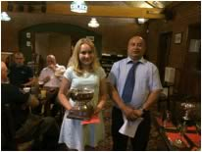 | 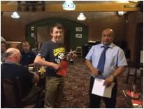 | 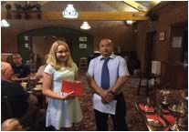
Tanwen Cox accepting the Pauls & White Cup on behalf of Glanmor Jerseys for Large Herd with Judge, Tony Hack | Iwan Jones of Salfach Jerseys accepting the Spoonhill Cup for the winning Small Herd with judge, Tony Hack. | Tanwen Cox, Whitefire Jerseys accepting the Gaylow Cup for the Maiden Herd.
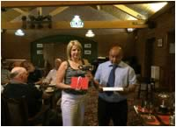 | 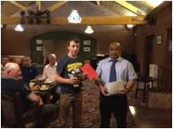 | 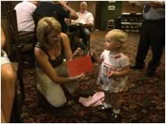
Nicola Evans of Nicel Jerseys receiving the BOCM Cup for Home Bred Junior Progeny Group. | Iwan Jones of Salfach Jerseys with the Pennyworld & Surelike Cup for Best Heifer Born 2013. | Sophie Carpenter & Nicola Evans of Nicel Jerseys with the Lowther Cup for the Best Home Bred Youngstock
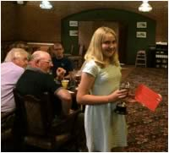 | 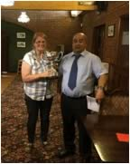
Tanwen Cox of Glanmor Jerseys with the Llanllyr Cup for Best Bull | Helen Carpenter receiving the Gorwyn Cup for Production Inspection on behalf of Nicel Jerseys

2013 South Wales Jerseys De Cymru News
Meeting - Welsh & Shropshire Jersey Breeders Association/ South Wales Jerseys De Cymru
Following a ballot of the membership and after discussion at the Executive Committee meeting, it was decided to amend the club area and name.
The geographical area covered by the club will include the counties of Ceredigion, Pembrokeshire, Carmarthenshire, Brecknock, Glamorgan and Gwent.
The club has been renamed as ‘South Wales Jerseys De Cymru’, with the original constitution being retained. Current elected club officials will remain in office.
Club cups will carry on to be utilized along with a range of herd competitions.
Shortly, there will be a launch of the club in the new area, along with communication of a diary of events.
Thank you for your support of the Welsh & Shropshire Jersey Breeders Association and we hope you will support the South Wales Jerseys De Cymru.
2013 South Wales Calf Show
Held at Carmarthen Livestock Centre on Saturday 21st September 2013.
RESULTS
Judge: Mr Mark Davis, Exeter.
Showmanship
Champion & Interbreed Champion - Elan Thomas
Reserve - Iwan Jones
Novice - Joint 1st - Sara Evans & Arthur Fenmore
Junior
1st - Elan Thomas
2nd - Gwenlais Cavenagh
3rd - Awen Jones
4th - Harri Ward
5th - Aled Owens
6th - Rhydian Phillips
Intermediate
1st - Iwan Jones
2nd - Rhydian Jones
Senior
1st - Ioan Harries
Mature
1st - Rachel Batchelor
Calf Classes
Champion Calf & Res. Interbreed Champion - Mydrim Tequila Tara
Reserve - Erie Greatness Blondette
Calves born after 1st March ‘13
1st – Late Entry – Davies Family, Hafod, Ferwig, Cardigan
2nd – Erie Greatness Patience – Morgan, Rickard & Webber.
3rd – Mydrim Actions Tara – James D Evans.
4th – Salfach Calcium Kiki – Salfach Jerseys.
5th – Nicel Riley Bella – Nicel Jerseys
6th – Nicel Riley Catmint – Nicel Jerseys.
Calves born between 1st Dec ’12 & 28th Feb ‘13
1st – Mydrim Trecanda Aimless Lady – James D Evans
2nd – Erie Tequila Elaine – Iwan Morgan & Luke Harries
3rd – Salfach On The Money SC Caramel – Salfach Jerseys
4th – Salfach Exploit Lola – Salfach Jerseys
5th – Nicel Signature Madam – Nicel Jerseys
6th – Chapel Lactation Winnie – R, A & K Batchelor
7th – Salfach Habit Dallas – Salfach Jerseys
8th – Glanmor Julian Puzzle – Glanmor Jerseys
9th – Glanmor Fantom M&M – Glanmor Jerseys
Calves born between 1st Sept & 30th Nov ‘12
1st - Erie Greatness Blondette – Morgan, Rickard & Webber
2nd – Mydrim Acting Louise – James D Evans
3rd – Mydrim Actions Louise – James D Evans
4th – Salfach IPod Yarrow – Salfach Jerseys
5th – Chapel Tornado Lulu – R, A & K Batchelor
6th – Glanmor Fantom Vimto – Glanmor Jerseys
7th – Salfach Exactly Poppy – G, H & S Carpenter
Calves born between 1st May & 31st August ‘12
1st - Mydrim Tequila Tara – James D Evans
2nd – Salfach Suspect Nutmeg – Salfach Jerseys
3rd – Elite Aimless Lady 225 – R, A & K Batchelor
4th – Glanmor Wesley Paradise – Glanmor Jerseys
5th – Nicel Governor Catmint – G, H & S Carpenter
Calves born between 1st Jan & 30th April ‘12
1st – CB Reagan Serenade – Christie Baker
2nd – Salfach Exploit Precious – Salfach Jerseys
3rd – Starlight Iatola Daphne – R, A & K Batchelor
4th – Salfach On Time Lwcus – Salfach Jerseys
5th – Gwenlas Action Tosca – Ioan Harries
Special Classes
Bull Progeny
1st - Forest Glen Avery Action – James D Evans
2nd – Bridon Jade’s Exploit – Salfach Jerseys
3rd – Chasin Rainow Riley – Nicel Jerseys
4th – Morgan, Rickard & Webber – Erie Greatness
Best Calf Sired By a Semex Bull
1st – Salfach Exploit Precious – Salfach Jerseys
2nd – Salfach Exploit Lola – Salfach Jerseys
3rd – Salfach On The Money SC Caramel – Salfach Jerseys
4th – Salfach Exploit Poppy – G, H & S Carpenter
2013 2nd Annual Dragon Jerseyfest Show
Members of the Welsh & Shropshire Young Jersey Breeders held their 2nd annual ‘Dragon Jerseyfest’ Show at the Carmarthen Livestock Centre on Easter Monday, 1st of April 2013. [report]
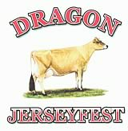
Members of the Welsh & Shropshire Young Jersey Breeders held their 2nd annual ‘Dragon Jerseyfest’ Show at the Carmarthen Livestock Centre on Easter Monday, 1st of April 2013.
The weather in South West Wales has been bitterly cold over the past few weeks with no sign of spring, which affected the number of cattle forwarded for judging. However Mr Matt Pye of Bay View Jerseys, Lancashire still had his work cut out to judge the high quality of handlers and stock in the ring.
A good crowd of spectators, all wrapped up against the cold, gathered to watch the excellent handling skills of the members in the showmanship classes followed by the calf and cow classes.
Champion Handler was Fflur Davies, with her sister, Awen in Reserve and Anwen Thomas Hon. Mention. Champion Calf was Salfach Jersey’s Salfach Exploit Precious, with James Evans’ Mydrim Actions Louise in Reserve and Hon. Mention to Miss Tanwen Cox’ Glanmor Wesley Acorn.
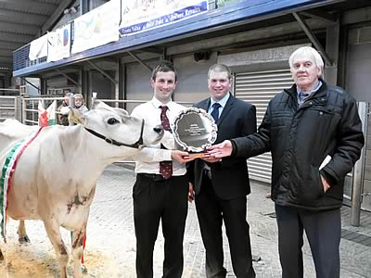
Barrie Evans, Molevalley Farmers, presenting the Molevalley Trophy for Champion Cow to Steven John, Glanmor Jerseys, with Matt Pye
Glanmor Jerseys took a clean sweep in the Heifer and Cow Championship with Glanmor Ring Trifle taking the top honours in the Heifer Championship and Glanmor Action Astra in Reserve. 2nd calver, Glanmor Saber Phlox was Champion Cow and also took the Best Udder and Best Exhibitor Bred awards.
Mr Huw ‘Bach’ Evans, BJP Marts judged the Junior and Senior Breeders Herd and the Female Progeny classes. Many thanks to him also for allowing the Young Breeders to use the mart site and its facilities to hold the show and to Iona and her team at Gegin Fach Y Wlad for keeping us all fed and watered all day! Thanks also to the senior club members who ‘volunteered’ to steward the show, raised funds and collected sponsorship for the show. We would also like to thank all the sponsors for their generosity and a special thanks to Helen Cox, Helen Carpenter and Ffiona Jones, without their organisational work, the show would not have been able to be held.
Results:
Class 1 - Handler 10 Years and under on day of show
1st Anwen Thomas
2nd Tanwen Cox
3rd Elan Thomas
4th Sara Evans, Arthur Fenmore, Rhydian Philips & Aled Owens
Class 2- Handler 16 years old and under on day of show
1st Awen Davies
2nd Rhydian Jones
3rd Awen Jones
4th Iwan Jones
5th Seren Northcroft
Class 3- Handler 21 years old and under on day of show
1st Fflur Davies
2nd Rachel Batchelor
Class 4- Handler 26 years old and under on day of show
1st- Steven John
Class 5- Champion handler
Champion- Fflur Davies
Reserve- Awen Davies
Honourable Mention- Anwen Thomas
Class 6- Heifer born on or after 1st September 2012
1st James Evans- Mydrim Actions Louise
2nd Salfach Jerseys & Miss Sophie Carpenter- Salfach Exactly Polly
3rd James Evans- Mydrim Acting Louise
4th Glanmor Jerseys- Glanmor Rolf Marmite
5th Nicel Jerseys- Nicel Signature Madam
Class 7- Heifer born on or after 1st May 2012 and born on or before 31st August 2012
1st Miss Tanwen Cox- Glanmor Wesley Acorn
2nd Glanmor Jerseys- Glanmor Riley Jubilee
3rd James Evans- Mydrim Tequilas Tara
4th Glanmor Jerseys- Glanmor Wesley Paradise
5th R, A & K Batchelor- Elite Aimless Lady 225
Class 8- Heifer born on or after 1st January 2012 and born on or before 30th April 2012
1st Salfach Jerseys- Salfach Exploit Precious
2nd Salfach Jerseys- Salfach On Time Lwcus
3rd R A & K Batchelor- Starlight Iatola Daphne
Class 9- Champion Calf
Champion- Salfach Jerseys- Salfach Exploit Precious
Reserve- James Evans- Mydrim Actions Louise
Honourable Mention- Miss Tanwen Cox- Glanmor Wesley Acorn
Class 10- Junior Herd
Group of three females from classes 5,6,7 & 8 bred & owned by exhibitor
1st Salfach Jerseys
2nd Glanmor Jerseys
3rd James Evans
Class 11- Breeders Group - Senior group of three animals from classes 9, 10,11 & 12 bred & owned by the exhibitor
1st Glanmor Jerseys
2nd Nicel Jerseys
Class 12- Dam & Daughter/Maternal Sisters (animals do not have to be owned by the same exhibitor)
1st Nicel Jerseys
2nd James Evans
3rd Salfach Jerseys
Class 13- In Calf Heifer (to be calved before 2 years 6 months)
1st Glanmor Jerseys- Glanmor Guapo Siswrn
2nd Miss Anwen Thomas- Bluegrass Regans Royal Sahara
3rd Glanmor Jerseys- Potterswalls Eclipse Dawn 2
4th Salfach Jerseys- Salfach Suspicious Miley
5th Nicel Jerseys- Salfach Jamaican Alesha
Class 14- Heifer in Milk
1st Glanmor Jerseys- Glanmor Ring Trifle Best Udder
2nd Glanmor Jerseys- Glanmor Action Astra
3rd Nicel Jerseys- Stowbeck On Time Mitt
4th Nicel Jerseys- Philmor Grand Prix Blossom
Class 14b Senior Heifer In Milk
1st Glanmor Jerseys- Glanmor Ring Icicle
2nd Nicel Jerseys- Nicel Pilgrim Moonray Best Udder
3rd Future Dreams Partnership- Future Dreams Seniors Veronica
Class 15- Champion Heifer
Champion- Glanmor Jerseys- Glanmor Ring Trifle
Reserve- Glanmor Jerseys- Glanmor Action Astra
Class 16- Dry Cow
1st James Evans- Mydrim Remake’s Tara
2nd Nicel Jerseys- Freeland Julian Delight
3rd Nicel Jerseys- Nicel Sargent Alexandra
4th Salfach Jerseys- Salfach Senior Maine
Class 17 Junior Cow In Milk (2nd or 3rd Calver)
17a Cow in Milk 2nd Calf
1st Glanmor Jerseys- Glanmor Saber Phlox Best Udder
2nd Nicel Jerseys- Nicel Ringer Silver
3rd James Evans- Mydrim Ringmaster Sandy
4th Glanmor Jerseys- Glanmor Guapo Fashion
5th Nicel Jerseys- Nicel Adventure Light
6th Glanmor Jerseys- Glanmor Action Piglet
7th Nicel Jerseys- Nicel Tonic Candy
Class 17b- Cow In Milk – 3rd Calf
1st Nicel Jerseys- Nicel Adventure Dulcette Best Udder
2nd Glanmor Jerseys- Glanmor Little Lottie
3rd Nicel Jerseys- Nicel Tonic Delight
Class 18- Senior Cow In Milk (4th calver or over)
1st Future Dreams Partnership- Starlight Remake’s Daffodil Best Udder
2nd Nicel Jerseys- Nicel Lieutenant Dulcette
3rd Nicel Jerseys- Nicel Spick
4th Glanmor Jerseys- Tregenna Zik Sauna
Class 19 – Championship
Champion- Glanmor Jerseys- Glanmor Saber Phlox
Reserve- Future Dreams Partnership- Starlight Remake’s Daffodil
Honourable Mention- Nicel Jerseys- Nicel Adventure Dulcette
Best Udder Champion- Glanmor Jerseys- Glanmor Saber Phlox
Exhibitor Bred Champion- Glanmor Jerseys- Glanmor Saber Phlox
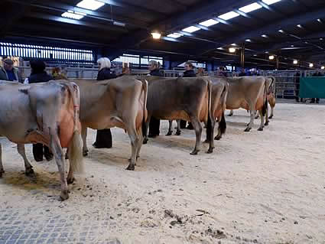

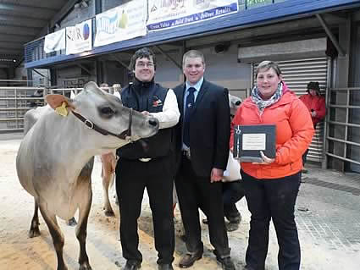
Rhiannydd Evans of Rhiger Jerseys presenting James Evans with the Rhiger & Carps Trophy for the Reserve Champion Cow, with Matt Pye, Judge

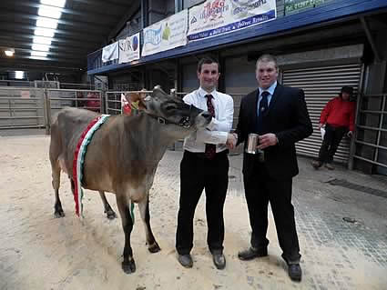
Judge, Matt Pye presenting Steven John, Glanmor Jerseys with the Bibby Tankard for the Champion Heifer

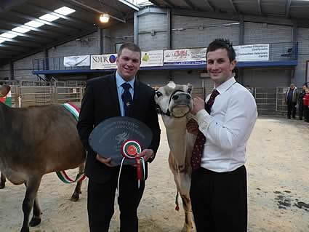
Matt Pye presenting the Freeland Trophy, in memory of Ian Plumb, for the Best Exhibitor Bred to Steven John from Glanmor Jerseys.

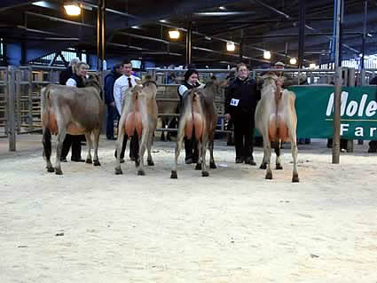

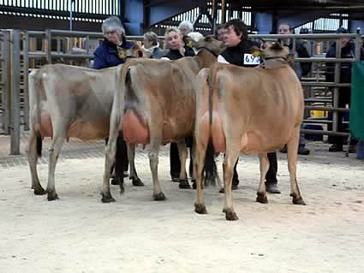
Breeders Herd winners, Glanmor Jerseys. (Tanwen Cox, Helen Cox & Steven John)

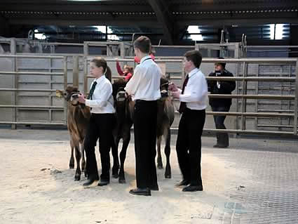
Junior Herd winners, Awen, Rhydian & Iwan Jones of Salfach Jerseys

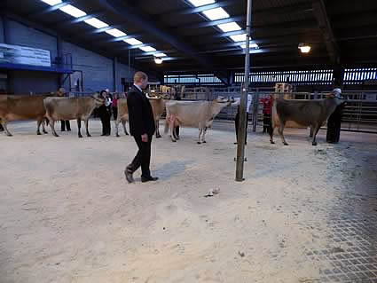

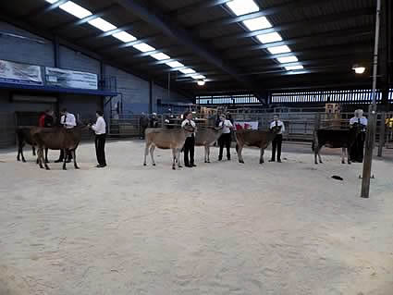

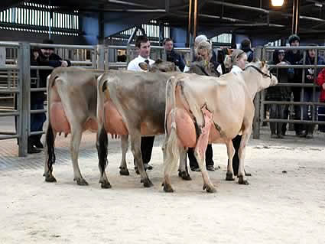

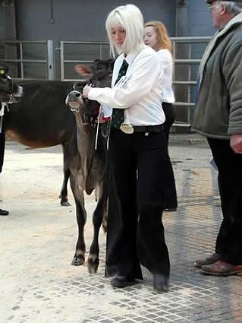
Fflur Davies, Champion Handler

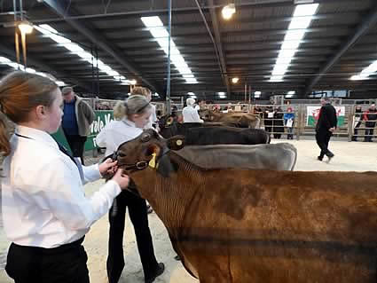
Champion Calf line-up

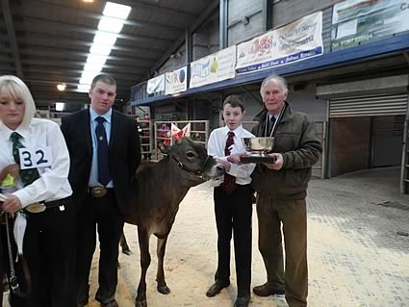
Edward Morgan, President of the Welsh & Shropshire Jersey Breeders Association presenting Iwan Jones, Salfach Jerseys with the W&SJBA Trophy for Champion Calf, with Matt Pye

2012 Welsh & Shropshire Jersey Breeders Association News
2012 SOUTH WALES All DAIRY BREEDS CALF SHOW - Saturday 15th September
JERSEYS – Judge; Mrs Jane Arrell
26 Jersey Calves Born after 1st March 2012 (1)
Salfach Jerseys
1st - SALFACH LT ANGEL 05.05.12 Sire: Lencrest Tyler Dam: Salfach Golden C Alabama
27 Jersey Calves born between 1st Dec 2011 & 28th Feb 2012 (6)
James D. Evans
1st - MYDRIM GRAND PRIX FESTIVE SANDY 03.12.11 Sire: Rapid Bay Grand Prix Dam: Mydrim Ringmaster Sandy
Nicel Jerseys
2nd - GLANMOR GRANDPRIX YELLOW 12.12.11 Sire: Rapid Bay Grand Prix Dam: Freeland Lieutenant Yarrow
Salfach Jerseys
3rd - SALFACH ON TIME SC SURPRISE 25.12.11 Sire: Lencrest On Time Dam: Bluegrass Remakes S Claire
Salfach Jerseys
4th - GLANMOR XAVIER SNEAKY SAUSAGE 03.12.11 Sire: Glanmor Belmont Xavier Dam: Glanmor Frosty Sambucca
Rachel Batchelor
5th - CHAPEL BLOSSMAN WINC 27.01.12 Sire: Philmor Blossman Dam: Philmor Coalition Winc
Nicel Jerseys
6th - NICEL SABER DIBBLE 24.02.2012 Sire: OF Montana Saber Dam: Longhills Crecent Dibble
28 Jersey Calves born between 1st Sept & 30th Nov 2011 (5)
EM, E & I Morgan
1st - ERIE GOVERNOR GORGEOUS 02.09.11 Sire Griffins Governor Dam: Rapid Bay Jade Glitter
Glanmor Jerseys
2nd - GLANMOR SCARY SCREAM 31.10.11 Sire: Altamot Fantom Dam: Glanmor Romeo Snowdrop
Future Dreams Partnership
3rd - FUTURE DREAMS EXCITATION’S BLOSSOM 02.09.11 Sire: Bridon Excitation Dam: Smiddiehill C Blossom
Nicel Jerseys
4th - NICEL DION TARE 26.11.11 Sire: Nicel Dion Dam: Nicel Adventure Tare
Salfach Jerseys
5th - SALFACH SENIOR TULISA 01.09.11 Sire: Pinehaven Senior Dam: Salfach Minister Utah
29 Jersey Calves born between 1st May & 31st August 2011 (5)
Webber & Rickard
1st - ERIE REGAN PRANCE 18.08.11 Sire: Rapid Bay Regan Dam: Shellen Governor Prance
James D. Evans
2nd - MYDRIM GRAND PRIX LOUISE 20.05.11 Sire: Rapid bay Grand Prix Dam: Mydrim Vindication’s Louise
Future Dreams Partnership
3rd - FUTURE DREAMS EXCITATION VERONICA 03.08.11 Sire: Bridon Excitation Dam: Future Dreams S Veronica
Glanmor Jerseys
4th - GLANMOR GUAPO SISWRN 15.07.11 Sire: Yellow Briar Heaths Guapo Dam: Glanmor Ring Smot
Salfach Jerseys
5th - SALFACH JAMAICAN ALESHA 29.05.11 Sire: Bridon Jamaica Dam: Salfach Golden C Alabama
30 Jersey Calves born between 1st Jan & 30th April 2011 (2)
Rachel Batchelor
1st - GLANMOR XAVIER RIOT 18.02.11 Sire: Glanmor Bigshow Xavier Dam: Glanmor Julian Relish
James D. Evans
2nd - MYDRIM EXCITATIONS TARA 28.03.11 Sire: Bridon Excitation Dam: Gaddesden Tara 2
Jerseys - Best Progeny (2 or more animals from the same sire)
1st - James D. Evans Rapid Bay Grand Prix
2nd - Rachel Batchelor & Salfach Jerseys Glanmor Big Show Xavier
3rd - Future Dreams Partnership & James D. Evans Bridon Excitation
Jerseys - Best Calf (any age) sired by a Semex Bull (7)
1st - Future Dreams Partnership
FUTURE DREAMS EXCITATION’S BLOSSOM 02.09.11 Sire: Bridon Excitation Dam: Smiddiehill C Blossom
2nd – Salfach Jerseys
SALFACH ON TIME SC SUPRISE 25.12.11 Sire: Lencrest On Time Dam: Bluegrass Remakes S Claire
3rd - Future Dreams Partnership
FUTURE DREAMS EXCITATION VERONICA 03.08.11 Sire: Bridon Excitation Dam: Future Dreams S Veronica
Champion Jersey Calf John Kendal Rose Bowl
Champion: Erie Governor Gorgeous – EM, E & I Morgan
Reserve: Erie Regan Prance – Webber & Rickard
Hon. Mention: Mydrim Grand Prix Louise – JD Evans.
Cribyn Trophy kindly donated by Chris Rankin for the Best Homebred Calf in the Jersey Section
Erie Governor Gorgeous – EM, E & I Morgan
INTERBREED CHAMPION – Judge; Mr Colin Evans
Erie Governor Gorgeous – EM, E & I Morgan
HANDLERS – Judge Mrs Jane Arrell
6 Jersey Novice (8 years & under on 1st Jan. 2012)
1st - Elan Thomas
7 Jersey Junior (aged between 9 & 12 years & under on 1st Jan. 2012)
1st - Tanwen Cox
2nd - Awen Jones
8 Jersey Intermediate (aged between 13 & 16 years on 1st Jan. 2012)
1st - Iwan Jones
2nd - Rhydian Jones
Jersey Section Best Turned Out Boy & Girl Society Tie for best dressed / turned out boy & girl
Iwan Jones & Awen Jones
Champion Jersey - Nicel Jerseys trophy for Champion Handler
Champion: Tanwen Cox
Reserve: Elan Thomas
Hon. Mention: Awen Jones
W&SJBA Plate for highest placed boy – Iwan Jones
W&SJBA Plate for highest placed girl – Tanwen Cox
Interbreed Handlers – Judge; Mrs Helen Carpenter
Handler attending Primary School on 1st Sept. ’12 (9)
1st – Elan Thomas
3rd – Tanwen Cox
Interbreed Champion Handler
Hon. Mention: Tanwen Cox
2012 Royal Welsh Show
23rd - 26th July 2012
JUDGE - Mr MARK LOGAN, Co Down.
CLASS 666 – MAIDEN HEIFER
1st – EM, E & I Morgan – Erie Grand Prix Radiance
2nd – EM, E & I Morgan – Erie Governor Gorgeous
3rd – Salfach Jerseys – Salfach Supicious Miley
4th – Glanmor Jerseys – Glanmor Guapo Siswrn
5th – S & S Murray Farms Ltd. – Windyridge Ministers Lilith
6th – Miss Rachel Batchelor – Glanmor Xavier Riot
Class 668 – HEIFER IN CALF
1st – Glanmor Jerseys – Glanmor Ring Icicle
2nd – Miss Rachel Batchelor – Mydrim Volcanos Lady
3rd – Salfach Jerseys – Salfach Grove Nutella
4th – S & S Murray Farms Ltd. – Windyridge Guapo Twiglett
5th – S & K Webber & Rickard – ITB Regans Mystery
Class 669 – HEIFER IN MILK
1st – Glanmor Jerseys – Glanmor Ring Money
2nd – Glanmor Jerseys – Glanmor Julian Jean
3rd – JH & JA Evans – Nicel Pilgrim Bella
4th – Glanmor Jerseys – Glanmor Action Piglet
5th – S & K Webber & Rickard – Harding Iatolas Ladybird
6th – Miss Rachel Batchelor – Glanmor Belmont Whistle
7th – Salfach Jerseys – Salfach Laser Dee Dee
CLASS 670 – HEIFER CHAMPIONSHIP
Champion: Glanmor Jerseys – Glanmor Ring Money
Reserve: Glanmor Jerseys – Glanmor Julian Jean
CLASS 671 – DRY COW
1st – Mr WJP Wilson – Tregibby Comerica Panama
2nd – Miss Emma Williams – Saxown Dukes Sweetdreaming
CLASS 672 – COW IN MILK WITH 2nd CALF
1st – EM, E & I Morgan – Erie Comerica Candy
2nd – S & S Murray Farms Ltd. – Windyridge Whispering Silva
3rd – JH & JA Evans – Nicel Adventure Dulcette
4th – Salfach Jerseys – Salfach Golden C Alabama
CLASS 673 – COW IN MILK WITH 3rd CALF
1st – Mr WJP Wilson – Bluegrass Charlies Happiest
2nd – Glanmor Jerseys – Tregenna Zik Sauna
CLASS 674 – COW IN MILK WITH 4th OR SUBSEQUENT CALF
1st – Mr WJP Wilson – Bluegrass Heritages Lovely Lady
2nd – S & S Murray Farms Ltd. – Abbotsley Sambos Opal
3rd – JH & JA Evans – Brackenhurst Bigtime Seamaiden 2
4th – S & S Murray Farms Ltd. – Shellen Connection Diamond
CLASS 676 – COW WITH BEST UDDER
1st – Mr WJP Wilson – Bluegrass Charlies Happiest
2nd – EM, E & I Morgan – Erie Comerica Candy
CLASS 680 – CHAMPION COW
CHAMPION: Mr WJP Wilson – Bluegrass Charlies Happiest
RESERVE: EM, E & I Morgan – Erie Comerica Candy
INTERBREED CHAMPIONSHIPS
CLASS 630 – FITZHUGH CHAMPIONSHIP PAIRS
RESERVE:
EM, E & I Morgan – Erie Comerica Candy
Mr WJP Wilson – Bluegrass Charlies Happiest
CLASS 631 – SUPREME CHAMPION HEIFER
RESERVE: Glanmor Jerseys – Glanmor Ring Money
CLASS 633 – THE NATWEST TEAM OF FIVE
RESERVE:
Glanmor Jerseys – Glanmor Ring Money
Glanmor Jerseys – Glanmor Julian Jean
E, EM & I Morgan – Erie Comerica Candy
Mr WJP Wilson – Bluegrass Charlies Happiest
Mr WJP Wilson – Bluegrass Heritages Lovely Lady
CLASS 634 – RWAS FEMALES OF THE FUTURE PAIRS
CHAMPION: E, EM & I MORGAN – Erie Grand Prix Radiance & Erie Governor Gorgeous
DAIRY YOUNG HANDLERS
CHAMPION: Jessica Hall
RESERVE: Rhydian Jones
3rd – Iwan Jones
5th – Phil Morgan
2012 July Newsletter
The Club has had a busy couple of weeks with both the South Wales Cluster Club/W&SYJB Stock
Judging Competition and the Annual Herds Competition being held.
Stock Judging Competition
The Stock Judging Competition was kindly hosted by the Evans’ family, Nicel Jerseys at Nantyci Farm,
Carmarthen. Master Judges for the day were Mr Russell Law, Fryn Jerseys and Mr Mark Williams,
Elite.
A good crowd of various ages competed and this year’s results are:
Juniors: Tanwen Cox, Glanmor Jerseys.
Intermediate: Awen Jones, Salfach Jerseys.
Seniors: Katherine Watkins, Pure Gold.
Mature: Geraint Evans, Rhiger.
Herds Competition 2012
We had an excellent response to this year’s Herds Competition, with 10 herds competing. Mr & Mrs
John & Jane Chester, Kerbanks, spent the first two days in Shropshire visiting the herds there, before
moving down to Carmarthen as their base for the remaining three days. The results & presentations
were held over lunch on the Saturday after judging at the New Inn, Newbridge on Wye.
Our thanks go to John for agreeing to judge this year’s competition and for the excellent work he did
in judging. Also for his kind words & praise of the herds. Many thanks also to Jane for her secretarial
work! Thanks also to all the members who were more than willing to host during the week.
Congratulations to all who participated.
Results 2012
Judge: Mr John Chester
The Longmynd Cup – Large Herds
1st – Plowden Farms
2nd – R&E Taylor, Blodwell
3rd – C. Rogers-Coltman, Myndtow
4th – AJ Farming
The Pauls & White Cup – Medium Herds
1st – Glanmor Jerseys
2nd – Nicel Jerseys
3rd – Pantal Jerseys
The Spoonhill Cup – Small Herds
1st – J & C Hart, Hillhoath.
2nd – Salfach Jerseys.
The Gaylow Cup – Maiden Herd
Pantal Jerseys.
The Grayswood Cup – Senior Progeny
1st – R&E Taylor, Blodwell – Sunset Canyon Futurity
2nd – Glanmor Jerseys – Valleystream Julian
3rd – Pantal Jerseys – Pinehaven Senior
The BOCM Cup – Junior Progeny
1st – Glanmor Jerseys – Family Hill Ringmaster
2nd – Pantal Jerseys – Forset Glen Avery Action
3rd – AJ Farming – SC Gold Dust Paramount Iatola
The Daimar Cup – Progeny by a UK Bull
1st – Glanmor Jerseys – Glanmor Julian Mr Frosty
2nd – Nicel Jerseys – Glanmor Julian Pilgrim
3rd – R&E Taylor – Blodwell Zolly
The Berwick Cup – Home Bred Cow
1st – Glanmor Jerseys – Glanmor Julian Relish
2nd – R&E Taylor – Blodwell Excitation Zeta
3rd – Plowden Farms – Plowden Excitation’s Zara
The Ellerdine Trophy – Home Bred Heifer in Milk
1st – R&E Taylor – Blodwell Dale Mary
2nd- Glanmor Jerseys – Glanmor Ring Money
3rd – J&C Hart – Hillhoath Ringmaster Jingle 2
The Lowther Cup – Home Bred Youngstock
1st – Plowden Farms
2nd – Glanmor Jerseys
3rd – Salfach Jerseys
The Distingue Cup – Dam & Daughter
1st – Glanmor Jerseys – Glanmor Julian Whiskey & Glanmor Rocket Wennol
2nd – Nicel Jerseys – Longhills Crecent Zulu & Nicel Belmont Zulu
3rd – Glanmor Jerseys – Glanmor Jet Slipstream & Glanmor Saber Serengetti
The Pennyworld & Surelike Cup – Home Bred Heifer born 2011
1st – Salfach Jerseys – Salfach Suspicious Miley
2nd – J&C Hart – Hillhoath Belmont Jingle
3rd – Glanmor Jerseys – Glanmor Guapo Siswrn
The Llanllyr Cup – Bull
1st – Glanmor Jerseys – Glanmor Blade Wesley Snipes
2nd – R&E Taylor – Blodwell Janes Jacob
The Gorwyn Trophy – Production & Inspection
1st – C Rogers-Coltman – Myndtown Glow
2nd – Nicel Jerseys – Nicel Starlight Trac Delight
3rd – C Rogers-Coltman – Myndtown Busker
The Moorish Cup – Judge’s Prize
J&C Hart – Hillhoath
Overall Herd
Champion – Plowden
Reserve – Glanmor
Hon. Mention – Nicel
2012 Welsh & Shropshire Young Jersey Breeders - Dragon Jerseyfest
The inaugural 'Dragon Jerseyfest' held on Monday 9th April 2012 was a resounding success, with over 50 animals forward for judging.
Miss Izzy Whittaker did an excellent job in judging some difficult & close classes.
Welsh & Shropshire Young Jersey Breeders Dragon Jerseyfest
Held at Carmarthen Livestock Centre
(by kind permission of BJP Auctioneers)
The inaugural 'Dragon Jerseyfest' held on Monday 9th April 2012 was a resounding success, with over 50 animals forward for judging.
Miss Izzy Whittaker did an excellent job in judging some difficult & close classes. A large crowd attended to watch the judging & they were rewarded with strong classes of quality cattle.
Many thanks to the main organisers, Helen Carpenter, Helen Cox, Ffiona Jones & Sian Williams for all their hard work and to all the members for doing their bit to get the 'show on the road'. Also to Elwyn Thomas, Rhian Roberts, Sophie Richards, Barry Evans, Huw Evans & Carolyn Davies for keeping everything running smoothly in the ring. Many thanks also to all the sponsors, BJP Marts for allowing us to use the mart site & facilities and everybody who came to support on the evening. Lastly, but certainly not least, to the exhibitors who made the show such a success.
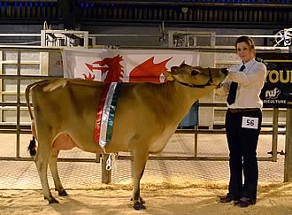
Champion Heifer - Glanmor Julian Igloo, owned by Glanmor Jerseys, with handler Jessica Hall
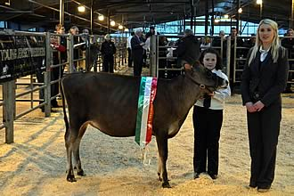
Champion Calf - Mydrim Grand Prix Louise, owned by JD Evans, with handler Elan Thomas & Judge, Miss Izzy Whittaker
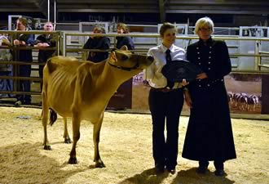
Mrs Sue Plumb presenting the 'Best Homebred' trophy in memory of her late husband, Mr Ian Plumb, who was a stalwart of the breed, to Glanmor Jerseys' Glanmor Julian Igloo
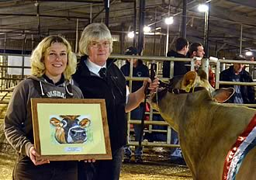
Helen Cox of Glanmor Jerseys presenting Jennifer Evans, Nicel Jerseys with the award for 'Best Udder' to Longhills Crecent Zulu, who was also Champion Cow
photos by Sophie Richards
Results
Class 1: Showmanship 10 yrs & under (5)
1st — Tanwen Cox
2nd — Elan Thomas
3rd — Dafydd Davies
4th — Dyfrig Thomas
5th — Aled Thomas
Class 2: Showmanship 11 — 16 yrs (6)
1st — Christie Baker
2nd — Ben Baker
3rd — Awen Davies
4th — Rhydian Jones
5th — Iwan Jones
6th — Awen Jones
Class 3: Showmanship 17 –21 yrs (3)
1st — Fflur Davies
2nd — Jessica Hall
3rd — Meinir Morgan
Class 4: Showmanship 22 –26 yrs (3)
1st — Kevin Rickard
2nd — Aled Morgan
3rd — Rhian Roberts
Champion: Fflur Davies
Reserve: Jessica Hall
Hon. Mention: Kevin Rickard
Class 5: Calf born after 1st Sept. ‘11 (5)
1st — Future Dreams Excitation’s Blossom — Future Dreams Partnership
2nd — Salfach On Time Yahoo — Salfach Jerseys
3rd — Salfach Senior Tulisa — Salfach Jerseys
4th — Glanmor Grand Prix Yellow — Glanmor Jerseys
5th — Morita Rolex Anon — M&N Davies
Class 6: Calf born 1st May — 31st Aug. ‘11 (5)
1st — Mydrim Grand Prix Louise — JD Evans
2nd — Future Dreams Excitation Veronica — Future Dreams Partnership
3rd — Glanmor Guapo Siswrn — Glanmor Jerseys
4th — Erie Regan Prance — K. Rickard & S Webber
5th — Morita Volcano Anon — M & N Davies
Class 7: Calf born 1st Jan — 30th April ‘11 (5)
1st — Salfach Suspicious Miley — Salfach Jerseys
2nd — Hillhoath Belmont Jingle — Claire Hart
3rd — Glanmor Xavier Ladybird — S. Williams
4th — Glanmor Xavier Riot — R. Batchelor
5th — Mydrim Excitations Tara — JD Evans
Champion Calf: Mydrim Grand Prix Louise
Reserve: Salfach Suspicious Miley
Hon. Mention: Future Dreams Excitation Blossom
Class 8: Heifer in Calf (to have calved by 2 1/2yrs) (7)
1st — Glanmor Julian Star — Glanmor Jerseys
2nd — Future Dreams Volcano’s Daffodil — Future Dreams Partnership
3rd — Glanmor Julian Catmint — Nicel Jerseys
4th — Mydrim Volcanos Lady — JD Evans
5th — Starlight Volcanid Daphne — S. Cussack
6th — Salfach Guapo Pepper — Salfach Jerseys
7th — Philmor Compos Cash — AJ Morgan
Class 9a: Junior Heifer in Milk (under 36 months) (6)
1st — Nicel Pilgrim Bella* - Nicel Jerseys
2nd — Glanmor Julian Jean — S. Williams
3rd — Nicel Adventure Liight — Nicel Jerseys
4th — Jubilee Excitation Ceres — JD Evans & Alex Hurd
5th — Nicel Belmont Zulu — Nicel Jerseys
6th — Glanmor Action Delight — Glanmor Jerseys
Class 9b: Seinior Heifer in Milk (over 36 months) (5)
1st — Glanmor Julian Igloo* — Glanmor Jerseys
2nd — Hardinge Iatolas Ladybird — K. Rickard & S. Webber
3rd — Glanmor Frosty Sambucca — Glanmor Jerseys
4th — Salfach Senior Lara — Salfach Connection Anon — M & N Davies
Champion Heifer: Glanmor Julian Igloo
Reserve: Nicel Pilgrim Bella
* - Best Udder
Class 10: Dry Cow (7)
1st — Mydrim Remake’s Tara 2 — JD Evans
2nd — Nicel Tonic Candy — Nicel Jerseys
3rd — Salfach Senior Maine — Salfach Jerseys
4th — Pukeko Sooty — Glanmor Jerseys
5th — Rise Totem 62 — AJ Morgan
6th — Hillhoath Brass Bayleaf — R. Batchelor
7th — Danish DH Lick Jane — AJ Morgan
Class 11: Junior Cow in Milk (having calved 2 or 3 times) (7)
1st — Nicel Minister Clemency* — Nicel Jerseys
2nd — Tregenna Zik Sauna — Glanmor Jerseys
3rd — Glanmor Saber Miami — Glanmor Jerseys
4th — Montgomery Manhattan Twilight — Nicel Jerseys
5th — Nicel Adventure Dulcette — Nicel Jerseys
6th — Starlight Remake Daphne — S. Cussack
7th — Salfach Karma Pennsylvania — Salfach Jerseys
Class 12: Senior Cow in Milk (having calved 4 times or over) (3)
1st — Longhills Crecent Zulu* - Nicel Jerseys
2nd — Glanmor Romeo Snowhite — Glanmor Jerseys
3rd — Nicel Leland Bev — Nicel Jerseys
Cow Progeny Class
1st — Longhills Crecent Zulu/Nicel Belmont Zulu (Dam & Daughter) — Nicel Jerseys
2nd — Salfach Senior Maine/Salfach Suspicious Miley (Maternal Sisters) — Salfach Jerseys
3rd — Pukeko Sooty/Glanmor Julian Star (Dam& Daughter — Glanmor Jerseys
Champion Cow: Longhills Crecent Zulu
Reserve: Nicel Minister Clemency
Best Udder: Longhills Crecent Zulu
Exhibitor Bred: Glanmor Julian Igloo

2011 Welsh & Shropshire Jersey Breeders Association News
South Wales All Breeds Calf Show
There was a good turnout of calves & handlers at the South Wales All Breeds Calf Show, held at the United Counties Showground, Carmarthen on Saturday 3rd of September 2011, despite the poor weather conditions & a number of exhibitors travelling to the NEC the following day for the Dairy Event.
JUDGE: Mr James Warren, Cornwall
Calf Classes
Calves born after 1st March 2011
1st – J D Evans, Mydrim Excitations Tara
2nd – Salfach Jerseys, Salfach Jamaican Alesha
Calves born between 1st Dec 2010 & 28th Feb 2011
1st – Salfach Jerseys, Salfach Suspicious Miley
2nd – Nicel Jerseys, Nicel Pilgrim Freight 2
Calves born between 1st Sept & 30th Nov 2010
1st – Salfach Jerseys, Salfach Grove Nutella
2nd – Glanmor Jerseys, Glanmor Belmont Fortune
3rd – Nicel Jerseys, Philmor Grand Prix Blossom
4th – Future Dreams Partnership, Futuredreams Volcanos Daffodil
5th – D & N Thomas, Philmor Signature Candy
6th – J D Evans, Mydrim Iatolas Louise
7th – D & N Thomas, Glanmor Xenon Waterfall
Calves born between 1st May & 31st August 2010
1st – Nicel Jerseys, Glanmor Julian Catmint
2nd – Starlet Jerseys, IBJ Regans Mystery
3rd – Nicel Jerseys, Philmor Volcano Sandy
4th – J D Evans, Mydrim Volcanos Lady
5th – Salfach Jerseys, Salfach Guapo Pepper
Calves born between 1st Jan & 30th April 2010
1st – S Williams, Glanmor Julian Jean
2nd – R Batchelor, Glanmor Belmont Whistle
3rd – Salfach Jerseys, Salfach Frosty Jewel
Semex Perpetual Cup – Best calf (any age) sired by a Semex Bull
S. Williams – Glanmor Julian Jean
Rhys Jones Cup – Progeny group
S. Williams & Nicel Jerseys – Valleystream Julian
Champion Jersey
Glanmor Julian Jean – S. Williams
Reserve
Salfach Grove Nutella – Salfach Jerseys
Hon. Mention
Glanmor Julian Catmint – Nicel Jerseys
Cribyn Trophy Best Homebred Calf
Salfach Grove Nutella – Salfach Jerseys
Handlers
Novice (8yrs & under on 1st Jan 2011)
1st – Tanwen Cox
2nd – Elan Thomas
3rd – Enfys Wheeler
4th – Joint – Dyfrig Llyr Thomas & Ifan Wyn Thomas.
Junior (9 – 12yrs on 1st Jan 2011)
1st – Gwenlais Cavanagh
2nd – Awen Jones
3rd – Aled Griffiths
4th – Aled Owain Thomas
5th – Henry Cavanagh
Intermediate (13 – 16yrs on 1st Jan 2011)
1st – Rhydian Jones
2nd – Iwan Jones
Senior (17 – 20yrs on 1st Jan 2011)
1st – Rachel Batchelor
Mature (21 – 30yrs on 1st Jan 2011)
1st – Mark Williams
2nd – Sian Webber
Champion Handler (& W&SJBA ‘Best Male Handler’) Mark Williams
Reserve (& W&SJBA ‘Best Female Handler’) Tanwen Cox
Hon. Mention Rhydian Jones
Best Turned Out Boy – Iwan Jones
Best Turned Out Girl – Awen Jones
Interbreed Primary School Age Handler Class
1st – Aled Griffiths
3rd – Tanwen Cox
Prize for Youngest Handler – Enfys Wheeler
Interbreed Champion Handler – Mark Williams
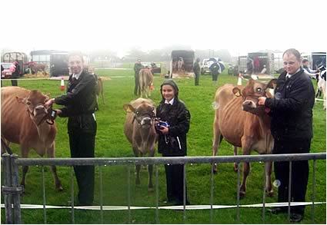
Handler Championship Winners; right – left, Mark Williams – Champion & Interbreed Champion Handler, Tanwen Cox – Reserve, Rhydian Jones – Hon. Mention
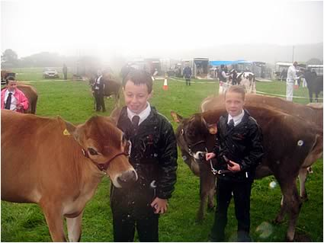
Iwan & Awen Jones – Best Turned Out Boy & Girl
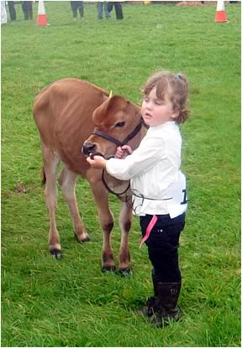
Enfys Wheeler – Youngest Handler

2010 Welsh & Shropshire Jersey Breeders Association
2010 UK Jersey Youth Weekend
Many congratulations to 13 year old Rhydian Jones of Salfach Jerseys, who won the Overall Stockman Award at the recent UK Jersey Youth Weekend which was held at Bayview Jerseys, Lancashire.
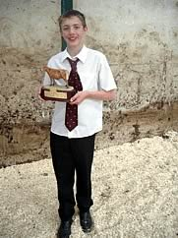
Rhydian Jones, Salfach Jerseys – Winner of the Overall Stockman’s Award at the UK Jersey Youth Weekend
Also, to 10 year old William Speak from Talley who was joint winner of the Best Newcomer Award. William & his family breed Welsh Blacks & had come along for the weekend with his friends, Henry & Gwenlais Cavenagh.
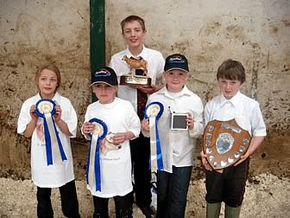
W&SYJB Members with their awards at the UK Jerseys Youth Weekend. Lt-rt; Awen Jones, Henry Cavenagh, Rhydian Jones, Gwenlais Cavenagh, William Speak.
Over 50 young members from all over the UK & Northern Ireland attended the weekend. All 5 W&SYJB members did extremely well during the weekend & came away with awards either individually or as team members.
2010 Herd Competition
A good crowd of members were present at Nantyci Farm for the Herd Competition Presentation evening on Wednesday 7th of July.
Many thanks to the Evans Family at Nantyci for hosting the evening, we are very grateful for your generosity. Thanks also to our judge, Mr Colin Jones, Penyfedw, Llandyfaelog, who I believe, as a Holstein man, was very impressed by the quality of stock.
We would also like to thank those members who entered the competition, ensuring it's success this year again.
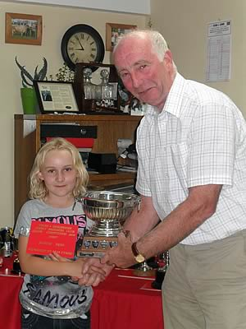
Tanwen Cox from Glanmor Jerseys being presented with the Pauls & White Cup by Mr Colin Jones, Judge
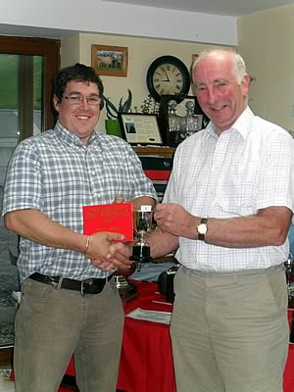
James Evans, Mydrim Jersey receiving one of the numerous cups he won
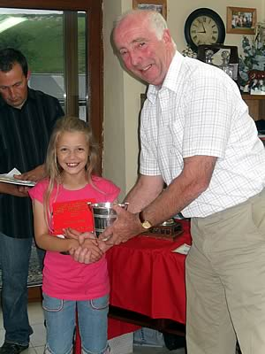
Awen Jones from Salfach Jersey receiving the Gaylow Cup
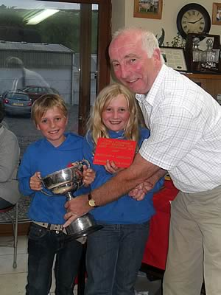
Henry & Gwenlais Cavenagh from the Gwenlas Herd, winners of the Gorwyn Cup
RESULTS
Class 1  Large Herd (3) – The Longmynd Cup  1st – Plowden  2nd – Blodwell  3rd – Longmynd  Medium Herd (4) – The Pauls & White Cup  1st – Glanmor  2nd – Nicel  3rd – Gwenlas  4th – Philmor  Small Herd (4) – The Spoonhill Cup  1st – Mydrim  2nd – Starlight  3rd – Salfach  4th – Hillhoath  Class 2  Maiden Herd - The Gaylow Cup  1st – Salfach  Class 3  Senior Progeny Group (5) – The Grayswood Cup  1st – Glanmor – Valleystream Julian  2nd – Gwenlas – Sooner Centurion  3rd – Philmor – Rock Ella Remake  4th – Nicel – Q Zik  5th – Salfach – Tregibby Romeo  Class 4  Junior Progeny Group (7) – The BOCM Cup  1st – Mydrim – Rock Ella Remake  2nd – Salfach – Pine Haven Senior  3rd – Nicel – Grahmar Future Tonic  4th – Philmor – Woodstock Lexington  5th – Philmor – Family Hill Signature  Class 5  Progeny Group by a UK Bull (5) – The Daimar Cup  1st – Glanmor – Glanmor Flyers Jumbo Jet  2nd – Nicel – Mydrim Remake Grandslam  3rd – Philmor – Philmor Compo  4th – Nicel – Llan Lester Highwayman  5th – Salfach – Tregibby Romeo  Class 6  Home Bred Cow (12) – The Berwick Cup  1st – Mydrim – Mydrim Vindication Louise  2nd – Glanmor – Glanmor Ring Florrie  3rd – Glanmor – Glanmor Julian Wishful  4th – Gwenlas – Gwenlas Centurion Triumph  = 5th – Blodwell – Blodwell Ringmaster Joy  - Salfach – Salfach Ringmaster Twts | Class 7  Home Bred Heifer in Milk (12) – The Ellerdine Cup  1st – Glanmor – Glanmor Julian Minstral  2nd – Starlight – Starlight Remake Daffoldil  = 3rd – Blodwell – Blodwell Vindication Jane  Mydrim – Mydrim Excitation Sandy  = 5th – Gwenlas – Gwenlas Iatola Erica Louise  Blodwell – Blodwell Futurity Focus  Hillhoath – Hillhoath Sargent Jingle  Philmor – Philmor Signature Rose  Class 8  Home Bred Youngstock (10) – The Lowther Cup  1st – Gwenlas  2nd – Plowden  = 3rd – Longmynd  Mydrim  5th – Salfach  Class 9  Dam & Daughter (10) – The Distingue Cup  1st – Mydrim – Regal Louise/Vindication Louise  2nd – Glanmor – Style Fimble/Ring Florrie  3rd – Hillhoath – Sambo Jingle/Sargent Jingle  4th – Gwenlas – Cent Triumph/Hallmark Triumph  = 5th – Starlight – Remake Daffodil/Julian Daffodil  Philmor – Glanmor Romeo Marmalade/ Philmor Julian Marmalade  Class 10  Home Bred Heifer born in 2009 (8) – The Pennyworld & Surelike Cup  1st – Blodwell – Blodwell Exciting Unicolour  2nd – Futuredreams – Futuredreams Ringmaster Tracey  = 3rd – Mydrim – Mydrim Sargent Sandy  Salfach – Salfach Ringmaster Paris  = 5th – Hillhoath – Hillhoath Jamaica Blossom  Philmor – Philmor Iatola Claire  Class 11  Bull (3) – The Llanllyr Cup  1st – Glanmor – Glanmor Julian Mr Frosty  2nd – Glanmor – Glanmor Saber Xenon  3rd – Philmor – Philmor Blossman  Class 12  Production & Inspection ( 9) – The Gorwyn Cup  1st – Gwenlas - Gwenlas Cent Nougat  2nd – Gwenlas - Gwenlas Cent Flora  3rd – Salfach - Salfach Ringmaster Twts  4th – Glanmor - Glanmor Julian Wishful  5th – Salfach – Churcham Valley Dawish 2  Class 13  Judge’s Prize – The Moorish Cup  Mydrim
Stock Judging
A very enjoyable and informative day was spent at Glanmor Jerseys, Llandawke, LAUGHARNE, by kind invitation of Helen, Dafydd and Tanwen Cox. There was a good turnout of members, young & old. Mr Meurig James, Chief Classifier, gave a presentation of the key points of a Jersey cow before the members were split into 3 age groups for the stock judging competition which was judged by Mr Edward Morgan.
Age group winners were:
Junior: Melissa Fletcher, Clover Hill.
Intermediate: Rhydian Jones, Salfach.
Senior: Phil Morgan, Philmor.
Many thanks to Mr Meurig James & Mr Edward Morgan for their contribution to the day and especially to Helen, Dafydd & Tanwen Cox for their hospitality.
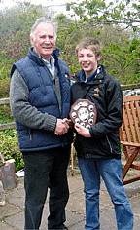 | 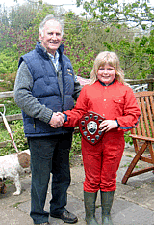 | 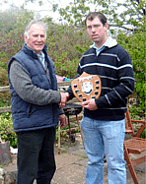
Rhydian Jones, Salfach – Intermediate winner with Mr Edward Morgan, Judge. | Melissa Fletcher, Clover Hill – Junior winner with Mr Edward Morgan, Judge. | Phil Morgan, Philmor – winner of the senior Stock Judging Competition
St Clears Show
Members from the West Wales area were out in force at St Clears Show which was held at the United Counties Showground, Carmarthen on Saturday 22nd May.
Judge: Mr B. Baker, Usk, Monmouthshire.
Local Interbreed Classes
Best Heifer in Calf:
1st R James, Nantycifach, Banyfelin.
Best Heifer in Milk:
1st Glanmor Jerseys, Parcgwyn, Llandawke.
2nd Sian Cusack, Caerlleon, Llanboidy.
Best Cow or Heifer to be Home Bred:
1st Glanmor Jerseys, Parcgwyn, Llandawke.
2nd Glanmor Jerseys, Parcgwyn, Llandawke.
3rd Sian Cusack, Caerlleon, Llanboidy.
Elfyn Thomas Challenge Cup – Best Local Champion
Champion: Glanmor Jerseys, Parcgwyn, Llandawke.
Reserve: Glanmor Jerseys, Parcgwyn, Llandawke.
Best Local Beast, Any Breed, Male or Female:
1st Glanmor Jerseys, Parcgwyn, Llandawke.
WP Davies Trophy – Best Local Beast, Any Breed, Male or Female
Champion: Glanmor Jerseys, Parcgwyn, Llandawke.
Open Jersey Classes
Best Maiden Heifer or Heifer in Calf:
1st JD Evans, Tynewydd, Meidrim.
2nd R James, Nantycifach, Banyfelin.
3rd R & F Jones, Cilarddu, Nantgaredig.
Best Cow in Milk:
1st Glanmor Jerseys, Parcgwyn, Llandawke.
2nd P Morgan, Goitan, St.Nicholas, Goodwick.
3rd Nicel Jerseys, Nantyci, College Rd, Carms.
Best Heifer in Milk:
1st Glanmor Jerseys, Parcgwyn, Llandawke.
2nd Sian Cusack, Caerlleon, Llanboidy.
3rd R & F Jones, Cilarddu, Nantgaredig.
Pennyworld & Surelike Perpetual Cup
Champion: Glanmor Jerseys, Parcgwyn, Llandawke.
Reserve: Glanmor Jerseys, Parcgwyn, Llandawke.
Special Show Rosette – Best Home Bred Animal in the Jersey Section
Champion: Glanmor Jerseys, Parcgwyn, Llandawke.
Reserve: Glanmor Jerseys, Parcgwyn, Llandawke.
Interbreed Classes
Best Interbred Dairy Pairs:
1st Glanmor Jerseys, Parcgwyn, Llandawke.
Calf & Calf Handling:
Best Dairy Calf Under 12 months old:
1st James Evans, Tynewydd, Meidrim.
2nd R & F Jones, Cilarddu, Nantgaredig.
Shield – Best Dairy Calf (Class C46)
Champion: James Evans, Tynewydd, Meidrim.
Reserve: R & F Jones, Cilarddu, Nantgaredig.
Best Calf Under 12 months old, handled by a child under 10yrs old:
1st Tanwen Cox, Glanmor Jerseys, Parcgwyn, Llandawke.
Best Calf Under 12 months old, handled by a child 10 - 15yrs old:
3rd Awen Jones, Cilarddu, Nantgaredig.
Challenge Shield – Best Handler (Classes C47 & C48):
Reserve: Tanwen Cox, Glanmor Jerseys, Parcgwyn, Llandawke.
Cothi Bridge Show
Saturday 29th May 2010
Judge: Mr Arwyn Wilson, Cardigan.
Maiden Heifer (6)
1st – Glanmor Perfector Texas Tee – Glanmor Jerseys
2nd – Salfach Senior Lara – Salfach Jerseys
3rd – Nicel Minister Clemency – Nicel Jerseys
Heifer in Calf (1)
1st – Salfach Karma Pennsylvania – Salfach Jerseys.
Heifer in Milk (3)
1st – Glanmor Julian Minstral – Glanmor Jerseys.
2nd – Glanmor Storm Force Five – Glanmor Jerseys.
3rd – Freeland Lieutenant Sunset – Salfach Jerseys.
Cow in Milk (5)
1st – Glanmor Julian Wishful – Glanmor Jerseys.
2nd – Glanmor Blade Primrose – Glanmor Jerseys.
3rd – Glanmor Jewel Jolly – Salfach Jerseys
Best Milk Recorded Cow or Heifer (1)
1st – Glanmor Julian Wishful – Glanmor Jerseys.
Group of 3
1st – Glanmor Jerseys
2nd – Nicel Jerseys
3rd – Salfach Jerseys
W&SJBA Rosette Home Bred Cow or Heifer: Glanmor Julian Wishful – Glanmor Jerseys.
Champion: Glanmor Julian Wishful.
Reserve: Glanmor Julian Minstral.
Interbreed Classes
Champion Group: Glanmor Jerseys
Champion Heifer: Glanmor Julian Minstral
Champion Cow: Reserve – Glanmor Julian Wishful.
YFC & Young Handler Classes
Calf under 12 months:
2nd – Salfach Senior Lara – Rhydian Jones, Salfach
3rd – Salfach Illusion Peanut – Iwan Jones, Salfach
Calf not showing any broad teeth:
1st – Salfach Karma Pennsylvania – Rhydian Jones, Salfach
2nd – Oakfield Jamaica Yarrow 2 – Steffan James, Oakfield
Champion Calf: Reserve – Salfach Karma Pennsylvania.
Young Handler 14 yrs & under.
1st – Rhydian Jones, Salfach
3rd – Awen Jones, Salfach
4th – Tanwen Cox, Glanmor
Young Handler 15 – 20yrs
1st – Steffan James, Oakfield
2nd – Nia Jones, c/o Salfach
2009 Welsh Dairy Show Results - 20th October 2009
Monday evening’s INTERBREED CALF SHOW
Jerseys highlighted in Red
Judge: Mr Ken Procter
Class 1 Heifer calf under 12 months old.
1st 9 M W & G M Williams, Lyganlan LB Sherry P Red, 01.01.09.s Aggravation Lawn Boy P Red
2nd 2 R & FF Jones, Salfach Senior Maine, 02.12.08.s Pine Haven Senior
3rd 3 A H Wilson & Son, Tregibby Outlaw Cheril, 03.12.08.s Tregibby Outlaw
4th 6 Richard & Bethan Thomas, Strumble Sam Panda 214, 20.10.08.S Regancreast Mr Drhamsam
Class 1a Heifer calf under 12 months old.
1st 10 E M & E & Iwan, Erie Mapleros PS Lustre Morgan, 02.01.09.sShotle
2nd 16 E M & E & Iwan Morgan, Erie Maplerose Jazzy Lustre, 02.02.09.s Jasper
3rd 14 R & FF Jones, Hillhoath Mini Julia, 02.02.09.s Select Scott Minister
4th 11 E M & E & Iwan Morgan, Erie Talent Roxy, 06.01.09.s Tallent
Class 2 Heifer over 12 months and under 18 months
1st 30 Richard & Bethan Thomas, Lyganian Shottle Kandy, 01.07.08.s Picston Shottle
2nd 21 R & FF Jones, Salfach Karma Pennsylvania, 23.09.08.s Scottiere Karma
3rd 32 MS & EAE Davies, Elkington Amber Princess 10, 22.08.08.sLoughdale Rising Star ET
4th 24 R & FF Jones, Salfach Minister Utah, 23.05.08 .s Select Scott Minister
Class 3 Heifer over 18 months and under 24 months
1st 42 E M & E & Iwan Morgan, Erie Renaissance Elsie, 02.12.07.s Renaissance
2nd 37 Philmor Jerseys, Smiddiehill Amadeo Marnie, 01.11.07.s Piedmont Grove Amedeo
3rd 34 A H Wilson & Son, Willsbro Talent Romance, 15.04.08.s Ladino Park Talent
4th 40 M W & G M Williams, Lyganlan Laramie Yana, 03.03.08.s Wedgwood Laramie EX96
Champion Calf
42 E M & E & Iwan Morgan, Erie Renaissance Elsie, 02.12.07.s Renaissance
Reserve Champion
37 Philmor Jerseys, Smiddiehill Amadeo Marnie, 01.11.07.s Piedmont Grove Amedeo
Champion Handler
Class 4 Handler under 12 yrs old.
1st 44 Awen Jones
2nd 45 Gwenlais Cavanagh
3rd 46 Nia Thomas
Class 5 Handler over 12 yrs old and under 18 yrs
1st 54 Harriet Anne Davies
2nd 47 Ffion Thomas
3rd 50 Steffan James
4th 52 Michael James
Class 6 Handler over 18 yrs old and under 26 yrs
1st 63 Katherine Watkins
2nd 58 Lizzy Bland
3rd 60 Phil Morgan
4th 61 Aled Morgan
Champion Handler
63 Katherine Watkins
Reserve Champion Handler
54 Harriet Anne Davies
MAIN SHOW RESULTS
Jersey Section – Judge : Mr Graham Wallace

Class 19: Heifer in Calf (7)
1st – Erie Renaissance Elsie – E M, E & Iwan Morgan
2nd – Smiddiehill Amadeo Marnie – Philmor Jerseys
3rd – Salfach Jamaican Dakota – Salfach Jerseys
4th – Tregibby Ringmaster Diamond – A H Wilson & Son
5th – Glanmor Julian Minstral – Glanmor Jerseys
6th – Glanmor Jet Hula Hoop – Glanmor Jerseys
7th – Mydrim Remake’s Lady – James D. Evans
Class 20: Cow in Calf (6)
1st – Bluegrass Remake Golden Plait – E M, E & Iwan Morgan
2nd – Bluegrass Heritages Lovely Lady – A H Wilson & Son
3rd – Glanmor Style Fimble – Glanmor Jerseys
4th – Tixall Angelos Victoria – Nicel Jerseys
5th – Burnbrae Remakes Stardust – Philmor Jerseys
6th – Glanmor Ring Dallas – Glanmor Jerseys
Class 21: Heifer in Milk (5)
1st – Glanmor Rocket Wennol – Glanmor Jerseys
2nd – Mydrim Excitation Sandy – James D. Evans
3rd – Salfach Belmont Yasmine – Salfach Jerseys
4th – Philmor Julians Marmalade – Philmor Jerseys
5th – Fryn Ringmaster Juniper – A R Law & Son
Class 21a: Heifer in Milk (5)
1st – Pavenham Centurion Devona – E M, E & Iwan Morgan
2nd – Glanmor Julian Jingle Bells – Glanmor Jerseys
3rd – Glanmor Blade Primrose – Glanmor Jerseys
4th – Glanmor Julians Winc – Philmor Jerseys
5th – Freeland Julian Delight – Nicel Jerseys
Champion Heifer
Pavenham Centurion Devona
Reserve
Glanmor Rocket Wennol

Class 23: Cow in Milk with 2nd Calf (6)
1st – Glanmor Ring Florrie – Glanmor Jerseys
2nd – Freeland Chairmans Yarrow 2 – Philmor Jerseys
3rd – Salfach Ringmaster Twts – Salfach Jerseys
4th – Brackenhurst Jetson Sophia – Glanmor Jerseys
5th – Freeland Remakes Candy 2 – Philmor Jerseys
6th – Saxown Bomer Cash 52 – Nicel Jerseys
Class 24: Cow in Milk with 3rd Calf (4)
1st – Bluegrass Deluxes Serengeti – A H Wilson & Son
2nd – Bluegrass Jetsons Bobs Mate – Nicel Jerseys
3rd – Churcham Valley Dawlish 2 – Salfach Jerseys
4th – Glanmor GMA Dimple – A R Law & Son
Class 25: Senior Cow in Milk (6)
1st – Bluegrass Jazzman Pams Panama – A H Wilson & Son
2nd – Gwenlas Hallmark Stephanie – E M, E & Iwan Morgan
3rd – Gaddesden Tara 2 – James D. Evans
4th – Saxown Dukes Blossom – Philmor Jerseys
5th – Glanmor Julian Wishful – Glanmor Jerseys
6th – Bluegrass Remakes Savanhanna Claire – Philmor Jerseys
Class 26: Best Group of 3 Animals (3)
1st – Glanmor Jerseys
2nd – E M, E & Iwan Morgan
3rd – Nicel Jerseys
Class 27: Milk Recorded Class (4)
1st – Gaddensden Tara 2 – James D. Evans
2nd – Bluegrass Jazzman Pams Panama – A H Wilson & Son
3rd - Glanmor Style Fimble – Glanmor Jerseys
4th – Glanmor Julian Wishful – Glanmor Jerseys
Breed Champion
Bluegrass Pams Panama
Reserve
Gwenlas Hallmark Stephanie
Hon Mention
Pavenham Centurion Devona
Tarian Caws Nantybwla Shield
Glanmor Jerseys
Best Udder Award in the Jersey Section
Bluegrass Pams Panama
INTERBREED CHAMPIONSHIP CLASSES
Supreme Champion Heifer
Reserve
Pavenham Centurion Devona
Supreme Champion Cow
Reserve
Bluegrass Pams Panama
Premier Breeder Award
Glanmor Jerseys
2009 SOUTH WALES ALL DAIRY BREEDS CALF SHOW - 26th September 2009 - Carmarthen Livestock Centre
The Jersey classes were very well supported by members, young & old(ish). 31 calves were forwarded along with 13 competitors in the young handler classes.
RESULTS
Calf Classes — Mr John Stubbs
Calves born after 01.03.09 (4)
1st—Mydrim Remake’s Tara 2—Mydrim Jerseys
2nd—Morita Connection Anon—M Davies
3rd—Freeland Encors Yarrow 20—Freeland Jerseys
4th—Hillhoath Jamaica Sunset—J & C Hart
Calves born between 01.12.08—28.02.09 (8)
1st—Glanmor Julian Relish—Glanmor Jerseys
2nd—Hillhoath Mini Julia—Salfach Jerseys
3rd—Hillhoath Sargent Jingle 2—J & C Hart
4th—Salfach Senior Maine—Salfach Jerseys
5th—Nicel Minister Clemancy—Nicel Jerseys
Calves born between 01.09.08—30.11.08 (6)
1st—Tregibby Julian Roxy—A.H. Wilson & Son
2nd— Erie Connect Plait—Iwan Morgan
3rd—Glanmor Illusion Tia Maria—Glanmor Jerseys
4th—Salfach Karma Pennsylvania—Salfach Jerseys
5th—Oakfield Jamaica Yarrow 2—Steffan James
6th—Clover Royal Victress Maisie 32—Andrew Fletcher
Calves born between 01.05.08 & 31.08.08 (7)
1st—Salfach Jamaican Dakota—Salfach Jerseys
2nd—Erie Comerica Grove—Iwan Morgan
3rd—Salfach Minister Utah—Salfach Jerseys
4th—Mydrim Remakes Lady—Mydrim Jerseys
5th—Salfach Minister Wyoming—Salfach Jerseys
Calves born between 01.01.08. & 30.04.08 (3)
1st—Tregibby Ringmaster Elsie—A.H. Wilson & Son
2nd—Hillhoath Sargent Jingle—J & C Hart
3rd—Clover Designs Day Dream—Andrew Fletcher
Cherrybrook Trophy (kindly donated by Liz Wynne) presented to the winner of this class.
Cribyn Trophy (kindly donated by Chris Rankin) for the Best Homebred Calf
Salfach Jamaican Dakota—Salfach Jerseys
Champion Jersey Calf—Salfach Jamaican Dakota
Res. Mydrim Remake’s Tara 2
Progeny (2 or more animals from the same sire) (5)
1st—Sunset Canyon Nadine Sargent—J & C Hart
2nd—Rock Ella Remake—Mydrim Jerseys
3rd—Select Scott Minister—Salfach Jerseys
4th—Glanmor Sultan Juggler _ Glanmor Jerseys
5th—Bridon Jamaica—Steffan James
Cup presented by Mr Rhys Jones
Best Calf sired by a Semex Bull (8)
1st—Salfach Jamaican Dakota—Salfach Jerseys
2nd—Erie Comerica Grove—Iwan Morgan
3rd—Glanmor Julian Relish—Glanmor Jerseys
4th –Salfach Minister Utah—Salfach Jerseys
5th—Salfach Senior Maine—Salfach Jerseys
Cup presented by Mr Rhys Jones
INTERBREED CLASSES - Mrs Louise Graham
Best Pair of Calves (same sire/dam owned by same exhibitor)
1st—Salfach Minister Utah/ Hillhoath Mini Julia—Salfach Jerseys
Interbreed Pair of Calves
Res.—Salfach Jamaican Dakota/ Tregibby Ringmaster Elsie—Salfach Jerseys/ A.H. Wilson & Son
Interbreed Champion Calf
Res.—Salfach Jamaican Dakota—Salfach Jerseys
JERSEY HANDLER CLASSES - Mr John Stubbs
Novice (8 yrs & under on 1st Jan ‘09) (6)
1st—Gwenlais Cavenagh—Gwenlas
2nd—Awen Jones—Salfach
3rd—Melissa Fletcher—Clover
Joint 4th -
Tanwen Cox—Glanmor
Henry Cavenagh—Gwenlas
Dafydd Davies—Morita
Plates presented to all competitors kindly donated by Mr & Mrs David Phillips
Junior (between 9 & 12 yrs on 1st Jan ‘09) (3)
1st—Rhydian Jones—Salfach
2nd—Iwan Jones—Salfach
3rd—Matthew Fletcher—Clover
Intermediate (between 13 & 16 yrs on 1st Jan ‘09) (2)
1st—Steffan James—Oakfield
2nd—Frazer Wyatt—Penbryn
Senior (between 17 & 20 yrs on 1st Jan ‘09) (1)
1st— Alaw Beynon-Thomas—Salfach
Mature (between 21 and 30 yrs on 1st Jan ’09) (1)
1st—Aled Morgan—Philmor
Class winners presented with trophies thanks to Helen, Dafydd & Tanwen Cox, Glanmor Jerseys
CHAMPION HANDLER—Alaw Beynon-Thomas
RESERVE— Rhydian Jones
Leather Halter presented to Champion Handler kindly donated by Barrie & James Evans, Future Dreams Partnership.
Best Female Handler—Alaw Beynon-Thomas
Best Male Handler—Rhydian Jones
Both presented with W&SJBA Plates
Best Turned-Out Boy—Dafydd Davies
Best Turned-Out Girl—Gwenlais Cavenagh
Both presented with W&SJBA Shields
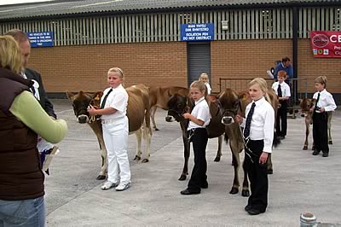
Novice Handler Line-up
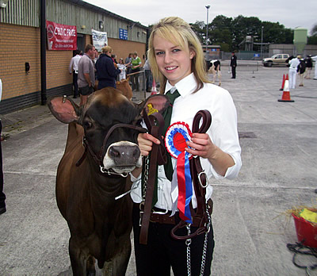
Champion Handler
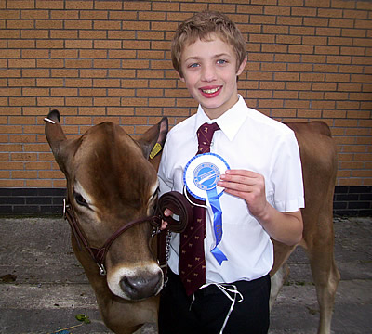
Reserve Champion Handler
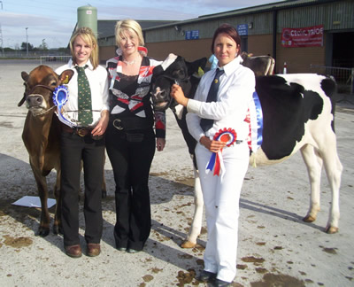
Interbreed Champion & Reserve

2009 ROYAL WELSH SHOW RESULTS
Many congratulations to all club members who exhibited at this year’s Royal Welsh Show.
The results were as follows:
Class 681 – Maiden Heifer (10)
1. Future Dreams Signature Veronica ET – Future Dreams Partnership
2. Tregibby Ringmaster Elsie – A H Wilson & Son
3. Salfach Jamaican Dakota – J R & Ff C E Jones
4. Mydrim Remakes Sandy – J D Evans
5. Salfach Karma Pennsylvania – J R & Ff C E Jones
6. Freeland Big Time Coconut – G B Thomas
Class 683 – Heifer in Calf (5)
1. Pavenham Centurion Devona – E M, E & I Morgan
2. Glanmor Julian Minstral – Glanmor Jerseys
3. Tregibby Ringmaster Diamond – A H Wilson & Son
4. Mydrim Excitation Sandy – J D Evans
5. Windyridge Sargents Teresa – S & S Murray Farms Ltd
Class 684 – Heifer in Milk (6)
1. Trecanda Vindication Lily – S & S Murray Farms Ltd
2. Bluegrass HWM Blondett – E M, E & I Morgan
3. Windyridge Supreme Lee Uggy – D P Manning & Co
4. Smiddiehill Connections Blossom – Future Dreams Partnership
5. Glanmor Blade Primrose – Glanmor Jerseys
6. Glanmor Ring Dallas – Glanmor Jerseys
Class 685 – RWAS Special Rosette Best Heifer
1. Trecanda Vindication Lily – S & S Murray Farms Ltd
2. Pavenham Centurion Devona – E M, E & I Morgan
Class 686 – Dry Cow (7)
1. Bluegrass Heritages Lovely Lady – A H Wilson & Son
2.Ellerdine Easton Crystal – D P Manning & Co
3. Brackenhurst Cowboys Cash – Nicel Jerseys
4. Glanmor Julian Popcorn – Glanmor Jerseys
5. Frosty Jazzman Brussel – G & R Jones
6. Mydrim Junos Louise – J D Evans
7. Saxown Dukes Sweetdreaming – W C & H Williams
Class 687 – Cow in Milk with 2nd Calf (5)
1. Clandeboye Jazzman Mabel – A H Wilson & Son
2. Windyridge Kevs Petunia – E M, E & I Morgan
3. Salfach Ringmaster Twts – J R & Ff C E Jones
4. Sowden Samson Tracy 3 – Future Dreams Partnership
5. Longhills Crecent Zulu – Nicel Jerseys
Class 688 – Cow in Milk with 3rd Calf (3)
1. Whiteoaks Jude Candytuft – S & S Murray Farms Ltd
2. Churcham Valley Dawlish 2 – J R & Ff C E Jones
3. Mydrim Junos Sandy – J D Evans
Class 689 – Cow in Milk with 4th or Subsequent Calf (4)
1. Whiteoaks Julian Flower – S & S Murray Farms Ltd
2. Bluegrass Jazzman Pams Panama – A H Wilson & Son
3. Gaddesden Tara 2 – J D Evans
4. Glanmor Julian Wishful – Glanmor Jerseys
Class 690 – RWAS Special Rosette Best Cow Classes 686-689
1. Clandeboye Jazzman Mabel – A H Wilson & Son
2. Whiteoaks Julian Flower – S & S Murray Farms Ltd
Class 691 – Progeny Group of 3
1. Glanmor Julian Minstral, Glanmor Julian Popcorn & Glanmor Julian Wishful – Glanmor Jerseys
Class 692 – Cow with Best Udder
1. Clandeboye Jazzman Mabel – A H Wilson & Son
2. Bluegrass Jazzman Pams Panama – A H Wilson & Son
Class 693 – Bryn Cwnin Trophy – Best Exhibit shown by an Exhibitor in Wales
1. Clandeboye Jazzman Mabel – A H Wilson & Son
2. Windyridge Kevs Petunia – E M, E & I Morgan
Class 695 – Best Exhibit Registered in Herd Book
1. Clandeboye Jazzman Mabel – A H Wilson & Son
2. Whiteoaks Julian Flower – S & S Murray Farms Ltd
Class 696 – Champion Jersey
1. Clandeboye Jazzman Mabel – A H Wilson & Son
2. Whiteoaks Julian Flower – S & S Murray Farms Ltd
INTERBREED RESULTS
Fitzhugh Championship
1. Clandeboye Jazzman Mabel – A H Wilson & Son
Whiteoaks Julian Flower – S & S Murray Farms Ltd
Supreme Champion Dairy Heifer
1. Trecanda Vindication Lily – S & S Murray Farms Ltd.
Supreme Champion Dairy Cow
Res. Clandeboye Jazzman Mabel – A H Wilson & Son
The Natwest Team of Five
Res. Clandeboye Jazzman Mabel, Glanmor Julian Popcorn, Glanmor Julian Wishful, Whiteoaks Julian Flower, Bluegrass Jazzman Pams Panama
Dairy Stockmens Competition
1. J D Evans / Future Dreams Partnership
3. Glanmor Jerseys

2009 HERD COMPETITION 2009
This year’s herd competition judging took place between the 30th of June & the 6th of July. 4 of the Shropshire herds and 10 of the West Wales herds entered the competition this year, giving judge, Mr Stephen Bland, Clifton, Cumbria, ample opportunity to compare a variety of quality stock.
23 of the members met up to enjoy a buffet lunch & hear the judge give his results at the Fox & Hounds, Bancyfelin, Carmarthen on Tuesday 7th of July. The cups were presented by Mrs Claire Bland and Mr Mike Davies of Alta Cymru presented 1st, 2nd & 3rd place cards, which were kindly sponsored by Alta Cymru.
RESULTS
THE LONGMYND CUP- LARGE HERDS
1st – Plowden – Plowden Farms
2nd – Whitton – C & G Halliday
3rd – Blodwell – R Taylor & family
THE PAULS & WHITE CUP – MEDIUM HERDS
1st – Glanmor – Glanmor Jerseys
2nd – Gwenlas – S Cavenagh
3rd – Philmor – G Morgan
THE SPOONHILL CUP – SMALL HERDS
1st – Mydrim – J Evans
2nd – Salfach – R & Ff Jones
3rd - Hillhoath – J & C Hart
THE GAYLOW CUP – MAIDEN HERD
1st – Philmor
2nd – Salfach
3rd – Penbryn - Frazer Wyatt
THE GRAYSWOOD CUP- SENIOR PROGENY
1st – Valleystream Julian – Glanmor Jerseys
2nd – Rock Ella Remake – G Morgan
3rd – Sooner Centurion – S Cavenagh
THE BOCM CUP – JUNIOR PROGENY
1st – Mydrim Grand Slam – Nicel Jerseys
2nd – RJF Big Show – Glanmor Jerseys
3rd – Family Hill Avery Signature – G Morgan
THE BERWICK CUP – HOME BRED COW
1st – Glanmor Julian Wishful – Glanmor Jerseys
2nd – Hillhoath Sambo Jingle – J & C Hart
3rd – Glanmor Julian Popcorn – Glanmor Jerseys
THE LOWTHER CUP – HOME BRED YOUNGSTOCK
1st – Plowden
2nd – Gwenlas
3rd – Glanmor
THE DISTINGUE CUP – DAM & DAUGHTER
1st – Glanmor Julians Domino & Glanmor Ring Dallas – Glanmor Jerseys
2nd – Saxown Dukes Blossom & Philmor Signature Blossom – G Morgan
3rd – Trinity Perry Sandy & Mydrim Junos Sandy – J Evans
THE PENNYWORLOD & SURELIKE CUP – HOME BRED HEIFER born in 2008
1st – Plowdens Sultan Bianca – Plowden Farms
2nd – Futuredreams Signature Veronica ET – B & J Evans.
3rd – Salfach Jamaican Dakota – R & Ff Jones
THE LLANLLYR CUP – BULL any age
1st – Whitton Hallmarks Smart – Halliday
2nd – Glanmor Julian Mr Frosty – Glanmor Jerseys
3rd – Philmor Compo – G Morgan
THE MOORISH CUP – JUDGE’S PRIZE
R & Ff Jones, Salfach Jerseys.
2009 CARMARTHENSHIRE COUNTY SHOW - 4th July
Judge: Mr Peter Prior, Radley Green, Essex.
Maiden Heifer
1st - Tregibby Comerica Elsie - A H Wilson & Sons
2nd - Salfach Jamaican Dakota - R & Ff Jones
3rd - Salfach Karma Pennsylvania - R & Ff Jones
In-Calf Heifer
1st - Pavenham Centurion Devona - E M, E & Iwan Morgan
2nd - Tregibby Ringmaster Diamond - A H Wilson & Sons
3rd - Freeland Silver Coconut - Steffan James
Heifer-in-milk
1st - Glanmor Ring Dallas - Glanmor Jerseys
2nd - Glanmor Jewel Jolly - R & Ff Jones
Cow-in-calf
1st - Bluegrass Lovely Lady - A H Wilson & Sons
2nd- Hellifield Easton Sophie - R & Ff Jones
Junior Cow-in-milk
1st - Clandeboye Jazzman Mable - A H Wilson & Sons
2nd - Salfach Ringmaster Twts - R & Ff Jones
3rd - Churcham Valley Dawlish 2 - R & Ff Jones
Senior Cow-in-milk
1st - Glanmor Julian Wishful - Glanmor Jerseys
Milk Recorded
1st - Glanmor Julian Wishful - Glanmor Jerseys
Champion - Clandeboye Jazzman Mable - A H Wilson & Sons
Reserve - Glanmor Julian Wishful - Glanmor Jerseys
Best Female bred by Exhibitor - Glanmor Julian Wishful - Glanmor Jerseys
Supreme Champion Cow - Res. - Clandeboye Jazzman Mable - A H Wilson & Sons
Young Handlers
U.16
1st - Steffan James - Oakfield
3rd - Iwan Jones - Salfach
U.21
1st - Esther Jones - Glanmor
2nd - Alaw Beynon-Thomas - Salfach

2009 COTHIBRIDGE SHOW - 30th May
JERSEY CLASSES - Judge: Mr Andrew Timbury, Bolebec Farm, Maulden, Bedford.
Maiden Heifer (4)
1st - Salfach Karma Pennsylvania - Salfach Jerseys, Nantgaredig, Carmarthen
2nd - Hillhoath Sargent Jingle - J & C Hart, Swn Afon, Meidrim.
3rd - Salfach Jamaican Dakota - Salfach Jerseys, Nantgaredig, Carmarthen.
In-Calf Heifer (1)
1st - Salfach Belmont Yasmine - Salfach Jerseys, Nantgaredig, Carmarthen.
Dry Cow (2)
1st - Brackenhurst Cowboys Cash - Nicel Jerseys, Nantyci, Carmarthen.
2nd - Glanmor Romeo Paprika - Salfach Jerseys, Nantgaredig, Carmarthen.
Heifer in Milk (4)
1st - Glanmor Ring Dallas - Glanmor Jerseys, Laugharne.
2nd - Montgomery Zik Starlight - Nicel Jerseys, Nantyci, Carmarthen.
3rd - Glanmor Blade Primrose - Glanmor Jerseys, Laugharne.
Cow in Milk (3)
1st - Glanmor Julian Popcorn - Glanmor Jerseys, Laugharne
2nd - Churcham Valley Dawlish 2 - Salfach Jerseys, Nantgaredig, Carmarthen.
3rd - Longhills Crecent Zulu - Nicel Jerseys, Nantyci, Carmarthen.
Milk Recorded (3)
1st - Glanmor Julian Popcorn - Glanmor Jerseys, Laugharne.
2nd - Churcham Valley Dawlish 2 - Salfach Jerseys, Nantgaredig, Carmarthen.
3rd - Longhills Crecent Zulu - Nicel Jerseys, Nantyci, Carmarthen.
Pairs (3)
1st - Glanmor Jerseys
2nd - Nicel Jerseys
3rd - Salfach Jerseys
Champion - Glanmor Julian Popcorn - Glanmor Jerseys, Laugharne
Res. - Churcham Valley Dawlish 2 - Salfach Jerseys, Nantgaredig, Carmarthen.
DAIRY INTERBREED - Judge: Mr Bill Pritchard, Cardiff.
Reserve Champion - Glanmor Julian Popcorn
CALF HANDLING & YFC CLASSES - Judge: Miss Helen Evans, Nantyci, Carmarthen.
Senior Dairy Handler (1)
1st - Nia Jones,c/o Salfach Jerseys.
Junior Dairy Handler (5)
2nd - Rhydian Jones, Salfach Jerseys
3rd - Tanwen Cox, Glanmor Jerseys
Dairy Calf Under 12 Months (3)
1st- Salfach Karma Pennsylvania, Salfach Jerseys
3rd - Salfach Jamaican Dakota, Salfach Jerseys
Champion Dairy Calf - Salfach Karma Pennsylvania, Salfach Jerseys.
St CLEARS SHOW - 23rd May 2009
LOCAL CLASSES (Inter-breed) - Judge: Mr Wyn Jones, Cilfeithy, Kidwelly.
Cow in Calf
1st - Glanmor Romulus Pepsi - Sarah Thomas, Treventy Farm, St Clears.
Cow in Milk
1st - Glanmor Julian Popcorn - Glanmor Jerseys, Laugharne.
Heifer in Milk
1st - Glanmor Blade Primrose - Glanmor Jerseys, Laugharne.
2nd - Freeland Dandy Sunset 2 - J & C Hart, Swn Afon, Meidrim.
Home-Bred
1st - Glanmor Julian Popcorn - Glanmor Jerseys, Laugharne.
2nd - Glanmor Blade Primrose - Glanmor Jerseys, Laugharne.
Champion Local (Dairy) - Glanmor Julian Popcorn.
Reserve - Glanmor Blade Primrose.
Champion Local Beast (Any Breed) - Glanmor Julian Popcorn.
JERSEY CLASSES - Judge - Mr Ian Plumb. Plasycerdin, Llangynin, St Clears.
Cow in Calf (2)
1st - Glanmor Romulus Pepsi - Sarah Thomas, Treventy Farm, St. Clears.
2nd - Freeland Laure Yarrow 2 - Steffan James, Awelfryn, Peniel, Carmarthen.
Maiden/In-Calf Heifer (4)
1st - Oakfield Jamaica Yarrow - Steffan James, Awelfryn, Peniel, Carmarthen.
2nd - Hillhoath Sargent Jingle - J & C Hart, Swn Afon, Meidrim.
3rd - Glanmor Belmont Will-O-the Wisp - Glanmor Jerseys, Laugharne.
Heifer in Milk (3)
1st - Montgomery Zik Starlight - Nicel Jerseys, Nantyci, Carmarthen.
2nd - Glanmor Blade Primrose - Glanmor Jerseys, Laugharne.
3rd - Hillhoath Dandy Sunset 2 - J & C Hart, Swn Afon, Meidrim.
Cow in Milk (3)
1st - Glanmor Julian Popcorn - Glanmor Jerseys, Laugharne
2nd - Hillhoath Sambo Jingle - J & C Hart, Swn Afon, Meidrim.
3rd - Longhills Creston Zulu - Nicel Jerseys, Nantyci, Carmarthen.
Jersey Champion - Glanmor Julian Popcorn
Reserve - Montgomery Zik Starlight
Dairy Interbreed Champion - Glanmor Julian Popcorn
HANDLER & CALF CLASSES - Judge: Mr Wyn Jones, Cilfeithy, Kidwelly.
Champion Dairy Calf (9) - Salfach Karma Pennsylvania - Salfach Jerseys.
Junior Handler (7)
1st - Awen Jones, Salfach Jerseys.
2nd - Tanwen Cox, Glanmor Jerseys.
Senior Handler (7)
2nd - Steffan James, Oakfield Jerseys.
3rd - Rhydian Jones, Salfach Jerseys.
Champion Handler - Awen Jones, Salfach Jerseys.

SHOW PREPARATION WORKSHOP
The Welsh & Shropshire club's Young Jersey Breeders held a show preparation workshop on Saturday, 25th April 2009 at the Jones family's 'Salfach' herd, Pontargothi, Carmarthen.
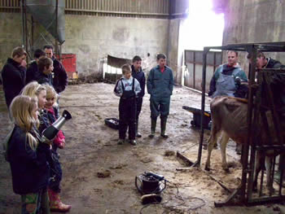
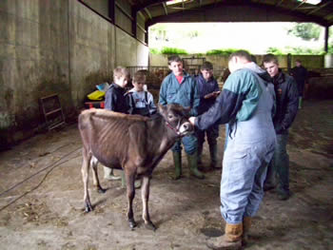
17 young members ranging from 5 to 26 years old spent the day learning how to wash, clip, top-line and handle calves for the showring as well as learning about the main points of the Jersey cow.
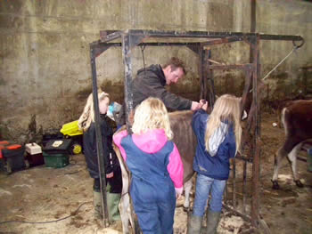
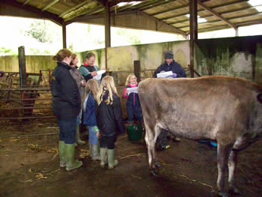
Instruction came from some of the area's leading show men & women; Helen Cox (Glanmor), Mark Williams (Lyganlan), Sian Phillips (Fryn), Helen Evans (Nicel) & Iwan Morgan (Erie).
