Scottish Jersey Cattle Club
Scottish Jersey Cattle Club
Chairman
Ian Heuchan
Gerranton Farm
Castle Douglas
DG7 3EW
Tel: 01556 504569
iheuchan67@gmail.com
ARCHIVE REPORT
2015 Calf Show - Sunday 27th September 2015
Judge, Mr Glyn Lucas, Carlisle.
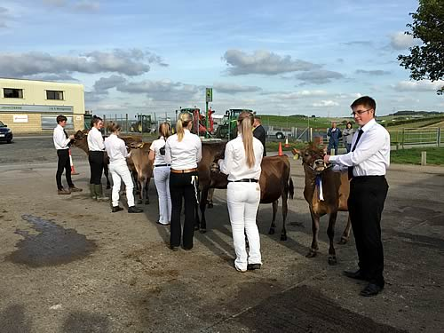
Showmanship Class: (Seven Entries)
1st Douglas Buchanan
2nd Alison Hunter
3rd Izzy Wright.
Calf Classes:
Calf Born Between 1st September 2014 And 28th February 2015: (five entries)
1st Alison Hunter, (Clydevalley Joel Celadine)
2nd Robert Buchanan (Tintoview Excitation Leanne, led by Douglas Buchanan)
3rd Robert Buchanan (Tintoview On Time Harvest)
Calf Born Between 1st May And 31st August 2014 (two entries)
1st Brian Yates (Logan Tequila Glamour, led by Izzy Wright)
2nd Robert Buchanan (Tinto May Blondie, led by Douglas Buchanan)
Calf Born Between 1st January and 30th April 2014 (five entries)
1ST Wellhouse Jerseys (Wellhouse Governor Sally 3 led by Mark McColm)
2nd Messrs Heuchan (Gerranton Valentino Hairy Scary, led by Emma Struthers)
3rd Wellhouse Jerseys (Wellhouse Governor Spry 2)
Champion: Logan Tequila Glamour from Brian Yates of Castle Douglas and shown by Izzy Wright.
Reserve Champion: Wellhouse Governor Sally 3 from Wellhouse Jerseys, Kirkcolm, Stranraer and shown by Mark McColm.
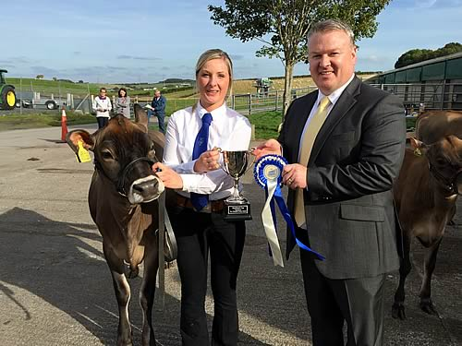
CAPTION: Champion Logan Tequila Glamour shown by Izzy Wright with Glyn Lucas Judge
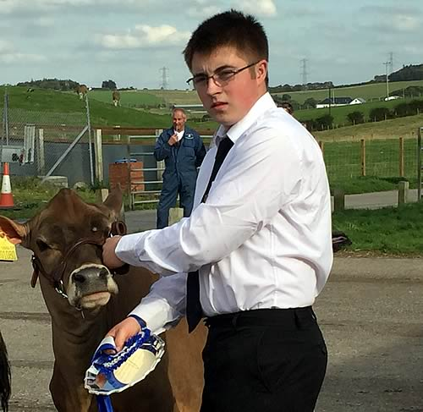
CAPTION: Reserve Champion Wellhouse Governor Sally 3 shown by Mark McColm
2013 Scottish Jersey Club Calf Show
Champion (Showmanship): Alison Hunter, West Tarbrax, Shotts
Reserve: Megan Heuchan, Gerranton, Castle Douglas
Champion Calf: "Tintoview Governor Leanne" shown by Douglas Buchanan, Laigh Kilphin, Ballantrae
Reserve Calf: "Clydevalley Governor Flora 2nd" shown by Alison Hunter, West Tarbrax, Shotts.
2009 Scottish Jersey Cattle Club
Top Jersey herds in Scotland – year to 30 September 2009
1. Robert Hunter, West Tarbrax, Shotts, Lanarkshire (27131)
• 18 cows, 6810kg, 634kg CFP
2. Alderston Farming, Alderston Mains, Haddington, East Lothian (60308)
• 182 cows, 6205kg, 587kg CFP
3. CMA Haigh, Airyhemming, Glenluce, Newton Stewart (10391)
• 110 cows, 5481kg, 563kg CFP
4. Messrs D Bunting and Son, Midtown, New Abby Road, Dumfries (11033)
• 18 cows, 5469kg, 562kg CFP
5. R and N Groat, Bishopston, Port Lethen, Aberdeenshire (70210)
• 17 cows, 5371kg, 545CFP
Top Jersey Cows in Scotland – year to 30 September 2009
1. J and R Hunter, West Tarbrax, Shotts, Lanarkshire (27131)
• Grahmar Sambo Twinkle, EX92, lactation 4, calved 12/03/08, 11,046kg, 1058kg CFP
2. J and R Hunter, West Tarbrax, Shotts, Lanarkshire (27131)
• Clydevalley Julian Flora VG89, lactation 2, calved 15/11/08, 10,078kg, 898kg CFP
3. Alderston Farming, Alderston Mains, Haddington, East Lothian (60308)
• Alderston Paramount Crocus GP83, lactation 4, calved 16/11/08, 9738kg, 895kg CFP
4. Alderston Farming, Alderston Mains, Haddington, East Lothian (60308)
• Alderston Impuls Pal GP82, lactation 3, calved 29/11/08, 9106kg, 872kg CFP
5. Alderston Farming, Alderston Mains, Haddington, East Lothian (60308)
• Alderston Paramount Flora VG85, lactation 3, calved 23/12/07, 9730kg, 864kg CFP
Top Jersey Heifers in Scotland – year to 30 September 2009
1. Alderston Farming, Alderston Mains, Haddington, East Lothian (60308)
• Alderston Maca Mallow GP80, calved 21/01/08, 7534kg, 703kg CFP
2. Alderston Farming, Alderston Mains, Haddington, East Lothian (60308)
• Alderston McCallum Fig, VG85, calved 07/10/08, 6902kg, 699kg CFP
3. Alderston Farming, Gordon Hastie, Alderston Mains, Haddington, East Lothian (60308)
• Alderston McBeth Sloe, GP81, calved 13/07/08, 7471kg, 684kg CFP
4. Alderston Farming, Alderston Mains, Haddington, East Lothian (60308)
• Alderston Action Marjoram, GP82, calved 07/06/08, 6532kg, 675kg CFP
5. Alderston Farming, Alderston Mains, Haddington, East Lothian (60308)

2008 Scottish Jersey Cattle Club
Top 10 herds in Scotland (year end 30th September 2008)
1. Robert Hunter, West Tarbrax, Shotts, Lanarkshire (27131)
20 cows, 6789kg, 5.50% Bf, 3.94% P, 641kg CFP.
2. Gordon Hastie, Alderston Mains, Haddington, East Lothian (60308)
177 cows, 6582kg, 5.36% Bf, 3.98% P, 615kg CFP.
3. CMA Haigh, Airyhemming, Glenluce, Newton Stewart (10391)
165 cows, 5331kg, 6.46% Bf, 4.26%P, 571kg CFP.
4. Grahams Dairies, Boquhan Home Farm, Kippen, Stirlingshire (34501)
218 cows, 5935kg , 5.53% Bf, 4.01% P, 566kg CFP.
5. TC McCreath and Co, Garlieston Home Farm, Newton Stewart (67883)
45 cows, 7522kg, 4.00% Bf, 3.39% P, 556kg CFP.
Top 10 Heifers
1. Grahams Dairies, Boquhan Home Farm, Kippen, Stirlingshire (34501)
Strathallan Master Willow, calved 01/04/07 6972kg, 6.08% Bf, 3.84% P, 305 days, 691kg CFP.
2. Gordon Hastie, Alderston Mains, Haddington, East Lothian (60308)
Alderston Jace Daffodil, GP84 calved 02/01/07 7835kg, 4.99% Bf, 3.72% P, 305 days 683kg CFP.
3. Grahams Dairies, Boquhan Home Farm, Kippen, Stirlingshire (34501)
Strathallan Master Model, calved 17/12/06 6860kg, 5.73% Bf, 4.05%P, 305 days, 671kg CFP.
4. Gordon Hastie, Alderston Mains, Haddington, East Lothian (60308)
Alderston Impuls Valerie GP82, calved 06/10/07 7581kg, 4.96% Bf, 3.87% P, 305 days, 669kg CFP.
5= JR Heuchan and Son, Gerranton, Castle Douglas, Dumfries (93840)
Gerranton Shakira, calved 15/12/06 6621kg, 5.98% Bf, 4.08% P, 305 days, 666kg CFP.
5= Gordon Hastie, Alderston Mains, Haddington, East Lothian (60308)
Alderston Paramount Dora, F68, calved 17/04/07 7304kg, 5.29% Bf, 3.83% P, 305 days 666kg CFP.
7= Grahams Dairies, Boquhan Home Farm, Kippen, Stirlingshire (34501)
Strathallan Impuls Freda calved 03/01/07 7459kg, 4.90% Bf, 3.90% P, 305 days, 656kg CFP.
7= Gordon Hastie, Alderston Mains, Haddington, East Lothian (60308) Alderston Jace Maria, calved 14/09/07 8007kg, 4.65%Bf, 3.54% P, 305 days, 656kg CFP.
9= Gordon Hastie, Alderston Mains, Haddington, East Lothian (60308) Alderston Macallister Mavis, VG85, calved 14/01/07 6698kg, 5.62% Bf, 3.98% P, 305 day 643KG CFP.
9= CMA Haigh, Airyhemming, Glenluce, Newton Stewart (10391)
Glenbay Hallmark Marjorie, calved 03/08/07 6687kg, 5.87% Bf, 3.76% P, 305 days, 643kg CFP.

