North East Jersey Cattle Club
President
Sue Heath
Chairman
Maurice Richardson
Vice Chairman
Wilf Gill
Treasurer
Edward Sugden
Secretary
Helen Stanier
JL Shaw and Son
Grey Leys Farm
Elvington
York
YO41 4AX
Tel: 07702 404289
greyleysfarm@hotmail.co.uk
ARCHIVE REPORT
2019
North East of England Jersey Cattle Club Show 2019
Saturday 18th May 2019
Judge: Mr Ben Etteridge
JUNIOR CALF, born after 1st January 2019
1st Saxown Victorious Heidi 27 - The Saxby Family
2nd Knayton Precision Golden Girl - Mrs PA Crosby
3rd Greyleys Devinci Lionbar - JL Shaw & Son
JUNIOR CALF, born between 1st September 2018 & 31st December 2018
1st Knayton Chief Special Pride Girl - Mrs PA Crosby
2nd Greyleys Dazzler Hannah 57 - JL Shaw & Son
3rd Greyleys Devinci Alpen - JL Shaw & Son
INTERMEDIATE CALF, born between 1st May & 31st August 2018
1st Saxown Barcelona Cash 100 - The Saxby Family
2nd Cherryview J Viral Lacey - Mrs J Waring
3rd Knayton Valiant Dazzler - Mrs PA Crosby
SENIOR CALF, born between 1st January & 30th April 2018
1st Cherryview Viral Pastime - Mrs J Waring
2nd Greyleys Broiler Perrie - JL Shaw & Son
3rd Greyleys Chili Annette 185 - JL Shaw & Son
CHAMPION Cherryview Viral Pastime
RESERVE CHAMPION Saxown Barcelona Cash 100
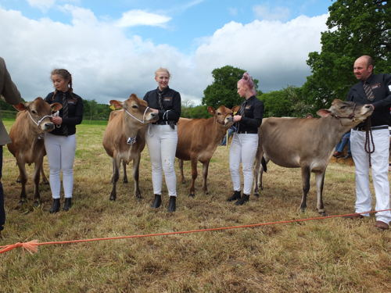

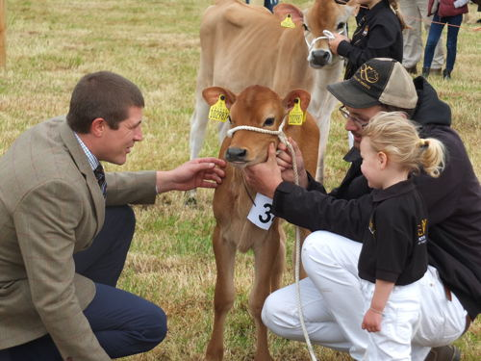

2018 North East All Breeds Calf Show
Sunday 16th September 2018
ALL BREEDS SHOWMANSHIP CLASSES
Judge: Mr Ross Murray
CHAMPION Bethany Waller
RESERVE CHAMPION Levina Bell
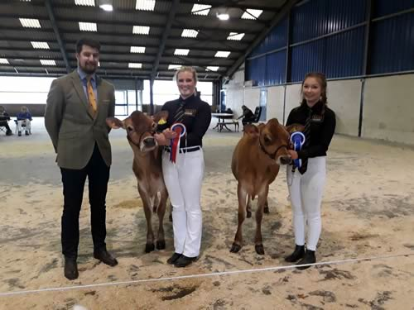
Showmanship
JERSEY CALF CLASSES
Judge: Mr Grant Woodburn
JERSEY CALF, born after 1st March 2018
1st Greyleys Broiler Del Ivory 205 - JL Shaw & Son
2nd Knayton Valiant Star - PA Crosby
JERSEY CALF, born between 1st December 2017 & 28th February 2018
1st Greyleys Chili Annette 185 - JL Shaw & Son
JERSEY CALF, born between 1st September 2017 & 30th November 2017
1st Firlands Blaze Lassie 2 - Mrs G Barker
2nd Regatta Geno Jane - GW & M Coates
JERSEY CALF, born between 1st May 2017 & 31st August 2017
1st Bayview Chrome Thyme - Enchanted Holsteins
2nd Knayton Precision Showstopper Girl - PA Crosby
JERSEY CALF, born between 1st November 2017 & 30th April 2017
1st Greyleys Joel Sway - JL Shaw & Son
BREED CHAMPION Bayview Chrome Thyme
RESERVE BREED CHAMPION Firlands Blaze Lassie 2
OVERALL INTERBREED Bayview Chrome Thyme
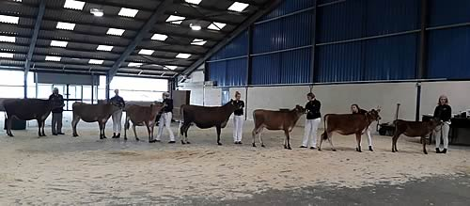
CAPTION; Championship Line Up
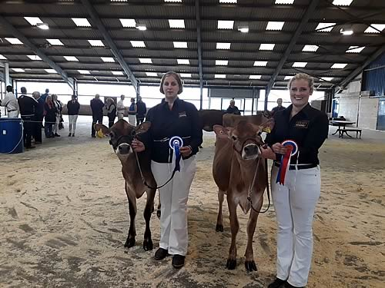
CAPTION: Championship
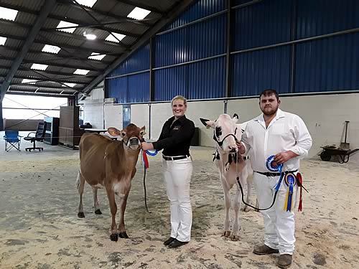
CAPTION: Interbreed Champion Bayview Chrome Thyme

2018 North East of England Jersey Cattle Club Show
Sunday 27th May 2018
Judge: Ms S Liddle
SENIOR HANDLER
1st Levina Bell
2nd Laura Crosby
JUNIOR HANDLER (aged 7-12 years)
1st Faith Davidson
2nd Maisy Flanagan
JUNIOR HANDLER (aged 6 & under)
1st Jake Waring
2nd Oscar Drake
CHAMPION HANDLER Levina Bell
JUNIOR CALF, born after 1st January 2018
1st Greyleys Chili Annette 185 - JL Shaw & Son
2nd Greyleys Lemonhead Annette 187 - JL Shaw & Son
3rd Gilbrook Barcelona Prance - The Richardson Family
JUNIOR CALF, born between 1st September 2017 & 31st December 2017
1st Gilbrook Barcelona Dolly - The Richardson Family
2nd Gilbrook MRT Drizzle - The Richardson Family
3rd Cherryview Joel Gemini - Mrs JM Waring
INTERMEDIATE CALF, born between 1st May 2017 & 31st August 2017
1st Cherryview Legal M Lacey - Mrs JM Waring
2nd Aireview Wizard Ruby - D Minish & G Fort
3rd Greyleys Link Del Ivory 193 - JL Shaw & Son
SENIOR CALF, born between 1st January 2017 & 30th April 2017
1st Cherryview Legal Lacey - Mrs JM Waring
2nd Greyleys Joel Sway - JL Shaw & Son
3rd Ravenfield Susie 5 - Ravenfield Jerseys
CHAMPION CALF Gilbrook Barcelona Dolly
RESERVE CHAMPION CALF Cherryview Legal M Lacey

North East All Breeds Calf Show 2017
Sunday 17th September 2017
YOUNG HANDLERS
“A great turnout for all ages, well done to everyone who entered the interbreed classes”
12 Years & Under Emily & Bethany Wood
13 – 15 Years Stella Chapman & Levina Bell
16 – 20 Years Ami Stanier
21 – 26 Years Laura Crosby
CHAMPION JERSEY HANDLER Stella Chapman
RESERVE CHAMPION JERSEY HANDLER Levina Bell

CHANNEL ISLAND CLASSES
Judge: Mr Tom Saxby
CALF, born after 1st March 2017
1st Brymor Wesward 57 - Brymor Dairy
2nd Knayton Yegabomb Will Do - Pam Crosby
3rd Greyleys Lemonhead Del Ivory 190 - JL Shaw & Son
CALF, born between 1st December 2016 and 28th February 2017
1st Knayton Braveheart Rosanta - Pam Crosby
2nd Ravenfield Maple 5 - Ravenfield Jerseys
3rd Greyleys Colton Edie - JL Shaw & Son
CALF, born between 1st September 2016 and 30th November 2016
1st Greyleys Legal Autumn Gem - JL Shaw & Son
2nd Knayton Precision Rose Marie - Pam Crosby
3rd Cherryview Joel Lacey - Waring Family
CALF, born between 1st May 2016 and 31st August 2016
1st Cherryview Colton CH Lacey - Waring Family
2nd Brymor Meadowsweet 94 - Brymor Dairy
3rd Greyleys Colton Jersey Gem - JL Shaw & Son
CALF, born between 1st January 2016 and 30th April 2016
1st Honeyfields O Let’s Dance - J & G Robinson
2nd Greyleys Olympian Hope 6 - JL Shaw & Son
3rd Greyleys Husky Charm - JL Shaw & Son
CHANNEL ISLAND CHAMPION
Greyleys Legal Autumn Gem - JL Shaw & Son
CHANNEL ISLAND RESERVE CHAMPION
Cherryview Colton CH Lacey - Waring Family

2016 North East Jersey Cattle Club
Yorkshire Milk Records Competition 2016
Judge: - Charles Reader, Evenley, Brackley
MANAGEMENT INSPECTION CLASS |  | The “Normanby” Challenge Cup
Scale of points as for County Championship |  | 5 Entries
Competitor |  | Lacs | Yield | F+P | CI | Cells | - | Ins pts | Total pts
1 | R J & C A Saxby | 70 | 5550 | 507 | 369 | 98 | 1231 | 1490 | 2721
2 | G M & A J Harrison | 106 | 5543 | 506 | 400 | 149 | 1116 | 1440 | 2556
3 | G B Corner & Son | 163 | 6855 | 647 | 416 | 113 | 1472 | 1080 | 2552
4 | J & E Dickinson | 273 | 5704 | 564 | 414 | 180 | 1172 | 1200 | 2372
5 | J L Shaw & Son | 288 | 4860 | 457 | 390 | 243 | 826 | 1250 | 2076

COWS & HEIFERS |  |  | YOUNG STOCK
The “Jersey Herd” Challenge Cup |  |  | The “Page Feeds” Challenge Cup
5 Entries |  |  | 5 Entries
1 | R J & C A Saxby | 98 | 1 | G M & A J Harrison | 92
2 | G M & A J Harrison | 96 | 2 | R J & C A Saxby | 90
3 | J L Shaw & Son | 88 | 3 | J & E Dickinson | 85
4 | J & E Dickinson | 85 | 4 | G B Corner & Son | 83
5 | G B Corner & Son | 80 | 5 | J L Shaw & Son | 80

BEST COW |  | The “Longley” Challenge Cup
5 Entries
1 | R J & C A Saxby | Saxown Excalibers Daylight 3 | 94
2 | G M & A J Harrison | Hillside Laser’s Ann | 93
3 | G B Corner & Son | Danish Hakea DJHB | 91
4 | J L Shaw & Son | Greyleys Pascalia | 90
5 | J & E Dickinson | Holmfirth Sultan Joyce | 89
BEST HEIFER |  | The “Carrs” Shield
5 Entries
1 | G M & A J Harrison | Hillside Action Leanna | 91
2 | R J & C A Saxby | Saxown Connection Éclair | 90
3 | J & E Dickinson | Holmfirth Paramount Olivia | 87
4 | G B Corner & Son | Harlsey Paramount Crester | 86
5 | J L Shaw & Son | Greyleys Brooklane | 85
BULL PROGENY GROUP |  | The “Jersey Progeny” Challenge Cup
4 Entries
1 | R J & C A Saxby | G I Pratt Belles Connection | 94
2 | G M & A J Harrison | Glen Forest Avare Action | 92
3 | J & E Dickinson | Lester Sambo | 87
4 | J L Shaw & Son | Jazz Hot | 83
BEST COW FAMILY |  | The “Shilleto” Challenge Cup
4 Entries
1 | G M & A J Harrison | Hillside Leanna Family | 94
2 | R J & C A Saxby | Saxown Centurions Cash Family | 92
3 | J L Shaw & Son | Greyleys Flamboyancy Family | 85
4 | J & E Dickinson | Rochelle Family | 83
EURA AUDIT UK COUNTY CHAMPIONSHIP
HERD MANAGEMENT INSPECTION CLASS Judge: - Lisa Walker
The “Eura Audit UK” Yorkshire Supreme Challenge Trophy 16 Entries
Inspection |  | 1,500 points |  | C I | 2 pts deducted for each day CI is over 400 & 2 points added for each day under
Wt of Fat/protein |  | 2 pts per kg Holsteins, 2.5 pts Ayrshires & Jerseys, others 3 points |  | Cells | 1 pt deducted for each 1,000 cells up to 150,000  2 pts for next 1,000 up to 250,000, then 3 pts
Competitor |  |  | Lacs | Yield | F+P | C I | Cells | Ins pts | Total
1 | R J & C A Saxby | J | 70 | 5550 | 507 | 369 | 98 | 1500 | 2731
BEST HERDS PERSON The “Miss Mitchell” Challenge Cup Richard Saxby
BEST ON INSPECTION The “Hindmarsh” Challenge Cup R J & C A Saxby
BEST COLOURED HERD The “Lloyds Animal Feeds” Trophy R J & C A Saxby
THE EFFICIENT MILK PRODUCTION CLASS Judge: - Dr, Richard Wynn
The “Lloyds TSB Agriculture” Challenge Cup 5 Entries
The most efficient milk producer based on land usage, labour, capital, housing plus management
=2 | G M & A J Harrison

CLASS FOR BEST HERD OVERALL on CALVING INDEX, CELLS, FAT & PROTEIN
The best 2008/9 herd on County Championship scale
Competitor |  | C I | Cell | F+P | Pts
1 | G B Corner & Son | 416 | 113 | 647 | 1472

MOST IMPROVED HERD FAT & PROTEIN |  |  |  | The “Burnhill” Challenge Cup
Highest Herd Average Fat & Protein Increase
8 Entries
Competitor |  | 08 FP | 09FP | Inc.
1 | R J & C A Saxby | 461 | 507 | +46
=2 | G B Corner & Son | 606 | 647 | +41
=2 | J & E Dickinson | 523 | 564 | +41

2016 North East Jersey Cattle Club Calf Show
A wonderful day was had by all the North East Jersey Cattle Club Calf Show held on Sunday 29 May 2016.
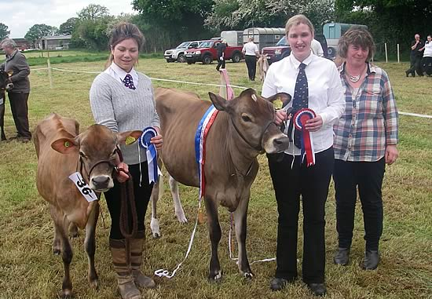
CAPTION: Judge Yvonne Raven presenting Champion Ravenfield Susie 3 from J & S Heath and reserve Cherryview Valentino Lacey from Mrs JM Waring.
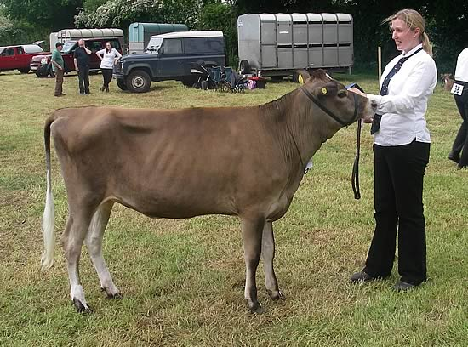
CAPTION: Champion Calf from John and Sue Heath's Ravenfield Jerseys. Ravenfield Susie 3 by Tequila shown by Lindsay Wood.
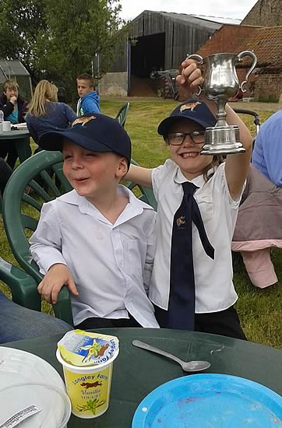
CAPTION: Junior handlers enjoying the North East Jersey Club Calf Show
Photos courtsey of Becky Waring
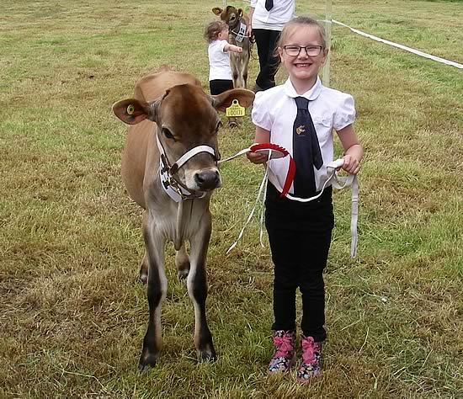
CAPTION; Faith Davidson (age 6) winning the Junior Showmanship class

