Cornish Jersey Cattle Club
Chairman:
Martin Williams
Secretary:
Lisa Hopwood
48 Kensey Valley Meadow
Launceston
Cornwall
PL15 9TJ
Tel: 07772 976935
lisa.hopwood@cogentuk.com
ARCHIVE REPORTS
CORNWALL CLUB HERD COMPETITION 2019
Judge: Mr Godfrey Hosking
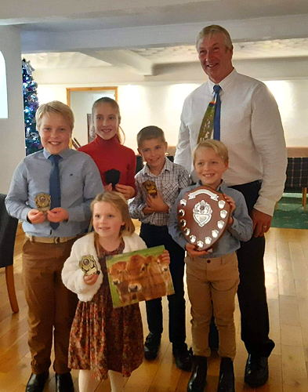
Cornish Young Breeders
MAIDEN HEIFER, 12-18 months of age
The Cardell Cup
1st Honeyfields Tequila Lets Dance Again - DW & GN Renfree
2nd Quintrell Christoph Fate - Michael, Claire & Jenny Colwell
3rd Justafew Headliner M Cornflower - Peter & Louise Phillips
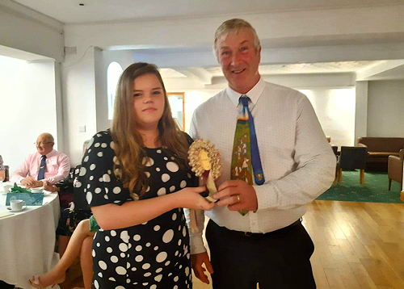
Abi Brotheridge - Justafew
HEIFER, in calf
Pennance Cup
1st Justafew Viceroy Ulex - Peter & Louise Phillips
2nd Honeyfields Lets Barn Dance - DW & GN Renfree
3rd Trenithon Lemonhead Amanda - Trenithon Farm
HEIFER, in milk
Sandquay Marget Cup
1st Quintrell Costus Irma - Michael, Claire & Jenny Colwell
2nd Mydrim Tequila Tara - DW & GN Renfree
3rd Trerose Chief Nell - David Christophers
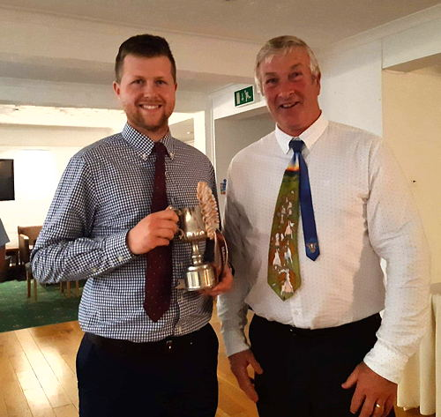
Ryan Renfree - Hayvalley
DRY COW
BOCM Tankard
1st Futuredreams Tequilas Flash Tracy - DW & GN Renfree
2nd Trenithon Topeka Cornet - Trenithon Farm
3rd Lynfield Charm - KJ & A Basher
JUNIOR COW, in milk
Anniversary Tankard
1st Hennikers Global Fan Milki - DW & GN Renfree
2nd Quintrell Spectrum Dianna - Michael, Claire & Jenny Colwell
3rd Trenithon Topeka Fire - Trenithon Farm
SENIOR COW, in milk
Founders Cup
1st Ansom On Time Melba - DW & GN Renfree
2nd Quintrell Ballard Devotional - Michael, Claire & Jenny Colwell
3rd Westmill Jupiter Christina - Gwavas Jerseys
GROUP OF THREE, same sire or from the same dam
Ross Cup
1st Michael, Claire & Jenny Colwell - Quintrell Maximus Cobalt
2nd Westmill Jerseys - Danish DJ Broiler
3rd Trenithon Farm - Steinhauers Samson Lemonhead
PRODUCTION & INSPECTION
Montrose Perpetual Tankard
1st Ansom On Time Melba - DW & GN Renfree
2nd Quintrell Reagan Scarlet - Michael, Claire & Jenny Colwell
3rd Quintrell Mohican Delight - Trenithon Jerseys
LIFETIME PRODUCTION
Trevine Cup
1st Quintrell Cobalt Osprey - Michael, Claire & Jenny Colwell
2nd Bojewyan Gentian - FE & EM Murley & Sons
3rd Sunnydawn Rocket Kiesemite - Trenithon Farm
DAM & DAUGHTER
Gunn Shield
1st Quintrell May Dina & Quintrell Spectrum Diana - Quintrell Jerseys
2nd Westmill Snowflake & Westmill Snowball - Gwavas Jerseys
3rd Sunnydawn Rocket Kiesemite & Trenithon Olympic Cornet - Trenithon Farm
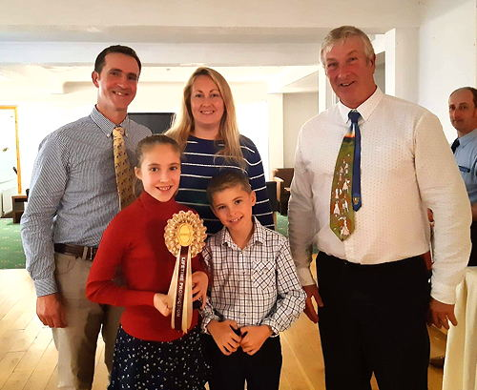
The Colwell Family - Quintrell
LARGE HERD
Basil Magic Cup
1st Quintrell Herd - Michael, Claire & Jenny Colwell
2nd Levant Herd - FE & EM Murley & Son
3rd Bojewyan Herd - FE & EM Murley & Son
MEDIUM HERD
Braywood Cup
1st Trenithon Herd - Trenithon Farm
2nd Westmill Herd - Gwavas Jerseys
3rd Lynfield Herd - KJ & A Basher
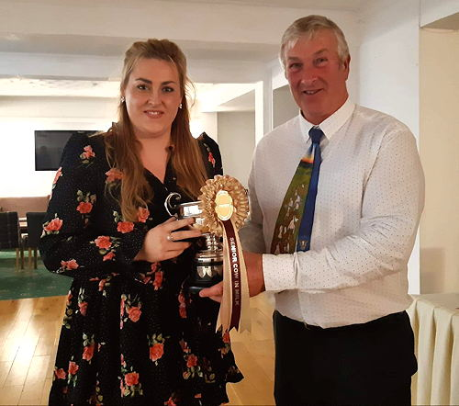
Rachel Abrahall - Hayvalley
SMALL HERD
Trenithon Churn
1st Hayvalley Herd - DW & GN Renfree
2nd Justafew Herd - Peter & Louse Phillips
3rd Trengilly Herd - AJ Carter
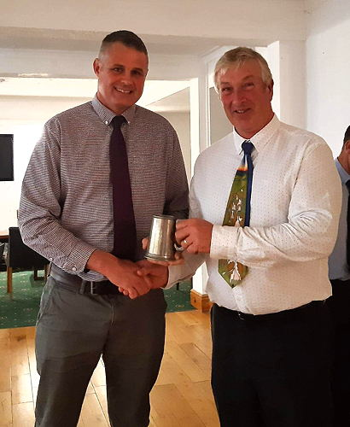
David Renfree - Hayvalley
MOST POINTS
1st DW & GN Renfree
1st Michael, Claire & Jenny Colwell
2nd Trenithon Farm
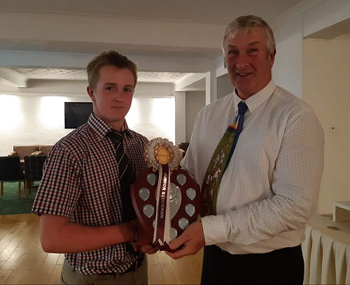
Owen Williams, Trenithon
JUNIOR STOCKMAN
AE Roddas & Son Shield
Owen Williams Trenithon
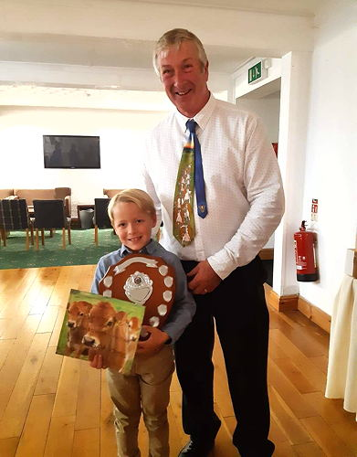
Sam Johns
JUNIOR MEMBER OF THE YEAR (Under 15)
East Lanescot Trophy
Sam Johns - Trenoweth
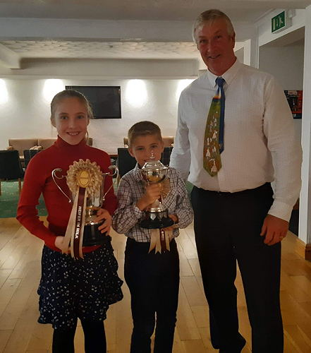
Ellen & Henry Colwell with judge Godfrey Hosking

Cornish Jersey Club Herd Competition 2018
Judge: Mr J Pollard

MAIDEN HEIFER, 12-18 Months (Cardell Cup)
1st Olympic Tequila Milki - David & Ryan Renfree
2nd Cardinney Impression Yorkie - JR Warren
3rd Justafew Joel Victory - Louise & Peter Phillips
INCALF HEIFER (Pennance Cup)
1st Cardinney Napoleon Claire 5 - JR Warren
2nd Trengilly Valentino Crimson - AJC Carter
3rd Trenithon Oliver Decirium - The Williams Family
HEIFER IN MILK, calved under 2 years & 6 months (Sandquay Margaret Cup)
1st Justafew Rodme Unite - Louise & Peter Phillips
2nd Cardinney Topeka Naomi 7 - JR Warren
3rd Trengilly Chief Waltz - AJC Carter

BEST EXHIBITOR BRED HEIFER Justafew Rodme Unite

DRY COW (BOCM Tankard)
1st Cardinney Big Boy Honey 2 - JR Warren
2nd Bojewyan Tinker - FE & EM Murley & Sons
3rd Trengilly Moment Melody 6 - AJC Carter
JUNIOR COW, in milk, 2 or 3 lactations (Anniversary Tankard)
1st Cardinney Vanahlem Cash - JR Warren
2nd Callestock Sam Saturn Victory - Louise & Peter Phillips
3rd Quintrell Tequila Imagine - Michael, Claire & Jenny Colwell
SENIOR COW, in milk, 4 or more lactations (Founders Cup)
1st Sowden Hilux Miranda - JR Warren
2nd Quintrell Winsford Darena - Michael, Claire & Jenny Colwell
3rd Winklands Completes Annette 135 - AJC Carter

GROUP OF THREE, same Sire or from the same Dam (Ross Cup)
1st Daughters of Pannoo Abe Vanahlem - JR Warren
2nd Daughters of Goldust Karbala Ladd - Michael, Claire & Jenny Colwell
3rd Daughters of Devichoys Pioneering Sam - Louise & Peter Phillips
PRODUCTION & INSPECTION (Montrose Perpetual Tankard)
1st Hennikers Global Fan Milki - David & Ryan Renfree
2nd Cardinney Seniors Winner - JR Warren
3rd Quintrell Elton Minstrell - Michael, Claire & Jenny Colwell
LIFETIME PRODUCTION (Trevine Cup)
1st Bojewyan Dee 13th Lactation - FE & EM Murley & Sons
2nd Bojewyan Frisky 12th - FE & EM Murley & Sons
3rd Quintrell May Gingermint - Michael, Claire & Jenny Colwell
DAM & DAUGHTER (Gunn Shield)
1st Cardinney Belmonts Naomi 3 and Cardinney Topeka Naomi 7 - JR Warren
2nd Quintrell May Dina and Quintrell Spectrum Dianna - Michael, Claire & Jenny Colwell
3rd Sunnydawn Rocket Kieserite and Trenithon Topeka Cornet - The Williams Family
LARGE Herd
1st Quintrell Jerseys
2nd Levant Herd
3rd Bojewyn Herd
MEDIUM Herd
1st Cardinney Herd
2nd Trenithon Herd
SMALL Herd
1st Justafew Herd
2nd Trengilly Herd
3rd Hayvalley Herd
MOST POINTS
1st JR Warren
2nd Michael, Claire & Jenny Colwell
3rd Louise & Peter Phillips
JUNIOR STOCKMAN OF THE YEAR, 16-21 Years of age (AE Rodda & Son Shield)
Owen Williams

2018 Social Evening
The Cornish Club recently held a fantastic Social evening on Saturday 7th July by kind permission of Wayne Jeffery, "Carvinack Jerseys".
Club Members and guests took part in Rounders & a lovely BBQ which provided a great opportunity for a mid-summer catch-up.
Thank you to Wayne, Lisa, Martin, Leeza and Cornish Club members for all of your efforts in creating a great evening.
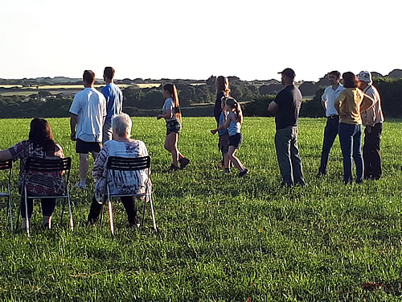

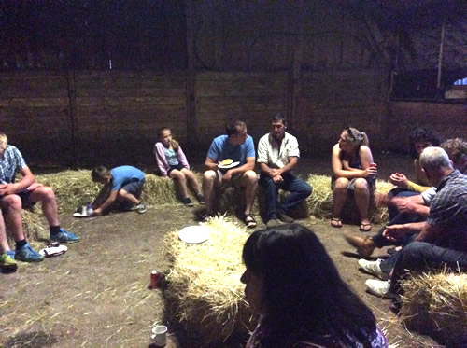
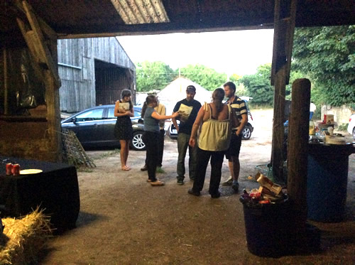
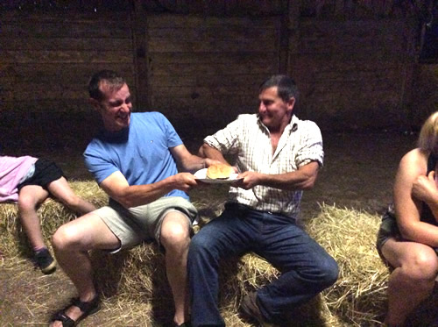
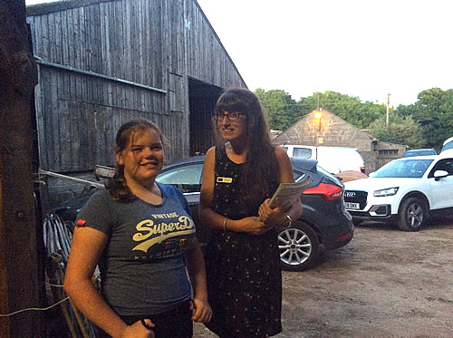
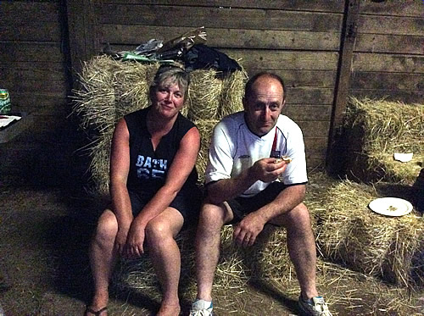

2015 Cornish Jersey Cattle Club Farm Walk
On Saturday the 20th June 2015, the Wiliams family, Trenithon Farm, Helston, Cornwall kindly hosted a farm walk and pasty lunch. We had a great turn out of farmers and the weather held out for a fantastic day.
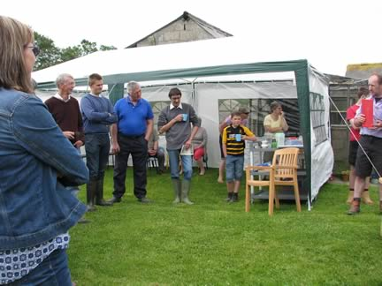
We started the day by going to visit the incalf heifers followed by a pasty lunch and homemade cake made by Leeza Williams.
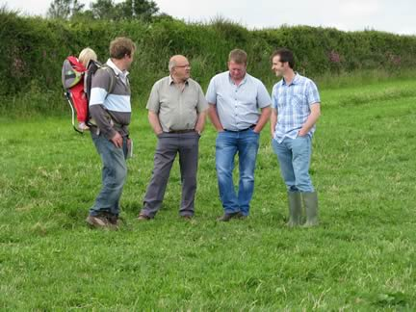
Sponsors included For Farmers, Harpers Home Mix, Head and Head Vets and Cogent. It was a great time for everyone to catch up and socialise.
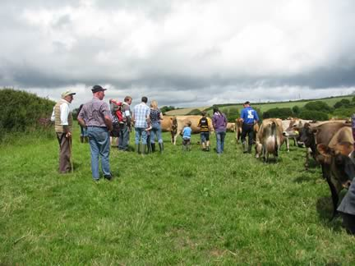
After lunch we headed out to see the main herd and dry cows. The Williams Family used to run a pedigree Holstein Herd of 90 cows and bought their first jerseys in November 2010 to help increase Butterfat and Protein in the herd. They continued to add a few each year until during the winter of 2012 when they decided to change over to a complete pedigree jersey herd. They recently classified for the first time and the results were 10EX 16VG 17GP & 3G.
Thankyou to the Williams family for a great day.

2014 Cornish Jersey Club Herd Competition
The Cornish Jersey Club held their on farm herd competition which was kindly judged by Mr Matthew Jenkin, Boderlogan Farm, Trenear, Helston, Cornwall. The Awards were presented on October 18th at the Clubs annual dinner held at the Sandy Lodge Hotel, Newquay.
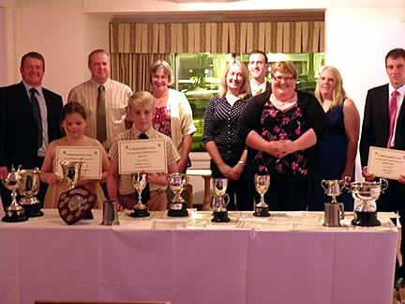
CAPTION: Herd Competition 2014 Prizewinners
Class 1 – Senior Cow in Milk 4 or more lactations (9 entered)
Founders Cup
1st JR & SM Warren, Tredinney Farm
Glanmor Julian Winc
2nd Mike & Claire Colwell, Glyn Crest Farm
Quintrell Iatola Inform
3rd A J C Carter, Trengilly Farm
Winkland Completes Annette 135 EX92
3rd Liz Nattle
Roselle Symphony
Class 2 –Junior Cow in Milk 2 or 3 lactations (7 entered)
Anniversary Tankard
1st Mike & Claire Colwell, Glyn Crest Farm
Quintrell Reagan Scarlett
2nd JR & SM Warren, Tredinney Farm
Glanmor Bigstone Pineapple
3rd Mr & Mrs Basher, Trelyn Farm
Lynfield Aero
Class 3 - Dry Cow (6 entered)
BOCM TANKARD
1st JR & SM Warren, Tredinney Farm
Sunnydawn Horatio Lottie
2nd AJC Carter, Trengilly Farm
Trengilly Dulcie VG 86
3rd C E A Williams & Son, Trenithon Farm
Ritherdens 1689 Ace
Class 4 – Maiden Heifer 12-18 months (5 entered)
CARDELL CUP
1st – JR & SM Warren, Tredinney Farm
Cardinney Flash Naomi 4
2nd – AJC Carter, Trengilly Farm
Trengilly Engage Dulcie
3rd – Abi Brotheridge
Richtop Supernova Borage 2
Class 5 – Heifer in Calf (8 entered)
PENNANCE CUP
1st - Mike & Claire Colwell, Glyn Crest Farm
Quintrell Reagan Annabella
2nd -JR & SM Warren, Tredinney Farm
Cardinney Governor Hettie 3rd
3rd- Mr & Mrs Basher, Trelyn Farm
Lynfield Hope

Class 6 – Heifer in Milk calved under 2yr 6 months (9 entered)
SANDQUAY MARGARET CUP
1st David Christophers
Trerose Cobalt Nell
2nd JR & SM Warren, Tredinney Farm
Cardinney Belmont Wishless
3rd Mike & Claire Colwell
Quintrell Cobalt Garland
3rd F.E & E M Murley & Sons
Bojewyan Bigshow Noddy
Class 7 - Group of Three either by the same sire or out of same dam (7 entered)
ROSS CUP
1st JR & SM Warren, Tredinney Farm
Valley Stream Julian
2nd Mike & Claire Colwell, Glyn Crest
Quintrell Iatola Inform
3rd F E & E M Murley & Sons, Bojewyan Farm
Hollylane Lilibet Legacy
Class 8 – Production & Inspection Class (7 entered)
MONTROSE PERPETUAL TANKARD
1st JR & SM Warren, Tredinney Farm
Sunnydawn Horatio Lottie
2nd Mike & Claire Colwell, Glyn Crest Farm
Quintrell Charismatic Moll EX92 (2E)
3rd Mr & Mrs K Basher, Trelyn Farm
Lynfield Maude
Class 9 – Lifetime Production Class (7 entered)
TREVINE CUP
1st F E & EM Murley & Sons
2nd Mike & Claire Colwell, Glyn Crest Farm
3rd AJC Carter, Trengilly Farm
Class 10 – Dam & Daughter, daughter to have at least one calf (9 entered)
1st Mike & Claire Colwell
Quintrell Sultan Datastream/Quintrell Mcgwire
2nd Mr & Mrs K Basher
Lynfield Dairymilk/Lynfield Aero
2nd JR & SM Warren
Glanmor Ring Christmas Wish/Cardinney Exciting Wishful
Class 11 – Large Milking Herd
BASIL MAGIC & BRAYWOOD CUPS
1st JR & SM Warren
2nd Mike & Claire Colwell
3rd F E & E M Murley
Class 11 – Small Milking Herd
1st Mr & Mrs Basher
2nd AJC Carter / 2nd Mr & Mrs Cardell
3rd C E A Williams
Class 12 – Most points in the competition
AMALEBRA CUP
1st JW & SM Warren
2nd Mike & Claire Colwell
3rd MR & Mrs K Basher

2011 Cornish Jersey Cattle Club Herd Competition
Judge: Mr Robert Stevenson
FOUNDER’S CUP – Senior cow in milk, 4 or more lactations
1st M and C Colwell Quintrell PJSM Ultra Marine
2nd J Rowe Trecanda Centurian Hannah
3rd=Devichoys Farm LTD Devichoys Lic Babs
3rd= J and SM Warren Freeland Blacky Sunset
5th Thomas family “izzy”
6th TRD Christophers Trerose Just Nell
6th AC Carter Trengilly Paragon Melody
6th JP and CA Bellringer Tregoose Sambo’s Lemon
9th ME Nattle Roselle Song
10th Cardell Family Carnance Lady
ANNIVERSARY TANKARD – Junior cow in milk, 2 or 3 lactations
1st J and SM Warren Glanmor Ring Christmas Wish
2nd Devichoys Farm LTD Devichoys Red Comet
3rd M and C Colwell Quintrell May Katrina
4th TRD Christophers Trerose Waiting Nell
5th Cardell family Carnance Julian Lady 2nd
6th Thomas family Emily
7th T Thomas Coffie
8th W Jeffery Carvinack Harvest Lotty
9th JP and CA Bellringer Tregoose Belleview Naomi
10th AC Carter Trengilly Caramel
BOCM TANKARD – Dry Cow
1st Thomas family Jess
2nd Devichoys Farm LTD Devichoys Beaty Bev
3rd JP and CA Bellringer Tregoose Julians Ellie
4th AC Carter Richan Zeus C83
5thJ and SM Warren Cardinney Sultans Hettie
6th Carvinick Impuls Nicolette
7th Cardell family Carnance Perimiters Sax
CARDELL CUP – Maiden Heifer, 12-18 months
1st M and C Colwell Quintrell Kookaburra Firethorn
2nd J and SM Warren Cardinney Belmonts Yarrow
3rd Devichoys Farm LTD Devichoys Rocky Hortense
4th Cardell family Carnance Mimi
5th W Jeffery Carvinick Amorous Starflower
6th AC Carter Trengilly Miracle Poppy
PENNANCE CUP – Heifer in calf
1st M and C Colwell Quintrell Perfecter Myfanwy
2nd J and SM Warren Tregibby Comerica Mabel
3rd AC Carter Richan Zeus
4th Cardell family Carnance
SANDQUAY MARGARET CUP – Heifer in milk, calved under 2 years 6 months
GORDON MCWILLIAM CUP for best exhibitor bred
1st TRD Christophers Trerose Perfecter Nell
2nd Devichoys Farm LTD Devichoys Show Belle
3rd ME Nattle Roselle Symphony
4th J and SM Warren Cardinney Comericas Hettie
5th J Rowe Old Kea Hannah
6th M and C Colwell Quintrell Excitation Dianne
7th W Jeffery Carvinck Perfecter Holly
8th Cardell Family Carnance
ROSS CUP – Group of three, either by the same sire or out of the same dam. The youngest animal to be at least 6 months old
1st Devichoys Farm LTD Quintrell Chosen One
2nd J and SM Warren Family Hill Ringmaster
3rd M and C Colwell Bridon Excitation
4th JP and C Bellringer Pine Haven Senior
5th Cardell family Valley Stream Julian
MONTROSE PERPETUAL TANKARD – Production and inspection class
Inspection Points: The maximum production points as declared at the time i.e. the highest cow’s production points in the entries.
Production Points:
a) 2 points for every 10kg butterfat yielded in the last completed 305-day lactation.
b) 3 points for every 10kg protein yielded in the last completed 305-day lactation.
c) 1 point deducted for every 10k cells above 150k. 1 point to be added for every 10k cells below 100k.
1st M and C Colwell Quintrell PJSM Ultra Marine
2nd J and SM Warren Glanmor Ring Christmas Wish
3rd ME Nattle Roselle Song
4th Devichoys Farm LTD Devichoys Lic Barberella
5th AC Carter Richan Zeus C83
TREVINE CUP – Lifetime production class
Production points: 10 points for every 100kg of fat and protein.
Inspection points: Maximum of 500 awarded.
1st J and SM Warren Lanhydrock Naomi
2nd M and C Colwell Quintrell PJSM Ultra Marine
3rd Devichoys Farm LTD Devichoys Amy
4th ME Nattle Roselle Song
5th AC Carter Richan Zeus C83
6th Cardell family Carnance Lady
GUNN SHIELD – Dam and daughter, daughter to have had at least 1 calf
1st J and SM Warren Glanmor Ring Christmas Wish and Cardinney Exciting Wishful
2nd J Rowe Trecanda Centurion Hannah and Old Kea Hannah
3rd Devichoys Farm LTD Devichoys Actress and Devichoys BT Angelina
4th TRD Christophers Trerose Just Nell and Trerose Perfecter Nell
5th ME Nattle Roselle Song and Roselle Symphoney
6th M and C Colwell Quintrell Sultans Soibhan and Quintrell Cobalt Soibhan
7th AC Carter Poyer Sweepstakes Melody and Trengilly Paragon Melody
BASIL MAGIC CUP - small herd
1st J and SM Warren Cardinney herd
2nd Thomas family
3rd W Jeffery Carvinick herd
4th Cardell family Carnance herd
BRAYWOOD CUP
1st M and C Colwell Quintrell herd
2nd Devichoys Farm Ltd Devichoys herd
3rd JP and C Bellringer Tregoose herd

2009 Cornish Jersey Cattle Club Herd Competition
Class 1. Founders Cup – Senior Cow in Milk
1st Mr FE & Mrs EM Murley & Sons Bowjewyan Heino Dee
2nd Mrs J & Mr & Mrs M Colwell Quintrell Sambos Nicandra
3rd Devichoys Farm Ltd Danish LH Marsha
Class 2. Anniversary Tankard – Junior Cow in Milk
1st Mrs J & Mr & Mrs M Colwell Quintrell Vindication Tweet
2nd Devichoys Farm Ltd Devichoys Cheerful
3rd Mr & Mrs J Warren Quintrell Lord Juno Nola
Class 3. BOCM Silcock Tankard – Dry Cow
1st Mr & Mrs J Warren Freeland Blackys Sunset
2nd Mrs J & Mr & Mrs M Colwell Quintrell PJSM Ultra Marine
3rd Mr FE & Mrs EM Murley & Sons Bowjewyan Lemvig Farina
Class 4. Cardell Cup – Maiden Heifer
1st Mr & Mrs J Warren Cardinney Comerica’s Yorkie
2nd Mr A Carter Trengilly Waltz
3rd
Class 5. Pennance Cup – Heifer in Calf
1st Mr & Mrs J Warren Cardinney May’s Gerbera
2nd Mr A Carter Trengilly Dulcie
3rd Mr S & Mrs R Thomas Tremeere Zik Maxey
Class 6. Sandquay Margaret Cup – Heifer in milk calved under 2 ½ Years
1st Devichoys Farm Ltd Devichoys Red Dot
2nd Mrs J & Mr & Mrs M Colwell Quintrell Ringmaster Magenta
3rd Mr & Mrs J Warren Glanmor Ring Christmas Wish
Exhibitor Bred – Gordon McWilliam Cup
Devichoys Farm Ltd
Class 7. Ross Cup – Group of Three
1st Mr & Mrs CR Cardell & Family Sire: Quintrell Chosen One
2nd Mr JP & Mrs CA Bellringer Sire: Wattlebrink Whisky
3rd Mr FE & Mrs EM Murley & Sons Sire: Bookmark
Class 8. Montrose Perpetual Tankard – Prod. & Inspect. – last full lactation
1st Mrs J & Mr & Mrs M Colwell Quintrell PJSM Ultra Marine
2nd Mr S & Mrs R Thomas Danish TM Lemvig Christensen
3rd Mr & Mrs J Warren Lanhydrock Naomi
Class 9. Trevine Cup – Lifetime Production
1st Mr A Carter Angersleigh Imperial Sam’s Waltz
2nd Mr FE & Mrs EM Murley & Sons Bojewyan Zorino Zawn
3rd Mr & Mrs J Warren Angersleigh Hero Bethsheba
Class 10. Gunn Shield – Dam & Daughter
1st Mr FE & Mrs EM Murley & Sons Bowjewyan Lemvig Cherry, Bowjewyan Hallmark Ginger
2nd Mrs J & Mr & Mrs M Colwell Quintrell Hot Maura, Quintrell Ringmaster Norah
3rd Mr A Carter Poyer Sweepstakes Melody, Trengilly Paragon Melody
Class 11. Milking Herd
Basil Magic Cup – Small Herd
1st Mr & Mrs J Warren Cardinney
2nd Mr W Jeffery Carvinack
3rd Mr & Mrs CR Cardell & Family Carnance
Braywood Cup – Large Herd
1st Mrs J & Mr & Mrs M Colwell Quintrell
2nd Mr FE & Mrs EM Murley & Sons Bojewyan
3rd Devichoys Farm Ltd Devichoy
Class 12. Amalebra Cup – Most Points in the Competition
1st Mrs J & Mr & Mrs M Colwell Quintrell
2nd Mr & Mrs J Warren Cardinney
3rd Mr FE & Mrs EM Murley & Sons Bojewyan

2009 SOUTH WEST CALF SHOW
Results
Class 1 Junior leader: Aged under 12 years on 01/01/09
1 Emily Davis 04/10/01
2 Oliver Schuster-Wood 12/07/99
3 Katherine Stidwell 18/07/01
4 Katie Davie 06/02/03
Class 2 Intermediate leader: Aged 12 to under 17 years on 01/01/09
1 Jessica Ravenhill-White 12/11/93
2 Marie Curtis 27/11/93
3 Bethan Senior 19/12/96
Class 3 Senior leader: Aged 17 to under 22 years on 01/01/09
1 Alan Carter 20/10/89
2 Jess Cardell 11/11/89
3 Kevin Davis 30/08/92
4 Joseph Herring 06/06/92
Class 4 Mature leader: Aged 22 to 26 on 01/01/09
1 Mark Davis 27/06/86
Champion Handler – Alan Carter
Reserve Champion Handler – Emily Davis
Class 5 Junior calf: Born 1st Jan 09 - 30th June 09
1 J,M & C Colwell Quintrell Viridian Daphne UK 381010 300590 27/03/09
Sire: Quintrell Whiskey Viridian
2 M Davis Rivermead Iatola Jordan UK 361664 101250 05/01/09
Sire: SC Gold Dust Paramount Iatola
3 ME Christophers Roselle Symphony UK 384363 700601 19/03/09
Sire: Shellen Perfecter
4 B & J Ravenhill Whitenhill Iatolas Amelia UK 364988 100729 19/04/09
Sire: SC Gold Dust Paramount Iatola
Class 6 Intermediate calf: Born 1st Sept 08 - 31st Dec 08
1 B & J Ravenhill Whitenhill Connection Greedy UK 364788 300703 07/11/08
Sire: Belles Connection
2 M Davis Rivermead Iatola Sunny UK 361664 301224 15/11/08
Sire: SC Gold Dust Paramount Iatola
3 ME Christophers Roselle Single UK 384363 100567 21/09/08
Sire: Q.F. Paramount Leader
4 TRD Christophers Trerose Perfecter Nell UK 384363 700580 26/10/08
Sire: Shellen Perfecter
Class 7 Senior calf: Born 1st May 08 -31st August 08
1 B & J Ravenhill Whitenhill Coalitions Hazelnut UK 364788 600657 22/06/08
Sire: Family Hill Cir Coalition
2 JR & SM Warren Cardinney Comericas Yorkie UK 383897 700817 09/07/08
Sire: Bridon Remake Comerica
Class 8 Mature calf: Born 1st Jan 08 - 30th April 08
1 B & J Ravenhill Whitenhill Valiants Hilary UK 364788 100645 07/03/08
Sire: Elliotts S.D. Valiant
2 J,M & C Colwell Quintrell UBL Girlish UK 381010 300478 19/03/08
Sire: Devichoys Unbeat a Bull
3 J,M & C Colwell Quintrell Colbalt Deliverance UK 381010 100441 10/03/08
Sire: Quintrell Maximus Cobalt
4 M Davis Rivermead Senior Analise UK 361664 501107 24/02/08
Sire: Pine Haven Senior
Champion Calf - B & J Ravenhill - Whitenhill Connection Greedy
Reserve Champion Calf - J,M & C Colwell - Quintrell Viridian Daphne

Cornish Jersey Cattle Club News 2008
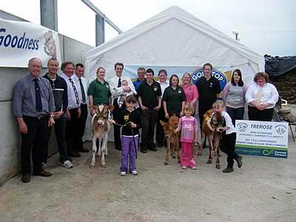
Jersey Youth members were welcomed to the Trerose and Roselle herds of David and Liz Christophers near St Allen, Truro
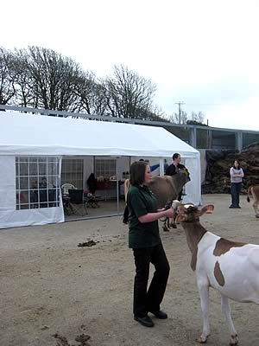
Supported by Cornwall Farmers’ Ltd the enthusiastic youngsters spent the day improving their show handling skills

2008 HERD COMPETITION
The Cornish Jersey club held the 2008 Herd Competition which was Judged by Arthur Walters, a leading cornish Ayrshire breeder, 11 herds entered the competition.
The results were announced after the annual dinner held at the Lakeview Country Club, Bodmin.
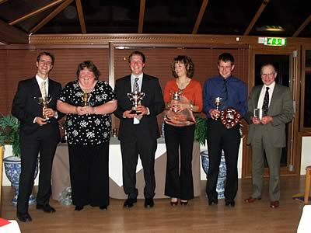
CAPTION: First prize winners from left to right Michael Colwell (Quintrell), Elizabeth Christophers (Roselle), James and Shelley Warren (Cardinney), Alan Carter (Trengilly) and Eric Murley (Bojewyan)
RESULTS
Class 1. Founders Cup – Senior Cow in Milk
1st Mrs J & Mr & Mrs M Colwell Quintrell PJSM Ultra Marine
2nd Mr & Mrs J Warren Lanhydrock Naomi
3rd Mr D Christophers Ventonwyn Nelly 2
Class 2. Anniversary Tankard – Junior Cow in Milk
1st Miss E Christophers Roselle Roxy
2nd Mrs J & Mr & Mrs M Colwell Quintrell Chosen Verbena
3rd Mr A Carter Trengilly Paragon Melody
Class 3. BOCM Silcock Tankard – Dry Cow
1st Mr FE & Mrs EM Murley & Sons Bojewyan Stuart Er Tiz
2nd Mr & Mrs J Warren Cardinney Mannix Miss Money Penny
3rd Mr AMR & Mrs BM Thomas Eglos Jessie
Class 4. Cardell Cup – Maiden Heifer
1st Mr & Mrs J Warren Glanmor Ring Medi
2nd Mr A Carter Trengilly Dulcie
3rd Mr & Mrs C Cardell & Family Carnance Julian Lady
Class 5. Pennance Cup – Heifer in Calf
1st Miss E Christophers Roselle Shambles
2nd Mr FE & Mrs EM Murley & Sons
3rd Mr A Carter Trengilly Flora
Class 6. Sandquay Margaret Cup – Heifer in milk calved under 2 ½ Years
1st Mrs J & Mr & Mrs M Colwell Quintrell Triumphs Trehane
2nd Mr S & Mrs R Thomas
3rd Mr FE & Mrs EM Murley & Sons Bojewyan Hallmark Ginger
Exhibitor Bred – Gordon McWilliam Cup
Mrs J & Mr & Mrs M Colwell
Class 7. Ross Cup – Group of Three
1st Mrs J & Mr & Mrs M Colwell Sire: Perfection Judes Style Master
2nd Mr JP & Mrs CA Bellringer Sire: Centurion Sultan
3rd Mr FE & Mrs EM Murley & Sons Sire: Rock Ella Paramount
Class 8. Montrose Perpetual Tankard – Prod. & Inspect. – last full lactation
1st Mrs J & Mr & Mrs M Colwell Quintrell PJSM Ultra Marine
2nd Mr & Mrs J Warren Tregibby Remake Elsie
3rd Mr D Christophers Ventonwyn Nelly 2
Class 9. Trevine Cup – Lifetime Production
1st Mr A Carter Angersleigh Imperial Sam’s Waltz
2nd Mr FE & Mrs EM Murley & Sons Bojewyan Boys Veil
3rd Mr D Christophers Ventonwyn Nelly 2
Class 10. Gunn Shield – Dam & Daughter
1st Mr A Carter Poyer Sweepstakes Melody Trengilly Paragon Melody
2nd Mrs J & Mr & Mrs M Colwell Quintrell PJSM Valerian Quintrell Chosen Verbena
3rd Mr JP & Mrs CA Bellringer Cockerills Lemvigs Beta Tregoose Centurions Beta
Class 11. Milking Herd
Basil Magic Cup – Small Herd
1st Mr & Mrs J Warren Cardinney
2nd Mr & Mrs C Cardell & Family Carnance
3rd Mr W Jeffery Carvinack
Braywood Cup – Large Herd
1st Mrs J & Mr & Mrs M Colwell Quintrell
2nd Mr FE & Mrs EM Murley & Sons Bojewyan
3rd Mr JP & Mrs CA Bellringer Tregoose
Class 12. Amalebra Cup – Most Points in the Competition
1st Mrs J & Mr & Mrs M Colwell Quintrell
2nd Mr & Mrs J Warren Cardinney
3rd Mr FE & Mrs EM Murley & Sons Bojewyan
3rd Mr A Carter Trengilly
Cornish Jersey Cattle Club News 2008
CAPTION: Jersey Youth members were welcomed to the Trerose and Roselle herds of David and Liz Christophers near St Allen, Truro
CAPTION: Supported by Cornwall Farmers’ Ltd the enthusiastic youngsters spent the day improving their show handling skills

